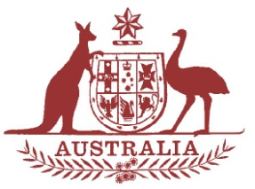

**Parliamentary Joint Committee on the National Disability Insurance Scheme**

**Chair**

The Hon. Mal Brough MP

**Deputy Chair**

Senator Alex Gallacher

**Members**

Dr David Gillespie MP  
Ms Jill Hall MP  
Mr Steve Irons MP

The Hon. Jenny Macklin MP  
Senator Barry O'Sullivan

The Hon. Amanda Rishworth MP  
Senator Zed Seselja  
Senator Rachel Siewert

Senator Dean Smith

Senator Ursula Stephens

**Correspondence and inquiries to:**

Committee Secretary

PO Box 6100

Parliament House

CANBERRA ACT 2600

Tel: 02 6277 3083

Fax: 02 6277 5829

**Email:**[**ndis.sen@aph.gov.au**](mailto:ndis.sen@aph.gov.au)

**Internet:** [**NDIS Committee home page**](http://www.aph.gov.au/joint_ndis)

**Public Hearing: Canberra**

**Date 14 May 2014**

**Time 11.30 am**

**Venue Committee Room 1S4**

**Parliament House  
Canberra**

| **Time** | **Witness** |
| --- | --- |
| 11.30 am–12.00 pm | * **National Disability Insurance Agency Board** Mr Bruce Bonyhady AM, Chair * **National Disability Insurance Agency** Mr David Bowen, Chief Executive Officer * Ms Sarah Johnson, NDIA Scheme Actuary |
| *12.00 pm* | *Adjournment* |