CONFIDENTIAL
FORM B
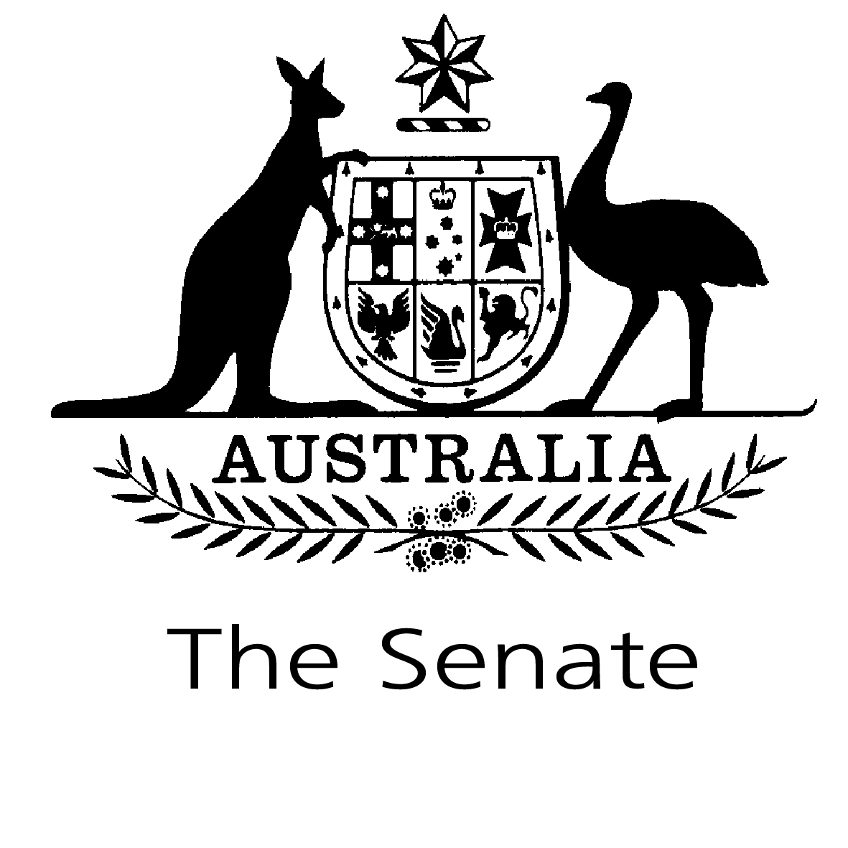
STATEMENT OF REGISTRABLE INTERESTS

FORM B – SPOUSES OR PARTNERS AND DEPENDENT CHILDREN

Surname: ……………………………………….....  (please print) | Other Names: ………………………………...........
State/Territory: ………………………………………………………………………………………..……

Signature: ……………………………………….... | Date: …………………………..………………..…

Send the original, signed form to the Registrar of Senators’ Interests, Parliament House, Canberra, ACT 2600. Please sign and date both this form, and Form B if required, which together constitute your statement of registrable interests. If there is insufficient space on the form, you may attach additional pages. Please date, and either sign or initial, each page of any attachment.

Do not use this form to notify an alteration of registrable interests

PLEASE READ THE ATTACHED EXPLANATORY NOTES BEFORE COMPLETING THE FORM

Senators complete Form B on behalf of their spouse or partner and/or dependent children to the extent that senators are aware of their interests. The forms remain confidential unless the Committee of Senators’ Interests considers that a conflict of interest arises. In those circumstances, the committee may table a Form B declaration.

Senators are not required to identify persons covered by Form B by name.

1. SHAREHOLDINGS IN PUBLIC AND PRIVATE COMPANIES (INCLUDING HOLDING COMPANIES) INDICATING THE NAME OF THE COMPANY OR COMPANIES (See Explanatory Notes)

(Note: It is NOT necessary to declare the size or value of the shareholding)
Spouse or partner | Name of company – (including holding and subsidiary companies if applicable)
 | Example—AMP, Telstra, XYZ Pty Ltd
Dependent children

2. FAMILY AND BUSINESS TRUSTS AND NOMINEE COMPANIES – (See Explanatory Notes)
(i) in which a beneficial interest is held, indicating the name of the trust and the nature of its operation and beneficial interest

Spouse or partner | Name of trust/nominee company | Nature of its operation | Beneficial interest
 | Example— Brown Family Trust | Property investment | Joint beneficiary
Dependent children

(ii) in which the Senator, the Senator’s spouse or partner, or a child who is wholly or mainly dependent on the Senator for support, is a trustee (but not including a trustee of an estate where no beneficial interest is held by the Senator, the Senator’s spouse or partner or dependent children), indicating the name of the trust, the nature of its operation and the beneficiary of the trust

Spouse or partner | Name of trust/nominee company | Nature of its operation | Beneficiary of the trust
 | Example— Black Family Trust | Share investment | Children
Dependent children
3. REAL ESTATE, INCLUDING THE LOCATION (SUBURB OR AREA ONLY) AND THE PURPOSE FOR WHICH IT IS OWNED (See Explanatory Notes)

(Note: The full street address of property is NOT required to be specified)
Spouse or partner | Location | Purpose for which owned
 | Example—Ainslie, ACT | Residential
Dependent children

4. REGISTERED DIRECTORSHIPS OF COMPANIES (See Explanatory Notes)

Spouse or partner | Name of company | Activities of company
 | Example—QRS Pty Ltd | Property services
Dependent children

5. PARTNERSHIPS, INDICATING THE NATURE OF THE INTERESTS AND THE ACTIVITIES OF THE PARTNERSHIP (See Explanatory Notes)

Spouse or partner | Name | Nature of interest | Activities of partnership
 | Example—Green & Sons | Financial partner | Farming
Dependent children

6. LIABILITIES, INDICATING THE NATURE OF THE LIABILITY AND THE CREDITOR CONCERNED (See Explanatory Notes)

(Note: It is NOT necessary to declare the amount of any liability)
Spouse or partner | Nature of liability | Creditor
 | Example—mortgage on investment property | Commonwealth Bank
Dependent children

7. THE NATURE OF ANY BONDS, DEBENTURES AND LIKE INVESTMENTS (See Explanatory Notes)

(Note: It is NOT necessary to declare the value of such investments)
Spouse or partner | Type of investment | Body in which investment is held
 | Example—managed funds | CDE
Dependent children

8. SAVING OR INVESTMENT ACCOUNTS, INDICATING THEIR NATURE AND THE NAME OF THE BANK OR OTHER INSTITUTIONS CONCERNED (See Explanatory Notes)

(Note: It is NOT necessary to declare actual amounts held in accounts)
Spouse or partner | Nature of account | Name of bank/institution
 | Example—savings | Commonwealth
Dependent children
9. THE NATURE OF ANY OTHER ASSETS (EXCLUDING HOUSEHOLD AND PERSONAL EFFECTS) EACH VALUED AT MORE THAN $7,500 (See Explanatory Notes)

(Note: It is NOT necessary to declare the value of any other asset)
Spouse or partner | Nature of any other assets
 | Example—life insurance
Dependent children

10. THE NATURE OF ANY OTHER SUBSTANTIAL SOURCES OF INCOME (See Explanatory Notes)

(Note: It is NOT necessary to declare the amount of the income)
Spouse or partner | Nature of income
 | Example—shareholdings
Dependent children

11. GIFTS VALUED AT MORE THAN $750 RECEIVED FROM OFFICIAL SOURCES (such sources being an Australian or foreign national, State, provincial or local Government or a person holding an office in such a Government) OR AT $300 OR MORE WHERE RECEIVED FROM OTHER THAN OFFICIAL SOURCES, provided that a gift received by a Senator, the Senator’s spouse or partner or dependent children from family members or personal friends in a purely personal capacity need not be registered unless the Senator judges that an appearance of conflict of interest may be seen to exist. (See Explanatory Notes)

(Note: It is NOT necessary to declare the value of the sponsored travel etc.)
Spouse or partner | Details of gifts
 | Example—laptop computer from ABC Pty Ltd
Dependent children
12. ANY SPONSORED TRAVEL OR HOSPITALITY RECEIVED WHERE THE VALUE OF THE SPONSORSHIP OR HOSPITALITY EXCEEDS $300 (See Explanatory Notes)

(Note: It is NOT necessary to declare the value of the sponsored travel etc.)
Spouse or partner | Details of travel/hospitality
Example—Upgrade from business to first class on QF123, Sydney to LA on [date];
tickets and hospitality, Australian Open tennis final on [date], Kenbank
Dependent children

13. BEING AN OFFICE HOLDER OF OR FINANCIAL CONTRIBUTOR DONATING $300 OR MORE IN ANY SINGLE CALENDAR YEAR TO ANY ORGANISATION (See Explanatory Notes)

Spouse or partner | Name of organisation
 | Example—President, NSW Women’s Guild; Donor—UNICEF
Dependent children

14. ANY OTHER INTERESTS WHERE A CONFLICT OF INTEREST WITH A SENATOR’S PUBLIC DUTIES COULD FORESEEABLY ARISE OR BE SEEN TO ARISE (See Explanatory Notes)

Spouse or partner | Nature of interest
Dependent children

