
Annual Report and
Financial Statements 2007-08

© | Commonwealth of Australia 2008
ISSN | 1832-0848

This work is copyright. Apart from any use as permitted under the Copyright Act 1968, no part may be reproduced by any process without prior written permission from the Commonwealth available from the Attorney-General’s Department, and inquiries concerning reproduction and rights should be addressed to:
Commonwealth Copyright Administration, Copyright Law Branch
Attorney-General’s Department
Robert Garran Offices
National Circuit
BARTON ACT 2600

or posted at: http://www.ag.gov.au/

ANNUAL REPORT CONTACT:
Mr Terry Crane
Assistant Secretary
Strategy and Business Services Branch
Department of Parliamentary Services
Parliament House
PO Box 6000
CANBERRA ACT 2600

Phone: (61) 02 6277 8812
Fax: (61) 02 6277 8999
Email: terry.crane@aph.gov.au

To access parliamentary material on the internet, including this report, see the department’s internet site accessed through the Australian Parliament’s home page: http://www.aph.gov.au

Other documents available on the department’s internet site which will assist the reader in understanding the operations of the department are:

DPS Portfolio Budget Statement 2007-08
Parliamentary Service Act 1999

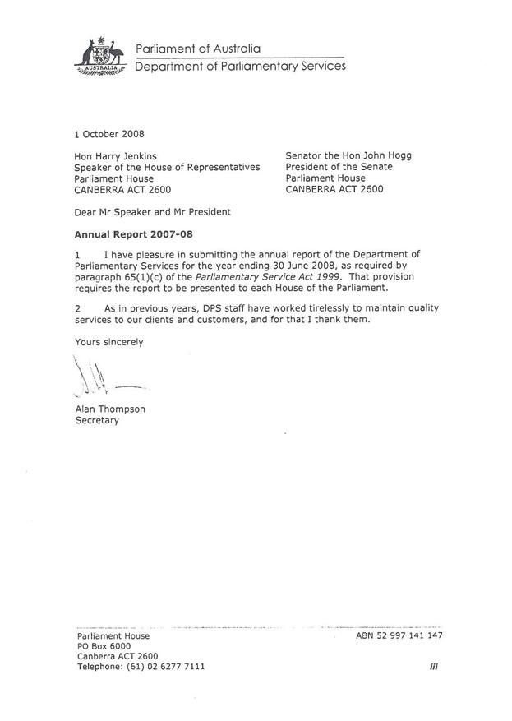

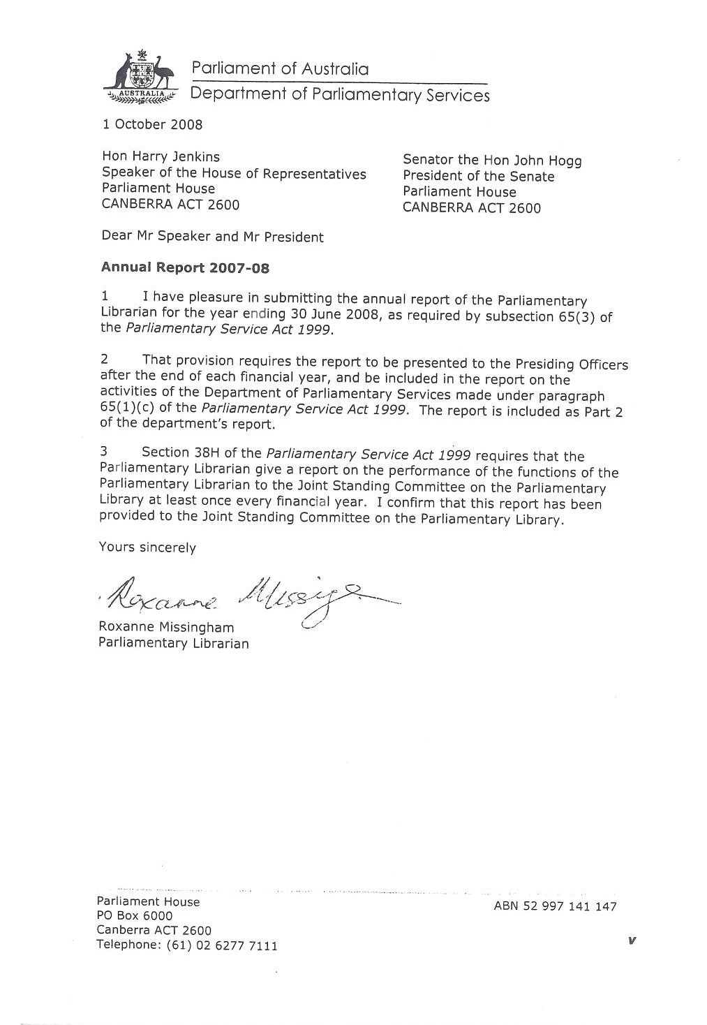

Contents

Part 1—Secretary’s review 3
Part 2—Departmental overview 11
Introduction 11
Departmental outcome statement 11
Departmental structure 11
Departmental services 14
Parliamentary Library 14
Building Services Branch 14
Infrastructure Services Branch 17
Content Management Branch 20
Product and Service Development Branch 22
Strategy and Business Services Branch 24
Chief Finance Officer Branch 26
Staff recognition 28
Part 3—Parliamentary Library 33
Parliamentary Librarian’s review 33
Introduction 33
Joint Standing Committee on the Parliamentary Library 35
Resource Agreement 36
Assessment of clients’ needs and Library performance: addressing the 2007 assessment findings 37
Continuous Improvement Review of the Information Access Branch 40
Parliamentary Library feedback 42
Australian National Audit Office (ANAO) 42
Significant improvements in services and systems 43
Assistance to parliamentary libraries in the region 43
Strategic and Workforce Planning 44
Parliamentary Library overview 45
Office of the Parliamentary Librarian 45
Research Branch 45
Information Access Branch 46
Report on performance 48
Introduction—Output 1 Library Services 48
Sub-output 1.1—Research services 48
Sub-output 1.2—Information access services 55
Parliamentary Library Financial Report 61
Part 4—Report on performance 65
Overview 65
Performance information and reporting model 65
Output cost attribution 65
Effectiveness in achieving the planned Outcome 67
Occupants of Parliament House are supported by integrated services and facilities, … 67
Parliament functions effectively … 67
… and its work and building are accessible to the public. 68
Output 1—Library Services 69
Introduction 69
Output 2—Building and Occupant Services 69
Introduction 69
Sub-output 2.1—Security services 69
Sub-output 2.2—Facilities services 74
Output 3—Infrastructure Services 80
Introduction 80
Sub-output 3.1—Building infrastructure services 80
Sub-output 3.2—IT infrastructure services 86
Output 4—Parliamentary Records Services 93
Introduction 93
Sub-output 4.1—Broadcasting services 93
Sub-output 4.2—Hansard services 98
Administered items 103
Introduction 103
Performance 103
Other reporting requirements 106
Purchaser-provider arrangements 106
Part 5—Environment and heritage 111
Introduction 111
Overview 111
Strategic plan 112
Sustainable purchasing practices 112
Communication and promotion 113
Legal requirements 114
Heritage Performance 117
Design Integrity Index 2007-08 117
Environmental performance 118
Water 118
Energy 121
Recycling and waste management 125
Emissions and effluents 129
Part 6—Management and accountability 135
Corporate governance 135
Introduction 135
Committees advising the Presiding Officers 135
DPS committees 137
Other governance matters 140
People management and strategy 144
Staffing, salary and classification structures 144
Purchasing 153
Overview 153
Consultants 154
Competitive tendering and contracting 155
Exempt contracts 155
Asset management 156
Accountability 157
External scrutiny 157
Freedom of information 158
Discretionary grants 158
Advertising costs 158
Legal services expenditure 159
Financial Statements 161
Appendices 219
Appendix A—Consultancy services 2007-08 221
Appendix B—Material errors in 2006-07 annual report 223
Glossary 225
Acronyms and abbreviations 231
Compliance index 235
Global Reporting Initiative index 239
List of figures 241
Index 243

Part 1—Secretary’s review

Part 1—Secretary’s review

An effective parliament requires excellent support services and administration. For the Australian Parliament, these functions are provided by the Department of Parliamentary Services (DPS), and the two chamber departments.

There is considerable detail in the body of this report about the wide range of services which DPS provided to support the Parliament in 2007-08. However, before delving into detailed issues, I would like to reflect on the big picture events in the life of the Parliament, against which the performance of DPS should be judged for financial year 2007-08. I will also briefly outline some of the challenges and work programs for DPS for 2008-09 and beyond.

The early focus of 2007-08 for DPS was to assist the 41st Parliament to complete its business, prior to the November 2007 federal election. This included the conclusion of Committee work as well as business in both Chambers.

As a result of the change of government, in November and December 2007 DPS worked with the Department of the House of Representatives and the Department of Finance and Deregulation to facilitate induction of 42 new members of the House of Representatives, as well as the considerable logistics of “moving out/moving in” for offices within the House of Representatives, and the Ministerial Wing. Staff from many parts of DPS were involved in these changeover processes, which assisted the commencement of operations of the 42nd Parliament.

A post-election changeover process, such as that in November–December 2007, involves many obvious tasks, but also some other less obvious tasks, such as the need for all of our Parliamentary Security Service staff to quickly memorise the identity of the 42 new Members of the House of Representatives; the logistical challenge of disposing or recycling large volumes of unwanted paperwork from the offices of departing Members and Ministers; providing briefings to new Members and their staff about important services such as that provided by the Library Research staff; and setting up computer access in Parliament House and each electorate office.

As we moved into 2008, it became clear that the new Government wished to hold two major events in Parliament House, namely the Apology to Australia’s Indigenous Peoples and the Australia 2020 Summit. For both of these events, many DPS groups and individual staff were actively involved in preparations and the actual events. Numerous staff have commented to me about how they were personally moved by the Apology ceremony.

In addition, in May 2008, DPS played a major role in celebrating the 20th anniversary of the opening of the new Parliament House.

Finally, as we approached the end of the financial year, DPS staff worked with the Department of the Senate to facilitate the departure of 14 retiring senators and the induction of 14 new senators, including a similar but smaller “moving out-moving in” process to that which had occurred in November-December 2007.

I also note that in terms of parliamentary activity, the last six months of 2007 were quieter than usual as a result of the election, while the first half of 2008 was back to business as usual in both chambers, together with a robust program of Committee work.

Although I joined DPS late in 2007-08, it is clear to me that the staff and management of DPS were strong contributors to a busy year in the overall life of the Australian Parliament. I thank all staff for their contribution.

In parallel with the parliamentary and Government activities outlined above, it is important to reflect that other DPS staff provided services less directly linked to the parliamentary cycle. For example, during 2007-08 there were some 867,220 visitors to Parliament House, including school groups. The visitor experience of these people was greatly enhanced by our guides, Parliament Shop staff, and our parliamentary security staff. In addition to the National Apology and the 2020 Summit events, Parliament House was the venue for some 114 events in the Great Hall and 96 in the Mural Hall. The success of these events was largely a result of the contribution of DPS staff and our events/catering contractors.

Finally, the overall program of building and landscape maintenance and upgrade continued, and we were able to achieve a further 27% decrease in water consumption compared with 2006-07. Once again, our building maintenance and landscape staff can take pride in all of their achievements.

Along with the program of service delivery outlined above, it is also important to recognise the major improvement programs that were completed or initiated across DPS in 2007-08. These include four separate strategic plans for Information Technology, Water, Energy and People. At a more tangible level, improved waste recycling systems were established for Parliament House, the new ParlInfo IT system approached completion, new catering contractors were appointed, and the arrangements for a Childcare Centre were advanced to the point that both Houses were able to approve the new facility in June 2008. Some important trials of different lawn grasses were also initiated, so as to minimise future water consumption.

Overall, 2007-08 was a year of considerable accomplishment for the staff of DPS. Some of the key DPS contributors were recognised through Australia Day Achievement Medallions (see page 29).

As we look ahead into 2008-09 it is important to identify the key challenges for the next few years. Some of the challenges are about how the Department operates, notably the need to improve our project delivery performance; excellent new project management systems were implemented in 2007-08 and these should result in timely and cost-effective delivery of future projects. Another issue for the Department is to fully understand our customer/client base; while we have a very strong focus on the needs of Senators and Members, and the business of the two Chambers and related Committees, there are many other events occurring in and around Parliament House where our focus has been less effective.

In 2008-09 we also need to proactively tackle the issue of climate change and water shortages in the Murray-Darling Basin. We have already taken difficult interim decisions to “turn off” numerous water features around the building, and to initiate grass trials and energy audits. An overall climate change plan is now required.

A further challenge is that our budget outlook is very constrained. A stark reality is that the operating budget (around $116 million) for DPS in 2008-09 is very similar to the combined budgets of the three predecessor agencies in 2000-01 (around $115 million), even though the Consumer Price Index (CPI) increased by over 30% in that same period. Moreover, it is becoming clearer that the amount of Committee work and Chamber time is now moving to levels well above those experienced for the three years of the 41st Parliament (when the Government held majorities in both Chambers). This increased activity is already affecting the work of DPS.

The staff of DPS can take pride in the various productivity initiatives that have facilitated continued delivery of high quality services, but further emerging cost pressures (including those relating to a heightened level of parliamentary and committee activity) point to a need to operate very frugally in 2008-09 and the years beyond.

On a more positive note, in my brief time as Secretary I have identified a significant strength for the Department, and this relates to the pool of talented individuals within DPS. The table on Page 8 provides a sample of these capabilities. By harnessing this diversity of talent we should make a huge contribution to the challenges I have identified.

Against this background, the work program for DPS for 2008-09 will include five key priorities.
- We plan to deliver a wide range of “improvement” projects for Parliament, including the new ParlInfo IT system and the new Childcare Centre.
- We will strengthen our client focus across the full range of customers/clients of Parliament House.
- A climate change action plan will be developed.
- We will ensure we maintain a program of infrastructure maintenance and prudent modernisation.
- We expect to continue with “normal” service delivery, albeit operating very frugally.

To deliver this program we will harness the diverse skills of DPS staff, and build on existing initiatives such as recognising staff through the Australia Day Achievement Medallions Program.

Before I conclude, it is appropriate to recognise some significant changes in key office holders.

On 11 January 2008, the first Secretary for DPS, Hilary Penfold QC, left to take up her appointment as Justice of the ACT Supreme Court. Ms Penfold was Secretary of DPS for four years. She successfully brought together the three predecessor agencies, established a sense of unity across DPS, and implemented highly effective administrative systems. Her intellectual rigour is well respected by DPS staff and many other building occupants.

On 12 February 2008, the Hon. David Hawker MP completed a four-year term as the Speaker, and Mr Harry Jenkins MP was elected as the new Speaker.

I wish to thank the former President of the Senate, Senator the Hon. Alan Ferguson, and Speakers, the Hon. David Hawker MP and Mr Harry Jenkins MP, for their support of DPS through 2007-08. On behalf of all DPS staff, I also thank Hilary Penfold for her leadership since 2004, and extend my thanks to David Kenny who acted as Secretary from January 2008 through to May 2008.

I commend the rest of this report to the reader as a useful record of the achievements of DPS for 2007-08. I look forward to working with the Presiding Officers, DPS staff and the chamber departments to deliver ever-better services while tackling some major challenges.

Alan Thompson

Maintaining the flagpole  Our cover photo depicts DPS staff and contractors engaged in safety equipment checks. The image captures the moment they enter the cage, just before the approximate 100m ascent up the south-east leg of the flagpole above the roof of Parliament House.  The insert shows the workers about to emerge from the carriage onto the platform to travel further up the flagpole.  These photos were taken by Brett Goodhew of Content Management Branch from the Opposition Leader’s courtyard. Other photos throughout the report were taken by Patrick Gallagher and Pat Gallagher also of Content Management Branch. | 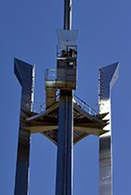

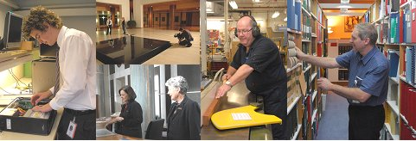

Skilled people
DPS employs some 900 people with a wide range of diverse skills. The following list, whilst not exhaustive, captures some of the capabilities of our talented people:

- Library management
- Publishing
- Arts collection and management
- Document and file management
- Policy and legislation research in, for example, social policy, politics, foreign affairs, economics, defence, science and statistics
- Broadcast services—development, operation and maintenance
- Hansard recording
- Security services
- Visitor guides
- Retailing
- Heritage preservation and environmental science
- Landscape services / horticulture / gardens
- Building and facilities maintenance, including carpentry, plumbing, electrical, cabinet-making, mechanical trades
- Project management
- IT hardware and software development operations and maintenance
- Telecommunications
- Finance
- HR services and Occupational Health and Safety
- Facilities and events management
- Nursing services
- Administrative skills
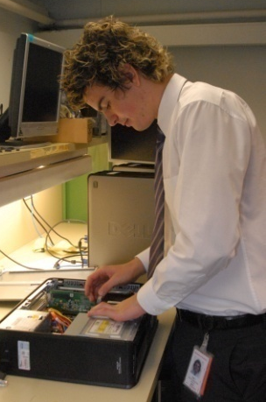

Part 2—Departmental overview
Part 2—Departmental overview
Introduction
  - The Department of Parliamentary Services (DPS) is one of three departments which comprise the Parliamentary Service, the other two being the Department of the Senate and the Department of the House of Representatives.
  - The Secretary, reporting to the Presiding Officers of the Parliament (the President of the Senate and the Speaker of the House of Representatives), is responsible for managing DPS and providing advice to the Presiding Officers on matters relating to DPS.
Departmental outcome statement
  - The Presiding Officers have approved the following Outcome statement for DPS:
Occupants of Parliament House are supported by integrated services and facilities, Parliament functions effectively and its work and building are accessible to the public.
Departmental structure
  - DPS has an Executive and eight branches, as illustrated in our organisational chart provided at Figure 1.
  - Our organisational structure is referred to as a “Plan/Build/Run” model. Work units are grouped according to whether they contribute predominately to business planning, capability development/capital investment or operational service delivery.
  - Supporting the business model are our core business principles of continuous improvement, seamless service delivery and accountability. Specifically, the organisational structure is designed to improve management decision-making, increase transparency and accountability, more effectively allocate resources, better interact with clients and customers to meet their needs and enhance our overall performance.
  - The Secretary is Chief Executive Officer (CEO) and the principal officer of the department’s leadership team. Executive officers reporting directly to the Secretary are the Parliamentary Librarian, the Deputy Secretary and the Chief Finance Officer (CFO).
  - The office of Parliamentary Librarian is a statutory one created by the Parliamentary Service Act 1999 (the Act). The Parliamentary Librarian reports to the Presiding Officers in respect of statutory functions detailed in the Act. However, for the exercise of normal management functions, including as detailed in the Act and the Financial Management and Accountability Act 1997, the Parliamentary Librarian reports of the Secretary.
  - The Parliamentary Librarian is responsible for the Research Branch and the Information Access Branch. Under the Act the Parliamentary Librarian is required to prepare an annual report to the Presiding Officers. The Parliamentary Librarian’s annual report is included at Part 3 of this document.
  - The Deputy Secretary is responsible for the activities of five branches (Strategy and Business Services, Building Services, Infrastructure Services, Content Management and Product and Service Development).
  - The CFO is responsible for the activities of the Chief Finance Officer Branch.
  - Each branch within DPS is headed by an Assistant Secretary and is divided into sections. The roles and responsibilities of each branch and their achievements and highlights for the 2007-08 year are described further in “Departmental services” (see paragraphs 13 to 95).
13
DPS Annual Report 2007-08
Part 2—Departmental overview
Figure 1—DPS Departmental Structure at 30 June 2008
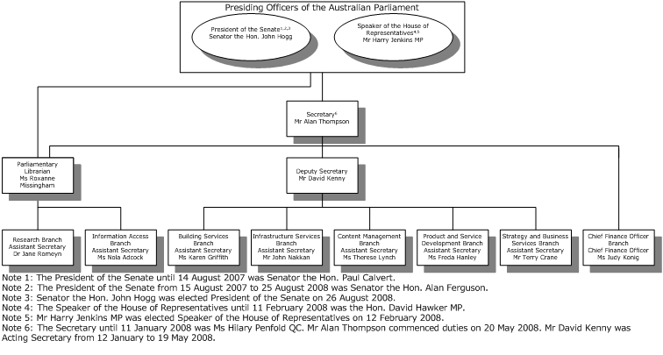

Departmental services
  - The services we provide are broad-ranging, encompassing the management, maintenance and provision of information, security, facilities, visitor, building, maintenance, landscaping, IT network , telecommunications, broadcasting and Hansard services. Details of the many services provided by DPS are contained in the DPS Services Catalogue, available on our website at http://www.aph.gov.au/dps/services.pdf. The work of each branch and their achievements and highlights for the 2007-08 year are described below.
Parliamentary Library
  - The Parliamentary Library provides information, analysis and advice to the Parliament and comprises the Office of the Parliamentary Librarian and two branches, the Research Branch and the Information Access Branch.
  - More detail on the role, functions and services provided by the Parliamentary Library can be found in Part 3 of this report.
Building Services Branch
  - The Building Services Branch (BSB) predominantly contributes to the ”run” part of our business model. It comprises three sections delivering a range of services to occupants of and visitors to Parliament House. These include security and emergency services, facilities management, retail services, health and wellbeing services and visitor services. BSB also manages a contract with the Australian Federal Police (AFP) for the provision of external security within the Parliamentary Precincts.
Security
  - Security services are provided by two sections:
Security Operations, which provides operational security and emergency services largely through Parliamentary Security Service (PSS) officers; and
Security Planning and Administration, which provides management and workforce planning functions for the PSS, security training and administration, security systems administration and support, key and locks management and also manages the pass office and the PSS roster office.
  - The protection portfolio of the Australian Federal Police—AFP-Uniform Protection (AFP-UP)—is contracted to provide a security service within the parliamentary precincts. Mobile patrols are provided by officers in vehicles, on foot and on bicycles. AFP-UP officers deal with security incidents within the precincts and provide an armed first-response capability for Parliament House. AFP-UP also provides security services within the Ministerial Wing (except for entrance security screening, which is a PSS function) and provides security for the Prime Minister’s Suite and the Cabinet Suite. The AFP officer-in-charge also undertakes the role of Parliament House Protective Security Controller (PHPSC).
  - PSS officers—who are DPS employees—provide access control and security screening at all entrance points and a mobile and static security presence throughout Parliament House, including the chambers and the public galleries. Access control and security screening involves the use of metal detectors and X-ray machines to screen incoming people, goods and mail. Internal and external security is supported by a closed-circuit television (CCTV) network and a variety of electronic security systems.
  - PSS officers provide security services to functions, official visits and other significant activities within Parliament House in addition to their routine security responsibilities. The PSS provides an unarmed first-response capability to security incidents and duress alarms within the building (except for the Ministerial Wing, where first response is provided by AFP-UP), as well as providing initial first aid services to Senators, Members, other building occupants and visitors.
  - Emergency management within Parliament House is coordinated by the Emergency Control Committee, chaired by the PHPSC. Responses to particular incidents are supported by wardens from all parliamentary departments, as are emergency response exercises.
  - Both Security Sections, and the PHPSC, contribute to the development of security policy through the Security Management Board, and to the implementation of security and emergency policy, procedures and response protocols for Parliament House.
Facilities
  - The Facilities Section administers the Presiding Officers’ policies on the use of Parliament House facilities by building occupants and members of the public, including the provision of catering, cleaning and pest control services through contracts with external providers. In addition, the section manages licence agreements for various commercial activities, including the Press Gallery, bank, travel agency, Aussie’s general store, post office, hairdresser, physiotherapist, Australian Government Photographic Service (AusPic) and florist.
  - The section provides a range of visitor services (including guided tours for building visitors and presentations for school groups) as well as operating the Parliament Shop, which sells a range of Parliament House souvenirs and Australian-made specialty goods.
  - The Nurses Centre provides first aid and a limited range of other health services to building occupants. The Health and Recreation Centre offers building occupants access to recreational facilities, including a gymnasium, squash courts, tennis courts, a swimming pool and fitness classes.
BSB highlights and achievements
  - We successfully provided significant security, administrative and logistical support to numerous major events held at Parliament House during 2007-08, including the Opening of Parliament, the Australia 2020 Summit, the Apology to Australia’s Indigenous Peoples, the Pre-Election Leaders Debate (commonly referred to as “the Great Debate”), Budget Night, and the 20th Anniversary of the Opening of Parliament House.
  - During 2007-08 there were 114 events in the Great Hall and 96 in the Mural Hall. All of the major events mentioned above used multiple venues throughout the building.
  - Following a comprehensive tender process for the provision of catering services to Parliament House, two new catering contractors were selected, with transition to the new contractors taking place on 1 July 2008. Under the new arrangements building occupants will continue to receive high quality catering services. The requirement for responsiveness to customer feedback is an important feature of the new contracts.
  - Another comprehensive tender process selected Anglicare Canberra-Goulburn as the provider for a parliamentary childcare service from January 2009. Construction of the childcare centre commenced in May 2008.
  - Following the November 2007 federal election our PSS officers moved to quickly memorise the faces of 42 new Members of the House of Representatives.
Infrastructure Services Branch
  - The five sections within Infrastructure Services Branch (ISB) are responsible for providing day-to-day support to Parliament House, building occupants and visitors by maintaining the building and its systems. While the branch is primarily part of the “run” component of our business model, it is also responsible for some capital investment work (a “build” activity), generally involving replacement of existing infrastructure such as carpet, furniture and landscape.
Maintenance Services
  - The Maintenance Services Section provides cost effective, high quality preventative maintenance and breakdown rectification services to Parliament House. Services maintained include:
high and low voltage electrical power distribution;
fire and security monitoring and control systems;
airconditioning, hydraulic and pneumatic systems;
the building’s structure, fabric and fit-out; and
the landscape.
  - Maintenance Services is responsible for the development and management of long—and short-term maintenance plans for Parliament House, plant maintenance history, management and analysis. The section also maintains engineering drawings and the technical manual library. In addition, we maintain historical plant records and provide continuous analysis on plant health against engineering benchmarks.
IT Operations (Support and Maintenance)
  - IT Operations (Support and Maintenance) provides support and assistance to customers using IT and broadcasting services.
  - An important and highly used service is the Client Support Desk (2020) which provides services to some 4,300 IT users in Parliament House and Electorate Offices. 2020 is usually a client’s first point of contact for information and communications technology (ICT), broadcasting and Hansard services, and it includes ICT training, assistance and advice.
  - The section also provides second-line software and hardware support for desktop and mobile computing devices, printers, televisions and pagers.
Computing Services
  - The Computing Services Section is responsible for the operation of central computer facilities, including:
the computer rooms, server and storage hardware;
system and data backup and restoration;
server, email and database software; and
ICT security operations, change management, and automated software distribution to desktops and laptops.
  - In addition, the section provides the Information Technology Security Adviser (ITSA) role for the department and assists the chamber departments with their ITSA functions.
Telecommunications
  - The Telecommunications Section provides data network and voice communications services to some 3,000 building occupants.
  - Data network services include:
connection from the desktop to the network servers, and to applications such as ParlInfo, digital audio and the Table Office and Hansard systems; and
the gateway to the internet and connections to electorate offices.
  - Voice communications services include:
the Alcatel telephone system;
voicemail;
the broadcast facsimile gateway; and
mobile phone coverage within Parliament House.
Broadcasting Infrastructure Support
  - The purpose of the Broadcasting Infrastructure Support Section is to support the broadcasting systems deployed in Parliament House. The major systems are:
television and radio production facilities in the chambers, committee rooms, and production control rooms;
broadcast cameras and camera robotics;
sound reinforcement systems in chambers and committee rooms;
the House Monitoring Service;
the Emergency Warning and Intercommunications System; and
the Master Clock System, division bells and lights.
ISB highlights and achievements
  - We were able to achieve a further 27% decrease in water consumption compared with 2006-07. More than half of the water we consume is used on the landscape.
  - Of great significance to our management of the parliamentary landscape was the completion of our landscape review. The review was prepared against a backdrop of continuing water restrictions in the ACT and increasing concerns about the health of rivers in Murray-Darling Basin. The review provides the landscape direction for the next 20 years and focuses on maintaining the original landscape design philosophy and functionality as much as possible, whilst creating a more sustainable and environmentally friendly landscape.
  - In July 2007 we implemented “spam tagging” for all parliamentary systems users. Messages assessed as unsolicited junk email have the phrase "Spam:" added to the start of the message subject line, which can be subsequently filtered by the Outlook application. Approximately 55% of the email received by the parliamentary network in 2007-08 were tagged as spam. The new spam tagging system is a significant improvement over the previous anti-spam system and has been of great use in dealing with the large amounts of spam email received.
  - A total of 401 new printers were put into service to replace out-of-warranty printers for the chamber departments and DPS. Some of the new printers are multi-function devices with a photocopier component and their introduction has reduced the number of stand-alone photocopiers required.
  - Our telephony system includes switchboard staff, telephone help desk staff and technical personnel to perform telephone hardware and software maintenance services (including maintenance to the PABX). During 2007-08 we transitioned to a new service provider to manage the telephony system. This change occurred with no service interruptions. The new arrangements have delivered significant savings while maintaining the same high quality telecommunications services.
  - Broadcasting Infrastructure Support staff developed a program of powering off all non-essential equipment during parliamentary adjournment periods, lowering our electricity demand by approximately 10KW during these periods.
  - Following the November 2007 federal election, we worked with the chamber departments to ensure a smooth transition. The range of DPS activities included telephony changes, computing network user additions and deletions, furniture changes and amending office name-plates.
  - Elections also provide us with an opportunity to engage in general suite maintenance, which may involve painting, woodworking, carpeting, and other general maintenance. Extensive work was undertaken to the Leader of the Opposition suite as part of our cyclical refurbishment program. Work completed included kitchen retiling, full repainting and recarpeting and refurbishment of the timber fixtures.
Content Management Branch
  - Content Management Branch (CMB) has four sections. It is responsible for broadcasting and archiving the audio-visual record of chamber and committee proceedings of the Parliament and for producing a Hansard record of those proceedings. The branch coordinates the management of DPS records and knowledge and is responsible for developing and implementing our online business strategy.
Broadcasting Content
  - The Broadcasting Content Section produces and distributes live audio and video coverage of all proceedings of the Senate and House of Representatives chambers and the Main Committee of the House of Representatives. It also televises selected parliamentary committee proceedings in Parliament House and provides audio coverage of hearings held in other venues around Australia. The section provides sound reinforcement for these venues as well as systems for the hearing-impaired in many locations within Parliament House. The proceedings are broadcast on the House Monitoring Service (a closed cable television and radio system at Parliament House) and also webcast via the internet.
  - A range of television and radio production services are available to Senators and Members through a fully equipped studio complex with video editing, audio production and post-production facilities. Other services include audio-visual support services for parliamentary events, video conferencing and teleconferencing facilities, provision of video and audio copies of parliamentary proceedings and television replays of those proceedings.
Hansard
  - The two Hansard sections (Hansard Operations Section and Hansard Support Section) transcribe and publish reports of proceedings in the Senate, the House of Representatives and the Main Committee of the House of Representatives, all parliamentary committee hearings and some ministerial or parliament-related conferences. Hansard transcripts are available in hard copy, and electronically via the internet (www.aph.gov.au) and on the internal Parliamentary Computing Network (PCN).
Knowledge Management
  - The Knowledge Management Section is responsible for DPS’s document and records management. It is also responsible for ensuring DPS complies with the Archives Act 1983, with internal and external audit recommendations for records management and with the Commonwealth Government’s Intellectual Property Principles.
Web Content
  - The Web Content Section develops and disseminates policy and guidelines aimed at ensuring compliance with legislation and web content standards. It is also responsible for developing the department’s online information and services strategy.
CMB highlights and achievements
  - With the opening of the 42nd Parliament, we broadcast the first ‘Welcome to Country’ ceremony held in the Members’ Hall and also the live coverage of the Apology to Australia’s Indigenous Peoples. These events were the two most widely distributed programs in our 20-year broadcasting history, with the content taken by both national and international media.
  - The Australia 2020 Summit, held on 19 and 20 April in Parliament House, saw us again adopt the role of host broadcaster. The events (both live and delayed) were distributed over the House Monitoring Service (HMS), to the national media, on the internet, and internationally via the Television Operations Centre (Telstra Tower). It was the largest production we have ever undertaken and required Broadcasting Content to provide five video and ten audio signals from venues simultaneously.
  - During the year we continued developing our records management framework, and in February the National Archives of Australia approved our first Records Authority. The new records authority recognises the unique functions carried out by DPS and is a significant sign of progress in records management by DPS.
Product and Service Development Branch
  - The Product and Service Development Branch (PSDB) is responsible for the management and delivery of all projects within DPS. As such, it primarily delivers the “build” part of our business model. PSDB also manages the Parliament House Art Collection.
Building and Security Projects
  - The Building and Security Projects Section is responsible for managing the delivery of building, engineering and security projects related to refurbishment, modification, upgrade, replacement or new works in Parliament House and the Parliamentary precincts.
Technology Projects
  - The Technology Projects Section is responsible for managing the delivery of projects related to the installation and implementation of new and replacement technology. Projects include development of IT, broadcasting, communication and security technology systems and infrastructure.
Project Management Office
  - The Project Management Office is responsible for:
ensuring all projects are undertaken using a consistent project management methodology;
providing project management best practice guidance and support to all project stakeholders; and
providing performance reporting on project progress.
Art Services
  - The Art Services Section manages the Parliament House Art Collection, with responsibilities including artwork acquisitions, collection conservation and managing access to artworks for display in Parliament House and the Parliamentary precincts. The section also administers the Historic Memorials and Gifts Collections.
PSDB highlights and achievements
  - The nature of project work conducted by PSDB is to build service capacity in conjunction with the operational areas of DPS. Our successes tend to be shared ones where we have collaborated with other parts of DPS or the chamber departments in delivering successful projects.
  - Our Technology Projects section worked with Building Services Branch staff to replace over 400 CCTV cameras and install new X-ray machines with improved screening capability at the building entrances. Security has been significantly enhanced through both of these projects.
  - We upgraded the ‘ParlTV’ service on the Intra-Commonwealth Optical Network (ICON) by adding additional laser transmitters. An increased number of Commonwealth agencies are now able to directly access television coverage of parliamentary proceedings.
  - In November 2007 we commenced work on the replacement of two key parliamentary information management systems: ParlInfo and Bills. Both projects are on schedule with the design completed and the infrastructure installed ready for release to parliamentary clients in late August 2008.
  - We continued to trial new water-saving sensor taps and dual-flush toilets with smaller bowls, seeking to reduce water consumption.
  - Refinement of project development, delivery and approval mechanisms continued throughout the year. As at 30 June 2008 there were 73 active projects with a combined capital and administered budget totalling $25.4 million.
  - Elections—particularly those involving a change of government—mean a considerable workload increase for Art Services staff. Since the November 2007 election, we have undertaken a significant number of artwork relocations. This includes facilitating the selection and installation of artworks for new Members, re-hanging of art for the special suites (Prime Minister, President of the Senate, Speaker of the House of Representatives, Leader of the Opposition and Cabinet suites) and artwork movement stemming from numerous office relocations.
  - The Art Advisory Committee reformed after a hiatus of some years, meeting twice during 2007-08 and approving the purchase of 124 new artworks. A substantial number of works acquired were by Aboriginal and Torres Strait Islander artists, as well as artists from all States and Territories of Australia.
Strategy and Business Services Branch
  - Strategy and Business Services Branch (SBSB) provides strategic planning and business services supporting DPS’s operations and strategic aims. SBSB primarily contributes “plan” services as well as general corporate support to the department.
Strategic Planning and Policy
  - The Strategic Planning and Policy Section (SPP) works with other areas of DPS to develop strategy, particularly relating to energy and water, heritage management, Broadcasting, IT and security. Other significant areas of SPP’s work include collaboration with other areas of the department to:
ensure that technical and design integrity standards are maintained, such as compliance with Building Code of Australia standards and regulations; and
manage Parliament House environmental matters, including energy and water usage and waste management.
  - Included within the section is the role of the Parliamentary Service Liaison Officer (PSLO), a position funded by the three parliamentary departments. The PSLO provides advice to the parliamentary departments on service-wide issues and matters related to the Parliamentary Service Act 1999.
People Management and Strategy
  - The People Management and Strategy Section (PMAS) provides a complete range of human resources services to DPS, including payroll and personnel records management, recruitment, training and development, performance management, workplace diversity, occupational health and safety (OHS) and workplace relations.
Governance and Business Management
  - The Governance and Business Management Section (GBM) is responsible for risk and fraud management, internal audit functions, insurance and legal liaison, performance reporting and external statutory reporting including portfolio budget statements and annual reports. The section also supports the Audit and Joint House Committees.
Customer Services and Communication
  - The Customer Services and Communication Section (CSC) is the first point of contact for all enquiries relating to potential new services. Responsibilities include customer account management for the chamber departments and the Department of Finance and Deregulation, administration of the Request Approval Process (RAP), maintaining the DPS Services Catalogue, conduct of client surveys, and the DPS customer communication policy. The section also provides support to the Presiding Officers Information Technology Advisory Group (POITAG).
SBSB highlights and achievements
  - Throughout the reporting period we achieved improved environmental outcomes for Parliament House. Details are reported in the first Environment and heritage section of the DPS Annual Report (see Part 5).
  - Recognising the variety of human resource challenges faced by DPS, we completed the DPS People Strategy 2007-2010. One of the first steps under this plan was improved OHS management arrangements and the framework for consulting with employees and staff representatives on OHS matters.
  - In addition to completing our people strategy, strategic plans for IT, energy and water were finalised.
  - Security for the building and its occupants also remained a priority, with a Memorandum of Understanding between the Australian Federal Police and DPS for the provision of security services being signed in February 2008.
  - In April 2008 we launched the inaugural internet and intranet version of the DPS Services Catalogue for customers, providing a comprehensive summary of the services we offer and ensuring that our stakeholders have access to better information on how we can help them and how they can best access our many services.
  - The way we pay our people and their terms and conditions of employment have also been reviewed during 2007-08, with negotiations involving employee and union representatives commencing for a Union Collective Agreement. The agreement will replace the existing DPS Certified Agreement 2005-2008 and the DPS (PSS) Certified Agreement 2006-2008. Both agreements had a nominal expiry date of 30 June 2008.
  - The payroll team enhanced our Human Resource Management Information System (HRMIS) and developed business process documents for all payroll tasks supporting HRMIS use.
Chief Finance Officer Branch
  - The Chief Finance Officer Branch (CFOB) consists of two sections providing advice to the Executive, Assistant Secretaries and other managers on a range of financial issues including compliance with statutory requirements. We maintain the Chief Executive’s Instructions (CEIs), Chief Executive’s Procedures (CEPs) and various financial delegations. In addition, the branch coordinates preparation of departmental budgets and provides monthly management reporting and statutory reporting, including annual financial statements.
Procurement and Support Services
  - The Procurement and Support Services Section (PASS) provides general office services and advice on a range of procurement issues. It develops and issues procurement and contract management policies to ensure legislative, regulatory and procedural obligations are observed. PASS also provides specialised purchasing, contract development and tendering advice and services to ensure that value for money is being achieved.
  - The Support Services sub-section provides general office services to the department, including coordinating furniture movements, managing leased vehicles and arranging telephone installations and repairs. The sub-section also coordinates capital equipment procurements for office equipment assets and provides loading dock and distribution services for Parliament House, including the management of off-site storage.
Finance
  - The Finance Section provides financial information supporting internal management decision-making. Key services include:
monthly and annual financial statements and monthly management reports;
internal accounting policies and procedures;
treasury function;
asset and taxation management;
accounts payable and receivable;
development and maintenance of the CEIs, CEPs and procedural guides; and
budget preparation for all cost centres.
CFOB highlights and achievements
  - During the year, improvements in tendering processes included the development and implementation of a new Request for Tender (RFT) document and evaluation methodology. In addition, we successfully implemented facilities for electronic download and upload of tender documents via AusTender.
  - We completed implementation of the recommendations arising from the Loading Dock Continuous Improvement Review. This has resulted in better, cheaper, more efficient and effective delivery of loading dock services.
  - Enhancements to financial guidance documents and CEPs were developed and released throughout the year, strengthening our governance framework.
  - An automated solution for distributing and capturing information and declaration returns for the Commonwealth-wide Certificate of Compliance process was developed. This greatly improved the efficiency of this important governance task.
  - Following the November 2007 federal election we managed the disposal—recycling as much as possible—of a significant amount of waste generate by the change over of offices in the House of Representatives and the Ministerial Wing.
  - For the fifth consecutive year since the formation of the department we achieved unqualified financial statements.
Staff recognition
  - DPS annually presents Australia Day Achievement Medallions to staff members who have made a significant contribution through innovation, conspicuous upholding of Parliamentary Service Values, service above and beyond the call of duty or a significant contribution to the broader community. For information of the 2007-08 award recipients see page 29.


Staff recognition -
Australia Day Achievement Medallions

Janet Wilson leads the team responsible for re-establishing the Hansard index, the most recent achievement in a career of more than 20 years of service to the Parliament as a librarian. She established standards for the selection and indexing of collection and is considered the font of corporate knowledge in relation to indexing and selecting practices.

Garry Teong has been a “quiet achiever” for many years in the Mechanical Services airconditioning section. He has demonstrated his professionalism and high commitment to delivering a superior service often under difficult circumstances. His knowledge of Parliament House’s electrical systems is excellent, and he is a tireless worker who strives for excellence, often working beyond the call of duty to achieve important targets.

Brett Milic made a major contribution in managing the building project required for the relocation of DPS staff from West Block into Parliament House. Brett’s outstanding commitment and effort was vital in managing the building works and the project more generally.

John Groat is the Manager of the Records Management unit. He has been almost solely responsible for records management in DPS since 2004. By proposing innovative, creative and practical ways of improving departmental productivity, John has almost single-handedly steered DPS towards its own records disposal authority.

Peter Lette has been providing a range of office services to DPS since its creation, including office moves; furniture managements, and the purchase and installation of office equipment. He takes pride in his work and ensures all activities are completed to the highest standard.

Sarah Miskin has made an enormous contribution to the completion of the Research Branch continuous improvement review. This involved a considerable amount of time, both within and outside normal working hours. Her willingness and expertise in leading change make her an asset to the Library and the broader department.

Shirley White works in the publishing area in the Library and is primarily responsible for the library catalogue. She is an outstanding staff member because of her fabulous communication skills and work on continuous improvement. In particular, she took the lead in working through the enormous amount of documentation associated with the ParlInfo replacement project.

Part 3—Parliamentary Library

Part 3—Parliamentary Library
Parliamentary Librarian’s review
Introduction
  - The Australian Parliamentary Library’s services are established under the statutory office of the Parliamentary Librarian with the following functions:
(a) to provide high quality information, analysis and advice to Senators and Members of the House of Representatives in support of their parliamentary and representational roles; and
(b) to undertake such other responsibilities within the joint Department, consistent with the function set out in paragraph (a), as are conferred in writing on the Parliamentary Librarian by the Secretary of the joint Department with the approval of the Presiding Officers.
  - The Library’s primary clients include Senators and Members and their staff, and committee staff. These clients receive the full range of the Library’s services. Other client groups include staff of the parliamentary departments and the Governor-General. Service entitlements for all clients are outlined in the Statement of Client Services.
  - The Parliamentary Library is composed of the Parliamentary Librarian and the employees of the Department of Parliamentary Services (DPS) assisting the Parliamentary Librarian.
  - The Parliamentary Library Executive comprising Ms Roxanne Missingham, Parliamentary Librarian, Dr Jane Romeyn, Assistant Secretary, Research Branch (RB), and Ms Nola Adcock, Assistant Secretary, Information Access Branch (IAB), was in place for the full year.
  - The reporting year saw the election of the new Rudd Government on 28 November 2007, with 42 new Members of the House of Representatives and 15 new Senators being elected. The Library has developed a contact officer program which provides each new Senator or Member with a Library staff member who undertakes initial training, support and acts as a first point of contact.
  - In addition, the Library provided an information session to new Senators and Members as a part of the training organised by each of the chamber departments. Assisting new Senators and Members to understand the range of the Library’s services and to use them effectively has been a major area of activity this year.
  - In election years there are different patterns of use for Library services. Election years are generally characterised by a reduction in the number of sitting days and in the number of Bills tabled in Parliament. Different work patterns also prevail as Senators and Members finalise their policy positions and turn their focus to campaigning in their electorates.
  - The major changes this year were a significant increase in use of the Library’s publications online (14%, 600,000 extra uses) and online collections (1.5% increase) combined with a significant decrease (25%) in the total number of individual client requests. The publications produced reflected the interests of the new parliament with a Briefing Book covering key policy issues and the Review of the Rudd Government’s first Budget, offsetting a decline in Bills Digests and other publications.
  - During the year the Library placed a particular focus on its clients. The assessment of client needs undertaken in mid 2007 was used to begin changes to services and products to better meet the need of all clients.
  - Major work occurred on the replacement of ParlInfo—the system used to deliver access to Library and parliamentary information—including migration of data to a new repository system. The new system will be launched in early 2008-09 and will include improvements in searching, alerts to enable clients to receive updates about new content, and improved reliability.
  - A major feature of Library operations was increased collaboration with other libraries. The Library is a member of Electronic Resources Australia, a national consortia approach of libraries in all sectors, which has achieved cost effective purchasing for news, general information, health and general reference products. The Library also participates in a purchasing consortium with government libraries.
Joint Standing Committee on the Parliamentary Library
  - An important governance arrangement for the Parliamentary Library is the Joint Standing Committee on the Parliamentary Library (the Library Committee).
  - The Library Committee membership at 30 June 2008 was:
The Hon. Dick Adams MP (Joint Chair)
Senator Russell Trood (Joint Chair)

Senator Lyn Allison
The Hon. John Anderson MP (to 24 November 2007)
Senator Guy Barnett (from 14 February 2008)
Mr Russell Broadbent MP
Mr Mark Butler MP (from 18 February 2008)
Mr Petro Georgiou MP (to 24 November 2007)
Mr Michael Hatton MP (to 24 November 2007)
The Hon. David Hawker MP (from 11 March 2008)
Senator Steve Hutchins
Ms Sharryn Jackson MP (from 18 February 2008)
Senator Linda Kirk (from 14 February 2008)
Senator Julian McGauran (to 24 November 2007)
Mrs Sophie Mirabella MP (from 11 March 2008)
Senator Fiona Nash (to 24 November 2007)
Mr Brendan O'Connor MP (to 24 November 2007)
Mr Graham Perrett MP (from 18 February 2008)
Mr Barry Wakelin MP (to 24 November 2007)
Senator Ruth Webber
  - The terms of reference of the committee are to:
consider and report to the President of the Senate and the Speaker of the House of Representatives on any matters relating to the Parliamentary Library referred to it by the President or the Speaker;
provide advice to the President and the Speaker on matters relating to the Parliamentary Library;
provide advice to the President and the Speaker on an annual resource agreement between the Parliamentary Librarian and the Secretary of the Department of Parliamentary Services; and
receive advice and reports, including an annual report, directly from the Parliamentary Librarian on matters relating to the Parliamentary Library.
  - The Library Committee met on 12 September 2007, 13 March 2008 and 19 June 2008. The Committee discussed collection development, particularly the need to increase the range of regional press directly available to Senators and Members; the Continuous Improvement Review of the Information Access Branch; restructuring and staffing of the Research Branch; policies on Statement of Clients Services and Parliamentary Library Feedback; and progress on addressing issues identified in the 2007 client-based assessment.
  - The Committee considered the Resource Agreement 2008-09 and, noting that it was prepared in the context of departmental budget frugality, resolved that the Joint Chairs write to the Presiding Officers recommending the adoption of the agreement.
Resource Agreement
  - The Parliamentary Librarian and the Secretary of Department of Parliamentary Services (DPS) developed a Resource Agreement (the Agreement) as required under the Parliamentary Service Act 1999.
  - The Agreement identifies the resources provided to the Parliamentary Librarian by DPS to enable the provision of library services to clients. It also details the services provided by DPS to the Librarian. In addition it describes the resources in terms of services provided by the Library to the rest of DPS.
  - The Agreement has been developed in light of the DPS budget, the relationship between the Library and the rest of DPS in delivering services to clients and the Department of Parliamentary Services Certified Agreement (the DPS CA).
  - The major budget pressures are the increasing cost of books, journals and electronic resources, which has resulted in a decrease in purchasing power by the Library, and increasing salary costs.
Assessment of clients’ needs and Library performance: addressing the 2007 assessment findings
  - The client survey has been a key document shaping Library business planning for 2007-08. As part of that process, initiatives to address the survey findings have been developed in consultation with all staff at Library, branch and section level. Major areas of activity which address the survey findings are outlined below.
  - Responding to individual requests from clients is the Library’s highest priority. To ensure consistent, high quality service the Parliamentary Librarian and the Assistant Secretary, Research Branch, have met with all staff in section meetings to discuss the importance of this finding.
  - Activities designed to improve performance involved training, implementation of clear guidelines and performance management, focusing on three themes:
tailoring products to the specific needs of the clients;
improving reference and follow-up communications; and
improving timeliness of responses.
  - Training in ‘research/reference interviews with clients’ was provided to all staff by an external consultant in October-November 2007. A successful research/reference interview has been recognised as playing a crucial role in providing effective and efficient client services that meet client needs.
  - A review of Library publications undertaken in 2006-07 resulted in revised Parliamentary Library operating policies and procedures for Bills Digests and other publications.
  - In 2007-08, as a result of revised practices recommended by the review, the timeliness of Bills Digests, which has been raised in every client survey undertaken by the Library, continued to be improved.
  - The 2007 assessment found that not all clients were aware of the range of the Library’s services, nor were they aware which services they were entitled to use. While the Parliamentary Library Statement of Client Services (Operating Policies and Procedures No 1) outlines the services available to clients, the range of services is different to those from other libraries that Senators and Members may have used.
  - A communications and marketing plan was developed for 2007-08 which includes:
contact officers for new members of Parliament to personally explain the range of services available and to act as the initial point of contact with the Library;
a new guide to Library services which more clearly advises all clients about the range of services available;
a new printable list of Library staff and their subject expertise to enable clients to find the right expert quickly—launched in January 2008;
a revamped Library web page, implemented in mid 2007, which highlights new resources and “hot issues”;
competency based training for Library staff who are contact officers or work on the Central Enquiry Point; and
improved online services through increasing information resources available to Electorate Offices and those in Parliament House.
  - The 2007 client assessment identified that many clients wanted significantly more resources available electronically at their desktop, in Parliament House and Electorate Offices. The Library Committee has also urged the Library to better respond to Senators’ and Members’ needs and deliver more electronic resources. There appears to be a significant gap between what members want and what the Library is able to deliver, particularly regional news.
  - Overall, the Parliamentary Library has a very small collection budget compared to national collecting institutions and universities. The major part of the Library’s collection expenditure is on current sources of information: journals, reference materials, and news sources.
  - In recent years, the Library’s planning has focused on increasing electronic delivery of information products and services to the desktop but, for the first time, in 2007–08 the Library set itself a target of increasing the number of electronic titles in the collection by 20%. Over the 2007-08 financial year the percentage of titles delivered in this manner across the books and serials collections increased from 17.3% to 22.2%. Within the serials collection alone, the number of titles available in electronic form from in-house and subscription services increased to just over 70%.
  - During the year the ongoing review of collection holdings identified some material that could be cancelled in order to purchase new electronic resources. The Library added several major electronic services to its collection in the year including:
Library PressDisplay, providing access to over 400 current Australian and international newspapers;
EBSCO Host Research Databases, providing access to Australian and international newspapers, newswires, journals and reference sources, including a specialised collection of environmental resources;
Gale Health and Wellness Center, which includes access to medical, statistical, health and wellness information;
Keesings World News Archive, with articles on world political, economic and social events back to 1931; and
JSTOR, a major digital journal archive.
  - The Library’s Electronic Media Monitoring Service (EMMS) provides access to radio and television current affairs and news programs. Work commenced on an enhancement to permit media content from other sources, including older analog content, to be added to the digital repository with the correct date and description attached. This will ensure that in future significant and high demand items from the Library’s historic collection of radio and television broadcasts can be replayed on demand through the EMMS interface.
  - The major discovery service for our digital collections, ParlInfo, is being replaced. Both ParlInfo and the Bills systems have reached the end of their lives. A tender process occurred in 2007 to obtain a new technical solution for the systems managing of bills and providing access to parliamentary resources through ParlInfo. A contract was signed with the successful tenderer, SAIC, in October 2007. The cut over to the new system will occur in the first quarter of 2008–09. DPS is working closely with the chamber departments, Office of the Parliamentary Council and Attorney-General’s Department on these projects.
Continuous Improvement Review of the Information Access Branch
  - The Information Access Branch Continuous Improvement Review (CIR) was completed in October 2007. The majority of these improvements are now in place. A small number need to wait until the implementation of ParlInfo, which will occur in the second half of 2008. A specific efficiency in 2007-08 was to cease duplicating processing and storing transcripts and program notes of radio and television current affairs and news programs into ParlInfo as well as EMMS.
  - Other improvements set out in the recommendations include:
efficiencies in the delivery of self-help services to clients;
efficiencies in relation to collection access with digitisation of the Library’s older information and press clippings files so that the material is available on demand and storage space reduced; and
development of a digital collection policy which sets out the types of information resources the Library needs to hold in its own repository and what resources can be accessed, on demand, from other trusted external repositories.
Australian Parliamentary Fellowship
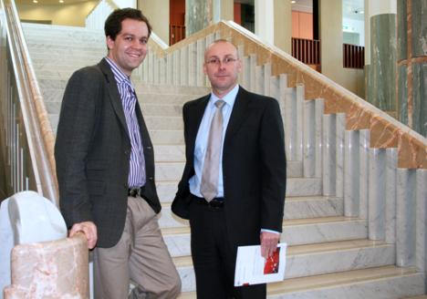
Figure 2—Australian Parliamentary Fellows Dr Joel Bateman (2008) and Dr Tim Kendall (2007)
  - The Library has, on behalf of the Parliament, managed the Australian Parliamentary Fellowship since 1970. The Fellowship provides support for 12 months to undertake a research project, prepare a monograph on the project and undertake client work in the Library.
  - Dr Timothy Kendall was the recipient of the 2007 fellowship. His topic was Australia’s China—China through the eyes of Parliament. His research includes a survey of Senators and Members and in-depth interviews. His monograph was published in August 2008.
  - Dr Joel Bateman is the 2008 Parliamentary Fellow; his topic is Shadow Cabinet in Australia: its Roles, Processes and Purpose. The project aims to explore the role of the Shadow Cabinet as a political institution. It will look at how different Shadow Cabinets under different parties or leaders operate, including policy-making processes, structures of organisation and internal processes, and relationships with the Opposition backbench and the media.

Parliamentary Library feedback
  - The Parliamentary Library is committed to constantly improving its service delivery. Feedback from clients, including compliments, complaints, suggestions and information requests about our services, are vital to enable the Library to:
improve our services and products;
prevent problems from occurring in the future;
ensure consistent service delivery; and
communicate with clients about Library services.
  - A policy was developed based on what has been Library practice for many years. It was developed with guidance from the Standards Association of Australia, the Commonwealth Ombudsman and Australian National Audit Office audits of complaints systems in Commonwealth agencies.
  - The Continuous Improvement Review provided an opportunity for the Library to consider how clients could be informed of the methods available to provide feedback. To assist them to provide feedback information has been provided through This Sitting Week.
  - Staff consultation occurred to ensure that the policy was clear and effective. The policy has been publicised to all staff and is included in induction training.
  - The Library Committee approved the new policy and is now well informed about the Library’s commitment to receiving and acting on feedback. Information about the policy and Library Committee’s role was published on the Library’s web site.
Australian National Audit Office (ANAO)
  - The ANAO released an updated Better Practice Guide: Agency Management of Parliamentary Workflows. For the first time the guide includes a section on “Providing information to the Parliamentary Library”. The section appears in chapter 4, parliamentary workflow tasks, and is a valuable means of reminding all agencies of the need to provide information to the Library.

Significant improvements in services and systems
  - The major area of work was preparation for the new ParlInfo system. In developing the data dictionary, the database fields were rationalised and processes streamlined. Further work will occur after the implementation of the new system in 2008-09.
  - Indexes for bound volumes of Hansard, which recommenced in 2007, continued this year. The index for the 2006 volumes was distributed in late 2007. Preparation of the 2007 indexes has been completed and they should shortly be printed and distributed.
  - The Briefing Book: Key Issues for the 42nd Parliament was distributed within a month of the election to assist Senators and Members prepare for the new Parliament. The book is also available online.
  - The Monthly Statistical Bulletin (previously known as the Monthly Economic and Social Indicators) was reviewed and enhanced to improve the content, including commentary highlighting key points and a regular feature article.
  - A review of the Parliamentary Handbook was undertaken in consultation with the Library Committee, Library staff and staff of other Parliamentary departments. The aim of the review was to ensure that the Handbook for the 42nd Parliament best meets the information needs of Senators and Members, and that the Australian community is easily able to access information about the Parliament. Enhancements to both the hard copy and online versions of the Handbook are planned for this edition, which is due to be published in October 2008.

Assistance to parliamentary libraries in the region
  - The Library is committed to supporting parliamentary libraries in the region, particularly in Pacific countries and, in emerging democracies. This year the Library provided:
support for visits organised by the Parliamentary Relations Office, including the Inter-Parliamentary Study Program;
information and training for visitors including hosting visits from Korean Parliamentary Library staff and the Kiribas Parliamentary Librarian;
advice to delegations from Tanzanian Parliamentary Departments, Ethiopian Parliament and the Sri Lankan Parliament;
resources to increase the collections of parliamentary libraries in Tuvalu, Vanuatu and Maldives and, with support from the Parliamentary Relations Office, purchased journals and reference material for Papua New Guinea;
support for reference/research services by encouraging libraries to pass on any relevant questions to us (during the year the Library answered a small number of enquiries from libraries in the region);
support for staff in regional parliamentary libraries with skills for specific tasks such as assisting the Cook Island Parliament set up their web site; and
support for libraries by providing free access to material on the Library’s web site and Parliamentary Library publications such as the Parliamentary Handbook.

Strategic and Workforce Planning
  - The Senior Management Group of the Library, which comprises all Directors, Assistant Secretaries and the Parliamentary Librarian, met to develop the Library plan for 2008–09. Initiatives identified for particular action in the year include:
service developments for clients including training for new Senators;
feedback mechanisms in a non-survey year;
quality—ideas for ensuring quality in Library services and products; and
strategic training and other key issues.
  - Workforce planning continued to be a priority, in particular a focus on attracting and recruiting quality staff and developing and retaining existing staff. Workforce analysis conducted in 2007 identified that the Library was vulnerable to a significant loss of expertise over the coming years because of its aging workforce. Mature age workers, those 45 years and older, accounted for 71% of the Library’s workforce. Retirements and recruitment action since that time, including the introduction of some Research Assistant positions in the Research Branch, have seen a slight reduction in the mature age profile to approximately 69%.
  - During 2007–08 17 ongoing staff left the Library, a separation rate of 11.6%. This rate is slightly lower than the DPS rate of 11.9% for the same period and well below the 17.6% ongoing separation rate for Library staff reached in 2006-07.
  - The main reasons for separation from the Library during 2007-08 were resignation (4 staff, 23.5% of separations), permanent transfer (5 staff, 29.4% of separations), retirement (4 staff, 23.5% of separations), promotion (1 staff, 5.8%) and voluntary retirement (2 staff, 11.7% of separations). One staff member’s employment was terminated. Most of the staff who resigned did so to take up positions in other organisations.
Parliamentary Library overview
Office of the Parliamentary Librarian
  - The Office of the Parliamentary Librarian comprises the Parliamentary Librarian, an Executive Assistant and the Director, Client Relations.
  - Relations with clients are managed by the Director, Client Relations, who provides orientation and training services for Senators, Members, their staff and other parliamentary staff. The Vital Issues Seminar series, a program for visitors and oversight of the editorial and promotional processes for Library publications are also managed by this officer.
  - Administrative support to the Parliamentary Librarian, including support for the Library Committee, is also provided from the Office.
Research Branch
  - The Research Branch (RB) provides information, research and analytical services to Senators and Members and their staff, parliamentary committees and the parliamentary departments to support parliamentary or representational duties (services are not provided to constituents or for commercial purposes).
  - The range of services provided includes individually commissioned information, research and advisory services for clients and research publications.
  - Commissioned information and research services involve responses to individual requests for information, research and/or critical analysis on subjects, issues and policies of interest to parliamentarians.
Information Access Branch
  - The Information Access Branch (IAB) develops and manages access to print and electronic resources. These resources include books, serials, information databases, electronic publications developed both within the Department of Parliamentary Services (DPS) and acquired externally, off-air recordings, transcripts and related materials.
  - Access to services is also provided through the Parliamentary Library’s Central Enquiry Point.
  - IAB staff selects, acquires and provides access to monographs, serials, electronic publications and external databases through the Library’s Catalogue. Access to radio and television news and current affairs programs is provided through the EMMS. Material for the Library’s information databases, available through ParlInfo, are selected and indexed.
  - IAB is responsible for publishing DPS materials both in print and electronically on the parliamentary web site (http://www.aph.gov.au/) and on the parliamentary and DPS intranets. This includes Hansard and Library publications.

Informed Support    Nina has been working for almost a year in the Research Branch of the Parliamentary Library. “It’s been a challenging, but very rewarding and stimulating experience. From the onset of my employment here I was immersed in a range of topics and able to put my qualifications into practice (Master of International Relations/Master of Diplomacy). I feel I have grown intellectually with each new task.  I have participated in some of the top conferences on foreign policy and security issues facing our region. I am working on developing my European expertise, and I recently presented my first research paper on EU–Australia relations at a national conference. | Working in the Foreign Affairs, Defence and Security Section of the Library has also provided me with the opportunity to utilise my foreign language skills”.  Nina finds the immediacy of dealing with Senators and Members and their staff, and the responsibility for providing accurate information, analysis and advice (often within short time-frames) makes for a unique working environment in which every day is different. She has also made a number of excellent contacts in government and academia through her position in the Parliamentary Library.  “I enjoy the combination of writing, the atmosphere of interesting and varied work, as well as an opportunity to advance professionally—all elements of an ideal job for me! Along with a very supportive environment, I enjoy preparing material on different countries for the parliamentary committees and delegations and briefing Senators and Members about the latest developments overseas”.  Looking to the future, Nina aspires to become an expert on international security, with her research enhancing the Parliamentary Library’s name domestically and internationally.

Report on performance
Introduction—Output 1 Library Services
  - Output 1 aims to provide an effective knowledge centre for the Parliament through the provision of information, analysis and advice. These services are provided through two sub-outputs:
Sub-output 1.1—Research services. These services include responding to requests from individual parliamentary clients for information and research, and the production of general distribution briefs and publications; and
Sub-output 1.2—Information access services. Information services are provided to the Library’s clients by acquiring and providing access to information resources in the collection and Library catalogue, through the selection, processing and indexing of material for library and media data bases in ParlInfo, and by publishing print and electronic works.
  - Performance is assessed using indicators that cover quality, quantity and price. Indicators, performance results and relevant comments are shown against each of the sub-outputs.
Sub-output 1.1—Research services
  - Sub-output 1.1—Research services to meet clients’ needs. The services contributing to this Sub-output are as follows:
Commissioned information, research and advisory services—these are tailored responses prepared following requests from individual Senators, Members and their staff, and other parliamentary clients; and
Research publications (Publications)—these are prepared where strong client demand is anticipated for briefing on specific policy issues. Publications include Bills Digests, Research Briefs, Research Notes, Chronologies, Electronic Briefs, Background Notes and internet Resource Guides. Publications are generally available to clients and to the public, through the internet. A small number of publications are not available through the internet because they contain content which the Library is only licensed to make available to members of parliament.
  - During the year, Library induction and orientation sessions were held for clients. These continued to be successful in providing, through individual and small group sessions, a timely and detailed introduction to Library services. A particular focus was new Members for January to March, and new Senators from June 2008.
Figure 3—Sub-output 1.1—Research services—quality indicator
Quality indicator | Measure | Performance
Quality indicator | Measure | 2006-07 | 2007-08
Client satisfaction with requests and general briefs and publications (GBPs) | High level of customer satisfaction (target: 90%) | 89% | 89%
 | Client service delivered to timeliness service standard (target: 90%) | 97% | 97%
 | Number of complaints from clients | 5 | 1
Indicator—Client satisfaction with requests and general briefs and publications (GBPs)
  - Three key quality indicators measure satisfaction with requests for client services:
an overall measure of client satisfaction with requests, publications and media services derived from the client survey;
a timeliness measure introduced in 2006-07, which measures the responses to individual client requests completed to the originally agreed or renegotiated deadline; and
the number of complaints made by clients.
  - The new timeliness target of 90% was exceeded—with 97% of individual requests being provided by the originally agreed or renegotiated deadline. Performance against this target has remained stable since its introduction.
  - There has been a major decline in complaints—only one client registered a complaint during 2007-08 and two others expressed strong views about individual publications. Each of the complaints was investigated and followed through with the complainant. The feedback was very valuable as it enabled us to review and improve some publications.
  - In addition, feedback from individuals and organisations that were not clients was received by email and telephone. All the feedback was about Library publications, which are available to the public through the internet. In three cases minor modifications or corrections were made to publications to address the issues raised.
Figure 4—Sub-output 1.1—Research services—quantity indicators
Quantity indicator | Measure | Performance
Quantity indicator | Measure | 2006-07 | 2007-08
Individual client requests | Percentage of primary clients (Senators’ and Members’ offices, including Ministers’ offices) using the service (target: 98%) | 100% | 100%
Individual client requests | Number of individual client requests (target: 19,000) | 19,819 | 14,907
Self-service requests | Number of online uses of the Parliamentary Library’s publications, including the Parliamentary Handbook and General Briefs and Publications, through ParlInfo and the internet (target: 9,000,000) | 4,349,240 | 4,956,922
General briefs and publications | Number of general briefs and publications produced (target: 220) | 275 | 231
Client training and seminars | Attendance at training courses and events (eg Vital Issues seminars) (target: 600) | 448 | 723
Indicator—Client requests
  - During 2007-08, consistent with the previous two years, all of the Library’s primary clients (Senators’ and Members’ offices, including Ministers’ offices) used the client request service at least once—exceeding the target of 98%.
  - For 2007–08, as noted above, there was a huge increase in online usage of the Parliamentary Library’s resources (600,000 extra uses) offset by a significant decrease (25%) in the total number of individual client requests, and the target for this measure (19,000) was not met. For 2007–08 there was also a decrease (17%) in the number of hours spent meeting client requests. This change is similar to that occurring in many other institutions. A number of further factors should be noted:
Since the mid-1990s, a small decrease in client requests to Parliamentary Libraries has been suggested internationally at discussions of the IFLA Standing Committee of the Section on Research and Library Services to Parliament, together with increased use of self-help resources;
The decrease in individual client requests at the Australian Parliamentary Library has continued for more than a decade; and
The number of client requests generally fluctuates, in election years there are usually fewer requests.
  - The 2008 election period and the three months immediately following the election saw significantly reduced client requests.
  - There has been a slight change in the average number of hours spent on client requests in the past three years. In 2005-06 the average was 2.83 hours per client request, falling to 2.50 in 2006-07 and rising to 3.41 in 2007-08. Factors affecting this include the complexity of requests, time constraints from requirements of clients and the number of newer staff who are not yet fully skilled in this work. There has not been a consistent pattern of change in this area.

Indicator— General briefs and publications
  - The number of publications produced was 18% lower than the previous year, although the hours spent on publications increased (by around 3000 hours). The decrease in the number of publications in part, reflects the fact that the number of Bills Digests published decreased from 191 last year to 152 in 2007–08, reflecting the effect of an election year on the legislative program.
  - Access to the Parliamentary Library’s publications online through ParlInfo and the internet increased significantly (14%).
Bills Digests
  - During 2007–08, 152 Bills Digests were produced—a decrease of 20% on 2006–07. The reduction was primarily due to the calling of the 2007 federal election and the consequent hiatus in the introduction of Bills, for around four months from October 2007.
  - In common with 2006-07, a large number of Bills were first debated a relatively short period after their introduction into Parliament, requiring rapid turnaround time by staff involved in the production of Digests. Bills in this category included those in the Northern Territory ‘national emergency response’ package, which was introduced on 7 August 2007 and debated in the House of Representatives on the same day. An interim Digest covering the major elements of the package was made available to Members and Senators on the day the Bills were introduced. The final Digests were completed within a few days.
  - Digests were not produced for 8 of the Government Bills introduced in 2007–08 (compared to 13 in 2006–07) because they did not address significant or controversial policy issues, did not require explanatory information to assist in the debate or were part of a suite of bills where the Digests were produced for the main bills. A further 9 Digests (compared to 14 in 2006–07) were not completed in time for parliamentary debate on the Bill concerned. However, where it was not possible to produce Digests in time for debates, clients were provided with draft Digests or other briefing material on request.
  - During the year, staff guidelines were developed to complement the Operating Policy and Procedure—Preparing and publishing Bills Digests. The guidelines and associated staff training are part of an ongoing process for improvement of Digests. Further initiatives to enhance quality control are planned for the second half of 2008.
Briefing book
  - Following each election the Library publishes a briefing book with the dual purpose of:
identifying issues which are expected to demand Senators’ and Members’ attention during the early months of the new Parliament and
‘showcasing’ Library capabilities and research expertise across a broad topic range, particularly to new parliamentarians and their staffers.
  - The briefing book presents a brief introduction to areas of key public policy concern, outlines the context for those concerns and discusses possible new policy and legislative directions.
  - The briefing book for the 42nd Parliament contained 85 issue briefs across 22 topic headings. It was distributed well in advance of Parliament’s first sitting period to assist Senators and Members to prepare for the new Parliament and has been well received.
Budget Review 2008–09
  - The annual Federal Budget (Budget) is perhaps the Commonwealth government’s most important political, economic and social document. The 2008-09 Budget was a critical document for establishing the policy directions and financial management initiatives of the newly elected Rudd Labor Government. The purpose of the Budget Review 2008-09 was to assist Senators and Members by providing an overall examination of the Budget from a macroeconomic perspective. It also incorporated social policy, legal and other perspectives.
  - Providing information on the Budget and the Budget process was a major success this year. The Library’s seminar, Understanding the Budget, which was attended by approximately 100 Senators, Members and their staff.
  - In addition to the review, newspaper articles including editorials, opinion pieces, and media releases were selected from the Library’s media collection and made available to clients online, with an introduction by a Senior Researcher from the Economics Section.
Figure 5—Distribution of client service hours by service type
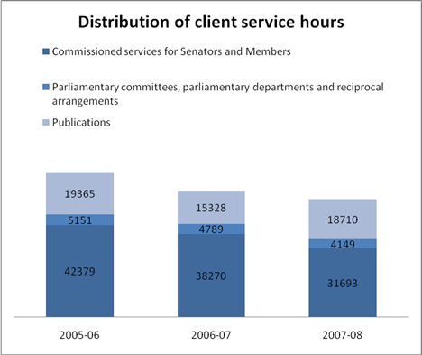

DPS Annual Report
Part 3—Departmental overview
  - The time spent on publications showed a small decrease in the total over the three-year period, but with a significant increase from 2007-08 to 2006-07. In 2008-09 consideration will be given to targeting publication resources to areas of strong client demand.

Indicator—Client training and seminars
  - Attendance at Parliamentary Library lectures, Vital Issues seminars and orientation training increased this year by 62%. The following lectures and seminars were held:
Professor the Hon. Alastair Nicholson AO RFD QC spoke on Citizenship—decisions by the executive as to the suitability or character of individuals;
a panel of distinguished visiting specialists addressed the topic Asia-Pacific Regional cooperation 'architecture'—competitive or cooperative?;
Dr John Hart spoke on The American Presidential Election: Retrospect and Prospect;
Professor Joshua Gans and Robin Eckermann gave presentations on the issue of Broadband; and
Professor Ian Goulter, Vice-Chancellor, Charles Sturt University spoke on the topic Growing our communities in inland Australia.
Figure 6—Sub-output 1.1—Research services—price indicator
Price indicator | Measure | Performance
Price indicator | Measure | 2006-07 | 2007-08
Cost of research services | Average cost per individual client request (staff time only) | $115 | $148
Cost of research services | Average cost per request (total cost including overheads) | $296 | $391
Cost of research services | Average direct cost per self-service client request (staff time only) | $0.19 | $0.20
Cost of research services | Average cost per self-service client request (total cost including overheads) | $0.48 | $0.48
Cost of research services | Total cost of sub-output 1.1 | $10,764m | $11,272m
Sub-output 1.2—Information access services
  - The services contributing to this Sub-output are as follows:
the Library collection—development of the collection to meet users needs and provision of access through the catalogue and ParlInfo;
online full–text content—news clippings; journal articles; political party documents; press releases and Library publications available through ParlInfo;
media services—desktop access to television and radio news and current affairs programs broadcast in Canberra, provided to Senators and Members for their parliamentary duties;
commercial databases—including online full-text journal and newspaper services available through the Library intranet and the Senators’ and Members’ Services Portal; and
client services—including the Central Enquiry Point and self-help services.
  - As far as possible, usage rates of all of these services are monitored to ensure that they remain relevant and are of practical assistance to Senators, Members and their staff.
  - To help clients use these services effectively, the Library provides orientation and training courses as well as online assistance.
Indicator—Client satisfaction with information access services
Figure 7—Sub-output 1.2—Information access services—quality indicator
Quality indicator | Measure | Performance
Quality indicator | Measure | 2006-07 | 2007-08
Client satisfaction with information access services | High level of client satisfaction (target: 90%) | 89% | 89%
Client satisfaction with information access services | New resources added to the Library’s collection within timeliness service standard (target: 85%) | 70% | 90%
Client satisfaction with information access services | Percentage of titles in Library collection available to clients online in full text (target: 20%) | 17.3% | 22.2%
Client satisfaction with information access services | Number of complaints from clients | 0 | 0
  - The timeliness service standard for new resources measures the percentage of titles added to the Library’s collection within defined turnaround times. For non-priority items, the performance standard is within two weeks of receipt. Priority titles performance standards are:
critically urgent—catalogued within one hour;
urgent—catalogued within one day;
reference books—catalogued within two days; and
requested by clients—catalogued within one week.
  - Performance was measured on the percentage of outstanding titles at the end of each month that were within two weeks of receipt. The result was 90%, which was above the 85% target. All priority titles (approximately 70-80% of new resources) were catalogued within their target turnaround times. In 2008–09, the method will be improved to measure the actual turnaround times of priority titles added to the collection.
  - Increasing the number of electronic resources available to clients through their computers was a priority. The client assessment and discussion at Library Committee meetings identified this as an area which required high priority.
  - The current budget provides some opportunity to increase electronic resources. Collaborative purchasing with other libraries, such as Electronic Resources Australia and the Australian Government Libraries Information Network, and reallocation of resources used for print serials has enabled the collection to increase further in this area in 2007-08. The total number of electronic monographs and serials in the collection increased from 21,312 at 1 July 2007 to 28,987 at 30 June 2008. The percentage of titles available to clients in electronic full text increased by nearly 5%.
Figure 8—Sub-output 1.2—Information access services—quantity indicator
Quantity indicator | Measure | Performance
Quantity indicator | Measure | 2006-07 | 2007-08
Material added to Library databases | Number of items added to databases created by the Library, including television and radio programs and transcripts in the Electronic Media Monitoring Service, and Library contributions to resources in ParlInfo (target: 160,000) | 187,926 | 167,537
Material added to Library collection | Number of new titles (monographs and serials) added to the Library’s collection (target: 4,000) | 4,418 | 4,630
Use of the Library collection and databases | Use of the collections and databases including loans from the collection, use of electronic journals, Electronic Media Monitoring Service and Library contributions to resources in ParlInfo (target: 2,100,000) | 2,281,750 | 2,544,500
Indicator—Material added to Library databases
  - Clients of the Library require access to accurate and up-to-date information. Because electronic material can be made accessible to clients 24 hours a day, 7 days a week, greater emphasis is being placed on collecting material in an electronic format and making it accessible through easy-to-use interfaces such as the Senators’ and Members’ Services Portal.
  - The number of newspaper clippings added to the database was slightly down—119,228 clips added in 2007-08 compared with 121,672 in 2006-07. One factor that contributed to this was that in the period after the federal election—from November 2007 until the 42nd Parliament commenced in February 2008—there were fewer items in the news relevant to the interests of the Parliament.
  - The Library completed a tender for the purchase of online news services during the year. This resulted in the purchase of subscriptions to Factiva iWorks and Library PressDisplay for direct access by clients. As well, a three-year contract was negotiated for the provision of newsclips to the Library’s newspaper clippings database.

Indicator—Material added to Library collection
  - The Library’s physical collection of monographs and journals is constantly updated in accordance with the Library’s Collection Development Policy. The Library aims to keep the collection at around 115,000 monograph titles. It has around 8,000 individual print and electronic journal titles, not including the large aggregated subscription services. New material is acquired; outdated, damaged or redundant material is discarded regularly. Materials on Australian politics, legislation and constitutional matters are retained permanently.
  - Increasingly, the collection emphasis is on acquiring current, up-to-date information through serial and other subscriptions. Fewer monographs are being requested for purchase.

Indicator—Use of the Library’s collection and databases
Increased use of Library databases
  - Clients can access the Library’s databases through ParlInfo either through a Windows based interface, which is only available to users of the Parliamentary Computing Network, or through the publicly available web interface.
  - The continuing increased use of Library databases in ParlInfo by Senators, Members and their staff indicates that the services are valuable and relevant to their needs. Usage reflects the growing success of the Library’s efforts to introduce and promote self-help services at the desktop.
  - The significant increase in the use of these resources in 2007-08, 12%, is consistent with long-term patterns. Use of the electronic collections is highest when Parliament is sitting. This has been a consistent trend for the last three years, with usage rising in the build up to the commencement of the 42nd Parliament.
Electronic Media Monitoring Service (EMMS)
  - In the lead-up to the introduction of the new ParlInfo, workflows have been reviewed with the aim of removing duplication of records. In particular, transcripts which were duplicated in EMMS and the Library’s database on ParlInfo—two separate systems with two sets of workflows—are being rationalised. This duplication will cease with the new ParlInfo because the software allows for better integration of records which will only need to be captured and described once.
Figure 9—Sub-output 1.2—Information access services—quantity indicators
Price indicator | Measure | Performance
Price indicator | Measure | 2006-07 | 2007-08
Cost of information access services | Average cost per item added to the Library’s collection | $362 | $412
Cost of information access services | Average cost per item added to the Library’s databases | $19.98 | $24.33
Cost of information access services | Average cost per use of the Library’s databases and collection | $3.36 | $3.54
Cost of information access services | Total cost of sub-output 1.2 | $10,027m | $10,246m

Parliamentary Library Financial Report

 | 2006-07 | 2007-08
 | $ | $
Income
Appropriations | 14,751,936 | 15,767,035
Depreciation | 1,784,617 | 1,183,378
Expenditure
Total Salaries | 12,220,319 | 12,323,494
Research Branch | 7,498,398 | 7,709,011
Information Access Branch | 4,303,104 | 4,217,910
Office of the Parliamentary Librarian | 418,817 | 396,573
Other employee expenses | 141,201 | 161,878
Staff training, travel and related expenses | 162,593 | 239,737
Collection (information resources) | 1,499,346 | 1,486,154
Collection (depreciation of monographs and reference collection) | 536,368 | 580,649
Other expenses | 329,809 | 347,864
Asset maintenance (software licences/maintenance) | 263,314 | 239,094
Total expenditure (including expenditure from depreciation funds) | 15,152,950 | 15,699,816
Total expenditure (excluding expenditure from depreciation funds) | 14,616,582 | 15,119,167
Staffing | 2006–07 | 2007–08
Research Branch | 75.25 | 78.12
Information Access Branch | 57.39 | 57.95
Office of the Parliamentary Librarian | 3.0 | 3.09
Total | 135.64 | 139.16
Figure 10—Parliamentary Library Organisation Chart
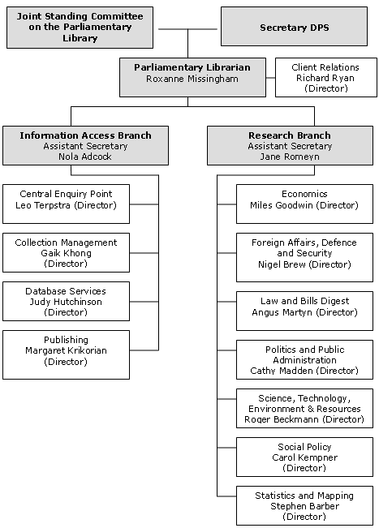

DPS Annual Report 2005-06
Part 3—Departmental overview

Part 4—Report on performance

Part 4—Report on performance
Overview
Performance information and reporting model
  - The DPS Outcome and Outputs Framework consists of four outputs—with sub-outputs—and administered work programs. The framework is summarised in Figure 11.
  - Performance indicators for each output are established in the DPS Portfolio Budget Statement 2007-08. The indicators cover the quality, quantity and price aspects of the department’s outputs or services.
  - In this part of the annual report, performance results and explanatory comments are provided against each of the department’s sub-outputs.
Output cost attribution
  - DPS operates through a branch structure that is aligned to its output structure.
  - Each branch comprises a number of cost centres that collect all direct operating costs, including depreciation, on an accrual basis. The internal overheads attribution process is completed in a number of steps. First, the costs of all corporate cost centres are allocated to sub-outputs. Then, the cost of providing internal services (IT, communications and accommodation) is attributed to those sub-outputs that receive the services. This methodology ensures that the department reports the total cost of services provided to clients for each sub-output.
  - However, for each sub-output report, costs shown for particular services do not include all attributable overheads. Where overheads are included, these are identified in the report.

Figure 11—Relationship between Outcome and Outputs
DPS Annual Report 2007-08
Part 4—Report on performance

66
OUTCOME
OUTPUT 1 | OUTPUT 2 | OUTPUT 3 | OUTPUT 4 | ADMINISTERED ITEM
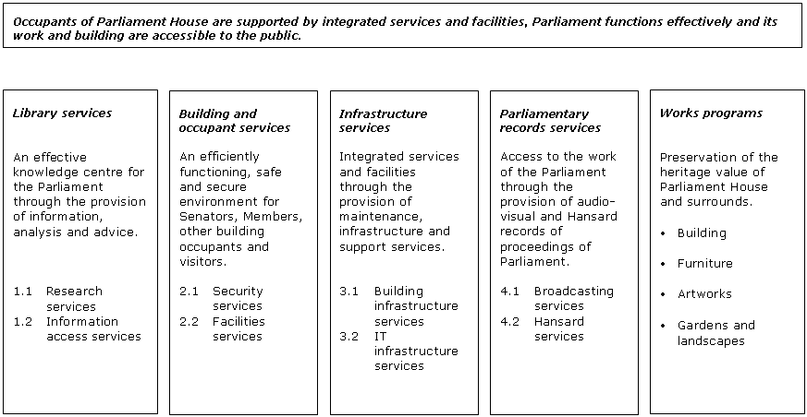

Effectiveness in achieving the planned Outcome
  - The Outcome statement of DPS is that “occupants of Parliament House are supported by integrated services and facilities, Parliament functions effectively and its work and building are accessible to the public”.
Occupants of Parliament House are supported by integrated services and facilities, …
  - DPS provides occupants and other users of Parliament House with a wide range of services and facilities. These are described in general terms in Parts 2 and 3. The performance reports in Parts 3 (Parliamentary Library) and 4 measure and discuss the DPS performance in delivering those services and facilities.
  - The results demonstrate success in a variety of areas but less satisfactory performance in others. Because of the ongoing nature of the outcome, and the scope for providing our services more efficiently and effectively, DPS will continue to look for further improvements.
  - The services and facilities provided by DPS are reviewed on a regular basis. We have continued to implement the recommendations of the Continuous Improvement Reviews (CIRs) which began in 2005. The CIRs have reviewed all of DPS’s operations and identified many opportunities for improvements. Part of the pay rise received by staff in July 2007 was conditional on savings found by the various CIRs.
Parliament functions effectively …
  - Parliament’s operations have continued to run smoothly to the extent that this is the responsibility of DPS. Our contribution includes:
ensuring the security of the building, including the chambers in particular, and of building occupants;
providing a suitable venue for parliamentary activity through building maintenance and provision of building services and information and communications technology services; and
providing Hansard and library services to enable members of Parliament to contribute effectively to parliamentary activities.
… and its work and building are accessible to the public.
  - In 2007-08, DPS facilitated access for the general public to the work of the Parliament and its building by:
providing 929 hours of chamber broadcasts;
providing 1,208 hours of committee broadcasts;
providing print-ready Hansard transcripts on the DPS internet site and the web interface to ParlInfo; and
hosting 867,220 visitors, including 114,086 school children.
  - The effectiveness of our services is assessed through a customer survey conducted each Parliament that collects customer views on:
the appropriateness of, and satisfaction with, existing services;
problems with service delivery;
identification of service gaps; and
the extent to which services and facilities are appropriately and conveniently integrated and accessible to assist the user.
  - The survey for the 41st Parliament was conducted during 2007. It is envisaged that the views of the 42nd Parliament will be surveyed during 2009.
Output 1—Library Services
Introduction
  - Output 1 is the provision of an effective knowledge centre for the Parliament through the provision of information, analysis and advice.
  - Performance reports for the Parliamentary Library sub-outputs 1.1 and 1.2 are set out in Part 3 of this annual report.
Output 2—Building and Occupant Services
Introduction
  - Output 2 of the DPS Outcome and Outputs Framework is the provision of an efficiently functioning, safe and secure environment for Senators, Members, other building occupants and visitors.
  - Two sub-outputs, Security services and Facilities services, contribute to Output 2.
Sub-output 2.1—Security services
  - DPS provides security and emergency services to occupants of, and visitors to, Parliament House.
Figure 12—Sub-output 2.1—quality indicator
Quality indicator | Measure | Performance
Quality indicator | Measure | 2006-07 | 2007-08
Extent to which security procedures are followed | Percentage of reported security incidents dealt with in accordance with agreed procedures (target: 100%) | 100% | 100%
Indicator—Extent to which security procedures are followed
  - During 2007-08 there were 234 reported security incidents. All of these were responded to in accordance with established procedures.

Figure 13—Sub-output 2.1—quantity indicators
Quantity indicator | Measure | Performance
Quantity indicator | Measure | 2006-07 | 2007-08
Validation of security procedures | Percentage of security validation program achieved  (target: 100%) | 92% | 100%
Security incidents | Number of reported security incidents | AFP-UP: 177 | 151
Security incidents | Number of reported security incidents | PSS: 86 | 83
Security services | Number of hours of internal guarding (PSS)—monthly average hours
Security services |  | 20,527 | 19,281
Security services | Number of hours of external guarding (AFP-UP)—monthly average hours | 12,982 | 11,722
Security services | Number of parliamentary functions (including official visits) requiring additional security resources | See paragraph 229 | See paragraph 229
Indicator—Validation of security procedures
  - Security validation exercises are conducted by the PSS and Australian Federal Police-Uniform Protection (AFP-UP), with exercises conducted monthly to test how well procedures work. All 24 scheduled validation exercises were conducted in 2007-08.
  - Five of these exercises were conducted as joint exercises between the PSS and AFP-UP.
Indicator—Security incidents
  - Security incident reports are completed in response to events that may require follow-up action, such as protests, threatening telephone calls, non-compliance with security screening and unattended or suspect items. Reports are completed by AFP-UP or PSS staff.
Indicators—Security services
  - The number of PSS hours used each month varies depending on the number of parliamentary sitting days and, to a lesser extent, the number of functions held in Parliament House.
  - The reduction in the number of internal guarding hours is attributed to a reduction in the number of parliamentary sitting days in the 2007-08 year.
Figure 14—Number of parliamentary and non-parliamentary functions requiring additional security resources
Measure | 2006-07 | 2007-08
Number of parliamentary functions (including official visits) | 199 | 79
Number of parliamentary functions (including official visits) requiring additional security | 30 | 5
Number of non-parliamentary functions | 607 | 676
Number of non-parliamentary functions requiring additional security | 512 | 375

  - The PSS provides services to parliamentary and non-parliamentary functions requiring additional security resources. During 2007-08, there was a substantial reduction in the number of parliamentary and non-parliamentary functions requiring extra security resources (see Figure 14).
  - Most notably, parliamentary functions requiring additional security resources fell from 30 in 2006-07 to five in 2007-08. This was largely due to the Presiding Officers approving—in May 2008—changes to the definition of what is, and what is not, a parliamentary function.
  - This led to fewer functions being assessed as parliamentary. The new definition of a parliamentary function includes functions in support of the whole of Parliament but excludes specific political party or executive government functions.
Figure 15—Sub-output 2.1—price indicator
Price indicator | Measure | Performance
Price indicator | Measure | 2006-07 | 2007-08
Security services | Staff costs for:
Security services | - internal guarding (PSS) | $10,441,498 | $10,593,453
Security services | - external guarding (AFP-UP) | $10,073,710 | $10,479,017
Security services | - guarding for standard operations (not including overheads) | $20,145,143 | $20,706,568
Security services | - additional guarding for parliamentary functions | $10,565 | $11,437
Security services | - additional guarding for non-parliamentary functions | $359,500 | $354,466
Security services | Direct costs of Pass Office operations | $221,994 | $210,223
Security services | Total cost of sub-output 2.1 | $29.640m | $29.875m
Indicators—Cost-effective security services
  - The cost of internal guarding increased to $10,593,453 in 2007-08. Increases to DPS salary costs were offset by the reduced number of parliamentary sitting days—65 in 2007-08 compared to 76 in 2006-07.
  - There is no cost recovery applied to security services provided to parliamentary functions. The cost of security services for non-parliamentary functions is recovered from function organisers.

Security Matters  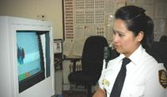  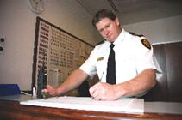  Ensuring a safe and secure Parliament House is a priority of DPS and the Parliamentary Security Service (PSS) staff who work around the clock every day of the year.  Dennis and Rose are two of our PSS staff members. Both agree that the people they work with are the best part of the job. “Great people and great conditions” is how Dennis describes it. “I also think the flexibility is fantastic. Not just the hours, but the chance to be a lot more involved in work that gets you out of an office, if that’s what you want to do”.  In his three years with the PSS Dennis has also had some great development opportunities, including a chance to undertake protective security training with the Attorney-General’s Department. | Rose came to the PSS almost a year ago from a background in retail and particularly enjoys the role of dealing with people. “I am so proud to come to work and be responsible for the building and, more importantly, the people in it”. The three shifts available each day also appeals. “There is usually some flexibility in the planning. The best thing is that the managers listen”. With the opportunity to develop her computer skills Rose couldn’t be happier. “It is just such a great environment to work in”.  The PSS achieves a lot more than keeping the building and staff secure. The Phil Botha Memorial Charity Fund was set up in memory of Phil Botha, a member of the PSS who died from cancer. In October every year the Phil Botha fun run raises money to assist the Make-a-Wish Foundation and an orphanage in East Timor. This is achieved through PSS volunteers and others taking turns to run around Parliament House from 5am to 5pm. Last year over $10,000 was donated to these causes, taking the total to approximately $100,000 since its inception.  Rose was one of the many DPS staff who completed some laps of the building last October. “It was great fun. The running caused some sore legs the next day, but my friends and colleagues were out there volunteering their own time to raise money for a great cause. I’m looking forward to doing it again this year”.

Sub-output 2.2—Facilities services
  - DPS provides facilities management, health and wellbeing and visitor services to occupants of and visitors to Parliament House.
Figure 16—Sub-output 2.2—quality indicators
Quality indicator | Measure | Performance
Quality indicator | Measure | 2006-07 | 2007-08
Customer satisfaction | High level of building occupant and/or user satisfaction with facilities management services | 90.27% | Not applicable
Customer satisfaction | Number of complaints about facilities management services | 19 | 69
Visitor satisfaction | Visitor satisfaction measured through visitor surveys (target: 85%) | 96.5% | See paragraph 238
Visitor satisfaction | Number of complaints about visitor services | 3 | 3
Indicator—Customer satisfaction (facilities management)
  - As DPS did not conduct a customer survey in 2007-08, there is no information to compare with previous satisfaction levels.
  - The reported number of complaints regarding facilities management services rose significantly from 19 in 2006-07 to 69 during 2007-08. The increase is attributable to changes in the process for reporting complaints. All feedback—including complaints—is now reported directly to Facilities Management staff, rather than direct to the contractors. This modification has allowed for more information to be captured by Facilities Management, resulting in more effective and efficient management of contractors.
  - Complaints about cleaning services made up 87% of all complaints about facilities management services during 2007-08.
Indicator—Visitor satisfaction
  - Three complaints were received from visitors during 2007-08, equalling the three received in 2006-07. Visitor satisfaction surveys were not conducted during 2007-08, but are currently being reviewed and should recommence in 2008-09.
Figure 17—Sub-output 2.2—quantity indicators
Quantity indicator | Measure | Performance
Quantity indicator | Measure | 2006-07 | 2007-08
Nurses Centre | Number of requests for first aid | 1,042 | 812
Nurses Centre | Number of health promotion programs conducted | 4 | 1
Nurses Centre | Number of vaccinations delivered under influenza vaccination program | 547 | 772
Nurses Centre | Number of incidents and accidents reported | 177 | 113
Nurses Centre | Number of health support services delivered | 421 | 390
Health and Recreation Centre | Number of members, by category:
Health and Recreation Centre | - Senators and Members | 65 | 67
Health and Recreation Centre | - staff of Senators and Members | 27 | 23
Health and Recreation Centre | - others | 534 | 667
Health and Recreation Centre | Number of casual visits by category of user:
Health and Recreation Centre | - Senators and Members | 78 | 33
Health and Recreation Centre | - staff of Senators and Members | 1,140 | 667
Health and Recreation Centre | - others | 276 | 680
Health and Recreation Centre | Classes conducted:
Health and Recreation Centre | - total number of places in classes | 6,424 | 6,156
Health and Recreation Centre | - total number of attendees at classes | 4,209 | 3,750

Quantity indicator | Measure | Performance
Quantity indicator | Measure | 2006-07 | 2007-08
Community engagement with Parliament House | Total number of visitors | 889,115 | 867,220
Community engagement with Parliament House | Total number of general (public) tours conducted | 5,055 | 4,981
Community engagement with Parliament House | Total number of school tours conducted | 3,379 | 3,256
Community engagement with Parliament House | Total number of special tours conducted | 719 | 610
Community engagement with Parliament House | School tours – total number of participants | 107,980 | 114,086
Community engagement with Parliament House | Special tours – total number of participants | 11,659 | 9,825
Community engagement with Parliament House | Open day – total number of visitors | Not applicable | 8,662
Community engagement with Parliament House | Garden tours – total number of participants | 251 | 330
Parliament Shop customers | Total number of customers | 68,541 | 62,257
Indicator—Nurses Centre
  - The role of the Nurses Centre is to deliver health services as situations arise.
  - The Nurses Centre experienced a decrease in demand for its services during 2007-08, due to the reduction of parliamentary sitting days as a result of the November 2007 federal election.
  - There was an increase in the number of participants in the influenza vaccination program. In 2007-08 all three parliamentary departments participated in the program compared to only two participating departments in 2006-07.
  - One health promotion program was conducted during 2007-08; this related to the management of common colds. The program involved the distribution of information outlining ways in which building occupants can prevent infection.
Indicator—Health and Recreation Centre
  - The total membership of the Health and Recreation Centre as at 30 June 2008 was 757, the highest level of membership over the past six years.
  - There was a decrease in overall class attendance and casual visits by non-Canberra-based staff due to the reduced number of parliamentary sitting days caused by the November 2007 federal election.
  - During 2007-08 overall visitor numbers to Parliament House decreased by 2.5% compared to 2006-07. The decrease in total visitors can be attributed to the reduced number of parliamentary sitting days due to the 2007 federal election and the long term trend of slight decline of visitors since Parliament House opened in 1988 as shown in Figure 18. The number of visitors to Parliament House is a count of people entering the building through the main front entrance.
Figure 18—Parliament House Visitors 1988-2008
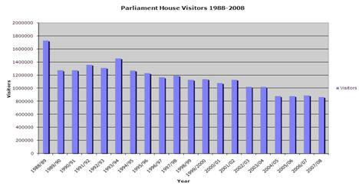
  - The number of school students participating in educational programs in Parliament House increased by 5.7% compared to 2006-07.
  - There was a 15.2% decrease in the number of special tours conducted compared with 2006-07. This decrease was due to the reduced number of parliamentary sitting days, as special tours generally coincide with parliamentary sitting.
  - To celebrate the 20th Anniversary of Parliament House an Open Day was held. This was the most popular Open Day of the six conducted since 2001.
Figure 19—Number of Open Day Visitors 2001 to 2008
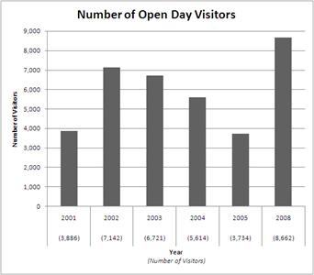
Indicator—Parliament Shop
  - As foreshadowed in the 2006-07 Annual Report, the Parliament Shop has commenced a review of the appropriateness of its merchandise. This review has resulted in the purchase of a number of new product lines and the discontinuation of unsuccessful products. The review is expected to be finalised in 2008-09.
  - The number of Parliament Shop customers declined by 9.2% in 2007-08. This is a result of the overall drop in visitor numbers to Parliament House and the reduced number of sitting days.
Figure 20—Sub-output 2.2—price indicator
Price indicator | Measure | Performance
Price indicator | Measure | 2006-07 | 2007-08
Facilities services | Cleaning costs under contracts:
Facilities services | - internal cleaning costs | $3,467,400 | $3,561,259
Facilities services | - external cleaning costs | $1,081,736 | $999,659
Facilities services | Waste management costs under contracts | $131,704 | $139,004
Facilities services | Gross revenue from non-catered functions | $17,115 | $37,599
Facilities services | Gross revenue from:
Facilities services | - Press Gallery licensees | $996,300 | $1,020,313
Facilities services | - catering contractors | $467,850 | $350,954
Facilities services | - other licensees | $177,524 | $189,571
Facilities services | Administration fee paid to catering contractors | $274,309 | $243,009
Facilities services | Nurses Centre: Direct costs | $217,826 | $209,229
Facilities services | Health and Recreation Centre: Net costs (direct costs less revenue) | $145,118 | $92,940
Facilities services | Parliament House Guides services: net costs (direct costs less revenue) | $1,403,076 | $1,465,102
Facilities services | Parliament Shop: Revenue (target: $1.3m) | $1,245,142 | $1,119,293
Facilities services | Parliament Shop: Net profit (revenue less stock and direct staff costs) (target: 12% of revenue) | $244,325  19.6% | $227,768  20.3%
Facilities services | Total cost of sub-output 2.2 | $9.968m | $9.918m
Indicator—Facilities services
  - During 2007-08 internal cleaning costs increased, in line with contractual CPI adjustments.
  - External cleaning costs have declined due to water restrictions. The restrictions have limited water-intensive cleaning of ductwork, carparks and external surfaces of the building including the building façade.
  - The substantial increase in revenue from non-catered functions reflects costs recovered by DPS for services provided to a number of special events held at Parliament House in 2007-08. The Australia 2020 Summit was the largest function held at Parliament House during 2007-08.
  - Net costs for the Health and Recreation Centre decreased during 2007-08 due to increased membership by DPS staff.
  - The catering contract for the staff dining room and Queen’s Terrace Café expired on 30 June 2007 and an extension was negotiated to allow for the tendering of two catering contracts. The reduced revenue from catering contracts is attributable to those interim contract arrangements. New catering contractors were appointed with effect from 1 July 2008.
  - The Parliament Shop recorded a decrease in net profit for 2007-08 due to reduced revenue, which was 21.2% less than the 2007-08 target of $1.42m. However, reduced stock—resulting from the review outlined in paragraph 249—and reduced direct staff costs meant that the profitability increased slightly and was well ahead of the 12% minimum target.
Output 3—Infrastructure Services
Introduction
  - Output 3 of the DPS Outcome and Outputs Framework is the supply of integrated services and facilities through the provision of maintenance, infrastructure and support services.
  - This output comprises two sub-outputs—Building infrastructure services and IT infrastructure services.
Sub-output 3.1—Building infrastructure services
  - This sub-output involves the provision of building and security infrastructure, maintenance services and landscape services.

Figure 21—Sub-output 3.1—quality indicators
Quality indicator | Measure | Performance
Quality indicator | Measure | 2006-07 |  | 2007-08
Extent to which the building condition is maintained | Building Condition Index (target: 89-92%) | 89.1% |  | 89.3%
Extent to which the landscape condition is maintained | Landscape Condition Index (target: 90%) | 89.0% |  | 83.0%
Condition and ageing of engineering systems | Engineering Systems Condition Index (target: 90%) | 88.7% |  | 90.0%
Performance of security systems | Scheduled availability of operational systems:
Performance of security systems | (a) card management system (target: 100%) |  | 100% |  | 100%
Performance of security systems | (b) radio communications equipment (target: 100%) |  | 100% |  | 100%
Performance of security systems | (c) x-ray equipment/ walk-through metal detection (target: 95%) |  | 100% |  | 100%
Performance of security systems | (d) CCTV (target: 98%) |  | Not available |  | 100%
Performance of security systems | (e) electronic door locks (target: 99.8%) |  | 100% |  | 100%
Performance of security systems | (f) satellite stations (target: 99.9%) |  | 100% |  | 100%
Performance of security systems | (g) alarms (target: 99.9%) |  | 100% |  | 100%
Explanation of indicators
  - The Building Condition Index (BCI) measures the current condition of the building fabric of Parliament House, expressed as a percentage of the original condition.
  - The Landscape Condition Index (LCI) measures the current condition of the landscape surrounding Parliament House, expressed as a percentage of the total possible condition.
  - The Engineering Systems Condition Index (ESCI) measures the current operation and condition of the engineering systems in Parliament House against the expected decline of those systems through their life cycles. The system of scoring has been designed so that the optimum target of 90% is achieved if all systems are ageing through their life cycle as expected.
Indicator—Extent to which building condition is maintained
  - Parliament House is divided into seven zones, as shown in Figure 22, to measure the BCI. The seven zones have different condition targets that combine to give an overall score for the BCI. The target range of 89-92% has been determined, based on external benchmarks, as the optimum balance of condition and cost.
Figure 22—Building Condition Index score by zone
Zone | Score %  2006-07 | Score %  2007 -08
Public Areas | 89.2 | 89.7
Parliamentary Chambers | 92.1 | 92.6
Ministerial Wing | 89.5 | 89.7
Senate Wing | 89.0 | 89.9
House of Representatives Wing | 89.2 | 89.4
Back of House | 85.2 | 84.4
Plant Rooms | 89.4 | 89.3
Total | 89.1 | 89.3
  - There has been a 0.2% increase in the overall Building Condition when compared to 2006-07. Higher levels of access provided to Senate, Ministerial and Members’ suites, along with the post election change of Government, enabled more time to be spent on building fabric maintenance in these areas. This has resulted in an increased rating in these areas. The only areas to experience a decrease were the Back of House and Plant Room areas.
Indicator—Extent to which landscape condition is maintained
  - The parliamentary landscape has been divided into eight zones for the purpose of measuring the LCI. The zones have different targets that combine to give an overall score.
  - There was a 6% decrease in landscape condition in 2007-08, with the result being 7% below the target. December 2008 marked the second consecutive year of stage 3 water restrictions. This has had a significant impact on the landscape condition, particularly those areas where no irrigation is provided under stage 3 restrictions.
Indicator—Condition and ageing of engineering systems
  - To arrive at the ESCI, 83 engineering and structural systems—including airconditioning, hydraulic, power, fire and security systems—have been scored for reliability, life cycle progress and actual versus expected condition.
  - Overall, ESCI met the target for 2007-08. Engineering services related items only had a score of 88.8%—similar to last year’s overall average score—which was offset by a score of 91.9% for building structure and surfaces.
  - Several systems are approaching the end of their life and preparations are underway for their replacement over the next few years. These systems include the central energy plant, kitchen equipment and exterior street and floodlighting.
Indicator—Performance of security systems
  - The card management system, closed circuit television system (CCTV), radio network, electronic doors, satellite stations and alarms are connected to a single security network. Overall, the security network remains stable, and there are a range of built-in redundancies to ensure the system continues to function in the event of equipment failure.
  - Standard security foot patrols are backed up by daily camera coverage checks and weekly camera maintenance. Performance checks are conducted on all CCTV cameras to ensure they are operational. From time to time these routine checks identify individual camera units that require some form of maintenance, but this does not detract from the overall performance of the CCTV system. Faults with individual camera units are generally rectified within acceptable timeframes.
  - In January 2008 work commenced on a CCTV camera replacement project, with the majority of work completed by June 2008.

Figure 23—Sub-output 3.1—quantity indicators
Quantity indicator | Measure | Performance
Quantity indicator | Measure | 2006-07 | 2007-08
Managing the potential impact on the environment | Electricity consumption (target: 96,951 Gj) | 93,984 Gj | 88,642 Gj
Managing the potential impact on the environment | Gas consumption (target: 48,641 Gj) | 45,382 Gj | 41,015 Gj
Managing the potential impact on the environment | Greenhouse gas emissions (target: 28,845 CO₂e) | 24,147  tonnes CO₂e | 22,286  tonnes CO₂e
Managing the potential impact on the environment | Water consumption (target: 240,00 kL) | 224,006 kL | 163,481 kL
Managing the potential impact on the environment | Waste recycled as a percentage of total waste generated (target 38%) | 39.0% | 43.0%
Maintenance of plant and building fabric | Percentage of planned maintenance achieved (target: 85%) | 88.8% | 94.0%
Maintenance help desk requests | Total number of calls | 4,286 | 3,790
Indicator—Managing the potential impact on the environment
  - This year, for the first time, all environmental and heritage performance reporting information has been consolidated in a single part of the annual report. Part 5—Environment and heritage includes information on the “managing the potential impact on the environment” indicator.
Indicator—Maintenance of plant and building fabric
  - The Maintenance Services Section achieved 94% of the planned maintenance for 2007-08 against a target of 85%. This good result reflects a year which included an election, so access to plant and equipment was more achievable.
Indicator—Maintenance help desk requests
  - The number of calls to the Maintenance Services Help Desk fell this year. Again this was contributed to by the November 2007 federal election.
Figure 24—Sub-output 3.1—price indicators
Price indicator | Measure | Performance
Price indicator | Measure | 2006-07 | 2007-08
Maintenance | Maintenance costs reduced by 1.25% from previous year | $18,324,796 | $19,208,066  (+4.8%)
Energy | Energy cost reduced by 1.25% from previous year | $2,863,839 | $2,698,528  (-5.8%)
Water and sewerage services | Water and sewerage cost reduced by 1.25% from previous year | $824,590 | $860,948  (+4.4%)
Building infrastructure services | Total cost of sub-output 3.1 | $20.347m | $21.210m  (+4.2%)
Indicator—Energy costs
  - Although our unit energy costs increased, reduction in consumption (helped by the November 2007 federal election) caused a 5.8% reduction in total cost.
Indicator—Water and sewerage costs
  - Expenditure on water increased by 4.4% when compared to 2006-07. Although actual consumption fell by 27%, this was affected by significant increases in the price of water and sewerage during 2007-08. It is likely that similar large increases in the price of water will be incurred in 2008-09.
Indicator—Total sub-output costs
  - The total cost of providing building infrastructure services has increased by 4.2% compared with 2006-07. This includes previously mentioned increases in the cost of water and electricity, CPI increases in other maintenance contracts, and salary increases provided for in the DPS certified agreement.
  - With several major elements of the building infrastructure nearing their end of life, asset replacement will provide opportunities to review the approach to maintaining these assets. While some savings are expected, they may not be realised for several years.
Sub-output 3.2—IT infrastructure services
  - IT infrastructure services provided include the maintenance of information technology, broadcasting and telecommunications infrastructure, and customer support for these services.
Figure 25—Sub-output 3.2—quality indicators
Quality indicator | Measure | Performance
Quality indicator | Measure | 2006-07 | 2007-08
Customer satisfaction | High level of user satisfaction | 82.1% | Not applicable
Customer satisfaction | Number of user complaints | 33 | 58
High level of critical systems availability | Number and percentage of hours of systems unavailable during scheduled service hours (target: 100%):
High level of critical systems availability | - information technology infrastructure (computing services) | 99.98% (unavailable for 2:53hrs) | 99.99% (unavailable for 4:44hrs)
High level of critical systems availability | - information technology infrastructure (network) | 99.85%  (unavailable for 13:30hrs) | 100%  (unavailable for 1hrs)
High level of critical systems availability | - broadcast support infrastructure | 99.99%  (unavailable for 1:13hrs) | 100%  (unavailable for 0:08hrs)
High level of critical systems availability | - telecommunications infrastructure | some components unavailable for 28hrs | 100%  (unavailable for 0:00hrs)

Quality indicator | Measure |  | Performance
Quality indicator |  |  | 2006-07 |  | 2007-08
Timeliness of problem resolution | Percentage of support requests resolved within service standards as follows (target: 95%):
Timeliness of problem resolution | - immediate priority – response 15 minutes, resolution 2 hours | 92.7% |  | 90.26%
Timeliness of problem resolution | - high priority – response 30 minutes, resolution 4 hours | 98.4% |  | 96.18%
Timeliness of problem resolution | - medium priority – response 30 minutes, resolution 8 hours | 98.2% |  | 97.38%
Timeliness of problem resolution | - as agreed – response 60 minutes, resolution as agreed | 98.5% |  | 98.20%
Indicator—Customer satisfaction (IT Infrastructure)
  - The number of customer complaints recorded increased from 33 in 2006-07 to 58 in 2007-08. The main reasons for client complaints were associated with:
time taken to resolve incidents;
the troubleshooting process;
reliability of some products; and
slowness of the Electorate Office network.
Indicator—High level of critical systems availability
  - Critical systems are defined as:
House of Representatives applications:
Chamber applications;
Table Office applications;
Senate applications:
Table Office; and
Procedures Office;
Hansard applications;
OneOffice;
Building Management System (BMS);
Parliamentary Computing Network (PCN);
home servers;
print servers;
email; and
DPS applications:
SAP; and
PeopleSoft.
  - Critical systems availability is defined as critical systems being operational and useable during scheduled service hours.
  - Although the 100% target for critical systems availability was not met, overall performance achieved high levels of availability. Responses to interruptions were timely and technical staff had the skills and resources to diagnose and correct the faults quickly.
  - IT critical systems were unavailable on various occasions throughout the year, with total aggregate outages being 284 minutes. The system failures were due to:
The three Email servers had an aggregate unavailability of 20 minutes during the year. This was due to email queue problems associated with the spam management software, each of which required a server reboot.
The six Home servers holding network drives had an aggregate unavailability of 72 minutes during the year. The most significant event was an electrical supply problem in September 2007 causing 30 minutes of unavailability.
The print server was unavailable for 10 minutes due to a software problem that required a reboot in July 2007.
The chamber systems server that underpins Hansard and Table Office systems was unavailable for 22 minutes due to an electrical supply problem in April 2008.
On numerous occasions DPS PeopleSoft pay processing stalled and the server needed rebooting during business hours. These occasions lasted 159 minutes in total.
  - Some aspects of broadcasting infrastructure were unavailable for a total of 8 minutes during required operating hours in 2007-08. Service interruptions were as follows:
Four minutes of audio was lost in Committee Room 2R1 in April 2008 when a routing switcher failed in the Central Equipment Area.
4 minutes of audio was lost on June 4 2008 in Committee Room 1R0 due to a hardware problem.
  - Broadcasting Infrastructure Support achieved an exceptional level of system availability. This can be attributed to very stringent preventative maintenance schedules implemented during the 2007-08 year.
  - IT infrastructure (network) down time was largely due to the failure of small-scale communications devices that connect PCs and printers from office areas to the network. During business and sitting periods these failed devices are quickly replaced, but outside these times a failed device might only be restored before the commencement of the next business day.
  - Major network components have a high degree of fault tolerance, with most of the critical systems being connected to the network via two communication paths. Faults that are detected in the major network switches can therefore be bypassed without affecting the overall performance of the network.
  - Telecommunications infrastructure down time was mostly attributed to the failure of individual handsets. The PABX system has a backup processor which takes over when any system faults occur. Given the number of handsets that are deployed, individual handset failures have an isolated, but personal, impact on performance.
Indicator—Timeliness of problem resolution
  - Service standards for resolution of Client Support help desk requests with high, medium or as agreed priority, totalling 51,194—99% of all calls—were met comfortably. Responses to immediate priority requests did not meet the 95% target for the 2007-08 year; only 90.26% of immediate priority requests were handled within the service standard. This failure was attributable to the large volume of calls received in January 2008—the first sitting of the new parliament—as well as the expected peak after the November 2007 federal election.
Figure 26—Sub-output 3.2—quantity indicator
Quantity indicator | Measure | Performance
Quantity indicator | Measure | 2006-07 | 2007-08
Support services | Number of support services, by category:
Support services | - support desk calls | 54,134 | 51,948  (-4.0%)
Support services | - training services | 355.5 student days | 472  student days  (+32.8%)
Support services | - consultations | 2,374 hours | 7,570 hours  (+218.9%)
Support services | - total number of registered users on the parliamentary Computing Network (PCN) | Not applicable | Not applicable
Support services | - amount of storage under management | 7,852 GB | 10,587  (+34.8%)
Support services | - emails transmitted across internet | 19,196,371 | 26,963,482  (+40.5%)
Support services | - external web accesses from PCN | 14,187 GB downloaded | 21,336 GB  downloaded  (+50.4%)
Support services | - number of telephone calls made | 4,217,582 | 2,931,214  (-30.5%)
Support services | - number of facsimiles sent | 1,409,975 | 674,584  (-52.2%)
Volume of IT services required | Number and percentage change in registered users supported on the PCN | 4,416 users | 4,375  (-0.9%)
Indicator—Support services
  - The demand for IT resources and support services continues to increase at significant rates. Infrastructure Services Branch regularly monitors demand on services, and industry trends, to enable DPS to anticipate future needs of the users of the Parliamentary Computing Network (PCN).
  - The number of consultation hours has significantly increased in 2007-08. This is due to the amalgamation of consultation reporting from both first and second level support. An active period of technology refreshment and the commencement of many new Senators and Members and their staff also contributed to this year’s figure.
  - Training services increased by 32.8%, reflecting more regular in-house courses being conducted.
  - The reduction in the number of facsimiles sent via the broadcast facsimile gateway (BFG) can be attributed to the internet and email offering alternative ways of sharing information. The BFG can only be accessed from Parliament House and therefore during an election period this service has limited use.
Figure 27—Registered PCN users
Registered PCN users
Users | 2003-04 | 2004-05 | 2005-06 | 2006-07 | 2007-08 | Change  since 2006-07
Department of Parliamentary Services | 1,376 | 1,350 | 1,315 | 1,054 | 1,111 | +57  (+5.4%)
Department of the Senate | 222 | 232 | 224 | 244 | 246 | +2  (+0.8%)
Department of the House of Representatives | 270 | 264 | 255 | 281 | 262 | -19  (-6.8%)
Senators and staff | 672 | 718 | 742 | 892 | 796 | -96  (-10.8%)
Members and staff | 1,591 | 1,531 | 1,425 | 1,636 | 1,658 | +22  (+1.3%)
Other clients (DoFD) | 443 | 450 | 413 | 309 | 302 | -7  (-2.3%)
Total | 4,574 | 4,545 | 4,374 | 4,416 | 4,375 | -41  (-0.9%)
Indicator—Volume of IT services required
  - This year saw a 0.9% decrease in the total number of PCN users from 2006-07. There was considerable PCN account turnover due to the federal election in November 2007. While the overall number of PCN accounts was reasonably stable, the number of requests for new, modified or deleted accounts was 7,750—compared with 5,717 in the 2006-07 year. The increased workload adversely affected timeliness of account creation on several occasions.
Figure 28—Sub-output 3.2—price indicators
Price indicator | Measure | Performance
Price indicator | Measure | 2006-07 | 2007-08
IT support infrastructure | Cost per registered user | $2,609 | $2,432  (-6.8%)
Broadcasting support infrastructure | Cost per broadcast hour | $1,455 | $1,744  (+19.8%)
Telecommunications infrastructure | Total costs | $3,664,608 | $3,854,004  (+5.2%)
IT infrastructure services | Total cost of sub-output 3.2 | $20.751m | $19.742m  (-4.9%)
Indicator—Broadcast support infrastructure
  - The increase in the cost of broadcast infrastructure support per broadcast hour is largely due to a 38% reduction in broadcast hours—see paragraph 305—without any reduction in the overall support requirement for the infrastructure. The infrastructure generally requires the same amount of maintenance and support regardless of the total broadcast time. A number of asset replacement activities will be completed in 2008-09 and it is expected that the newer equipment will require less maintenance per broadcast hour.
Indicator— Total of sub-output
  - The reduction in the cost of this sub-output is due to a combination of staff vacancies and improved procurement practices.
Output 4—Parliamentary Records Services
Introduction
  - Output 4 of the DPS Outcome and Outputs Framework is access to the work of the Parliament through the provision of audio-visual and Hansard records of parliamentary proceedings.
  - Two sub-outputs, Broadcasting services and Hansard services, contribute to Output 4.
Sub-output 4.1—Broadcasting services
  - Broadcasting services involve the production of an audio-visual record of parliamentary proceedings (including committees) which is available for broadcasting and archiving.
Figure 29—Sub-output 4.1—quality indicator
Quality indicator | Measure | Performance
Quality indicator | Measure | 2006-07 | 2007-08
Customer satisfaction | High level of customer satisfaction | 90% | Not applicable
Customer satisfaction | Number of customer complaints | 7 | 4
Indicator—Customer satisfaction (Broadcasting services)
  - As DPS did not conduct a customer survey in 2007-08, there is no information to compare with previous satisfaction levels.
  - During 2007-08 a total of four formal complaints were received. The complaints were due to human errors and technical failures which adversely affected broadcasting services. To ensure the problems do not occur in the future, operational procedures are revised on an ongoing basis.
  - Twelve plaudits were received including positive feedback on DPS’s broadcast of the Apology to Australia’s Indigenous Peoples and the Australia 2020 Summit production.

Figure 30—Sub-output 4.1—quantity indicator
Quantity indicator | Measure | Performance
Quantity indicator | Measure | 2006-07 | 2007-08
Broadcasting services | Hours of material captured on audio-visual record, by category:
Broadcasting services | - chambers | 1,448 | 929
Broadcasting services | - committees (ACT hearings) | 1,357 | 785
Broadcasting services | - committees (interstate hearings) | 638 | 423
Broadcasting services | - client-specific | 303 | 87
Broadcasting services | Number of audio-visual services | Not applicable | 1,081
Broadcasting services | Number of master control services | Not applicable | 921
Indicator—Quantity (Broadcasting services)
Chambers
  - There were 929 hours of broadcast chamber proceedings—television and audio—in 2007-08. The large decrease from the 1,448 hours in 2006-07 occurred because there were less parliamentary sitting days due to the federal election in November 2007. The level of activity—929 hours—is consistent with the 963 hours recorded in the previous election year of 2004-05.
Figure 31—Broadcasting and Hansard—Chamber Hours 1993-94 to 2007-08 Sub-outputs 4.1 and 4.2
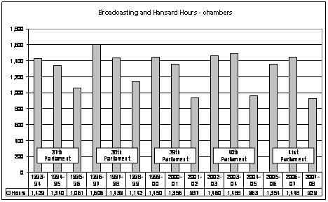
Committees
  - In 2007-08, 1,208 hours of parliamentary committee hearings were recorded. This is a large decrease when compared with the 2006-07 results—1,995 hours—and is approximately 20% lower than the 2004-05 election year—1,479 hours.
  - The reduced workload provided an opportunity for staff to participate in broadcast system asset replacement projects, training and development programs and various maintenance activities.
  - As in previous years, Senate Estimates hearings (Estimates) placed considerable pressure on broadcasting resources. During each week of Estimates, four committees generally sit concurrently from 9am until 11pm. This is usually in addition to sittings of the House of Representatives, the Main Committee of the House of Representatives and, on occasion, House of Representatives Standing Committees.
Figure 32—Broadcasting and Hansard—Committee Hours 1993-94 to 2007-08, Sub-outputs 4.1 and 4.2
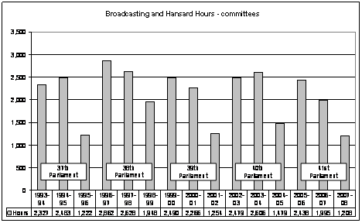
Client-specific services
  - The televised and/or audio recording of parliamentary proceedings forms the major part of the broadcasting section’s activity. However, other services are provided to Senators and Members such as recording of press conferences, pieces to camera, and the provision and operation of audio-visual equipment.
  - In 2007-08, 87 hours of client-specific service material were provided. In previous years the figures reported were estimates. However, this year we established a method of recording actual hours captured. The number of actual hours provided in 2006-07 is not available.
  - Client-specific services in 2007-08 included the Australia 2020 Summit, the Opening of the 42nd Parliament and Apology to Australia’s Indigenous Peoples productions.
Audio-visual services
  - In 2007-08 Broadcasting Content provided stand-alone audio-visual services on 1,081 occasions. This is a new performance measure introduced this year. This service, for the most part, includes loan of audio-visual equipment to clients in Parliament House. It also includes sound reinforcement and recording services for functions, meetings, seminars and special events.
Master control services
  - In 2007-08 921 master control services were provided. This is the first year this activity has been recorded as a separate service. Master control services involve Broadcasting Content staff making audio and video patches to enable media organisations to gain specific access to selected parliamentary proceedings and other special event productions.
Figure 33—Sub-output 4.1—price indicators
Price indicator | Measure | Performance
Price indicator | Measure | 2006-07 | 2007-08
Broadcasting services | Cost per hour of material captured on audio-visual record, by category:
Broadcasting services | - chambers | $497 | $961  (+72%)
Broadcasting services | - committees (ACT hearings) | $600 | $998  (+52%)
Broadcasting services | - committees (interstate hearings) | $689 | $1,198  (+52%)
Broadcasting services | - client-specific | $1,351 | $6,906
Broadcasting services | Total cost of sub-output 4.1 | $5.762m | $6.216m
Indicator—Broadcasting services
  - The large increases in cost per hour of material captured on the audio-visual record for chambers and committees are due to the substantial reduction in broadcast hours during an election year. Broadcasting’s cost structure is largely fixed and it is therefore difficult to reduce costs during election periods. With actual production reduced the unit cost of production increases.
  - Overall the total cost for broadcasting services in 2007-08 increased by approximately 8% due to salary increases, recruitment costs to fill vacancies and increased indirect costs.
  - The cost per hour of material for client-specific services should not be compared to the prior year’s cost. For the 2006-07 year, the calculation of the cost was based on an estimated number of hours captured on the record (see paragraph 310). The number of actual hours provided in 2006-07 is not available.
Sub-output 4.2—Hansard services
  - Hansard services comprise transcribing and publishing reports of proceedings in the Senate, the House of Representatives and the Main Committee of the House of Representatives including parliamentary committees. Hansard also provides transcription services for some ministerial or parliament-related conferences.
Figure 34—Sub-output 4.2—quality indicators

Quality indicator | Measure | Performance
Quality indicator | Measure | 2006-07 |  | 2007-08
Customer satisfaction | High level of customer satisfaction | 88% |  | Not applicable
Customer satisfaction | Number of customer complaints | 5 |  | 2
Accuracy of transcription | Error rate as notified by customers (target: 5 per 100 pages transcribed):
Accuracy of transcription | - chambers | 3.7 errors |  | 3.0 errors
Accuracy of transcription | - committees | 0.7 errors |  | 1.4 errors
Timeliness of transcription | Percentage of transcripts delivered for chambers within service standards (target: 95%):
Timeliness of transcription | - individual draft speeches (2 hours after speech finishes) | 97% |  | 94%
Timeliness of transcription | - electronic proof Hansard reports (within 3 hours after house rises) | 81% |  | 74%
Timeliness of transcription | - hard copy proof Hansard reports (available in Parliament House by 8:30am the following sitting day) | 98% |  | 97%
Timeliness of transcription | - electronic official Hansard (15 non-sitting working days following the last sitting day in the week) | 15% |  | 100%
Timeliness of transcription | - hard copy of official Hansard (delivered to publisher within 15 non-sitting working days following the last sitting day in the week) | 3% |  | 82%
Timeliness of transcription | Number of transcripts delivered for committees within the following standards. Transcripts for priority committees are negotiated with the Clerk Assistant, Committees (target 95%):
Timeliness of transcription | a) within 24 hours |  | 82% | 100%
Timeliness of transcription | b) 1-3 days |  | 90% | 94%
Timeliness of transcription | c) 3-5 days |  | 81% | 97%
Timeliness of transcription | d) over 5 days |  | 96% | 94%
Indicator—Customer satisfaction (Hansard)
  - As DPS did not conduct a customer survey in 2007-08, there is no information to compare with previous satisfaction levels.
  - Hansard received only two customer complaints during 2007-08, even though some 2,137 hours of proceedings were transcribed. One complaint related to the delay in publishing answers to questions on notice due to technical issues, and the other to policy and practice on the incorporation of handwritten material into Hansard.
Indicator—Accuracy of transcription (Hansard)
  - Hansard error rates are based on the number of corrections to pinks and greens—draft chamber speeches—returned by Senators and Members, or corrections to committee transcripts made by witnesses, and accepted as Hansard errors. Error rates for both chambers (3.0) and committees (1.4) were within the target of 5 errors per 100 pages transcribed and demonstrate a high standard of accuracy.
Indicator—Timeliness of transcription (Hansard)
Chambers
  - The service delivery standards for chamber transcripts are in five categories, as listed at Figure 34—Sub-output 4.2—quality indicators. As the delivery of draft speeches gives Senators and Members their first opportunity to review the Hansard transcript, delivery time is critical, and Hansard achieved a 94% result against this standard, which was slightly below the 95% target, and down on the 97% achieved in 2006-07.
  - The service standard for loading electronic proof Hansard reports was met on 74% of occasions, down on the 2006-07 result of 81% and below the 95% target. Delays were experienced for two main reasons: technical difficulties in publishing, due often to the processing of answers to questions on notice or in writing, and the additional supervision required to check trainee editors’ work. The delivery standard for hard copy proof Hansard reports delivered to Parliament House was met on 98% of sitting days.
  - Loading the electronic Official Hansard (Officials)—100% within the delivery standard—and delivery of the hard copy Official Hansard to the publisher—82% within the delivery standard—were a significant improvement of last year’s results of 15% and 3% respectively.
  - In 2007-08 we instituted a process whereby the corrections Senators and Members submit for the Officials can be made and reloaded to the internet within three days of the sitting day concerned. Further Hansard quality assurance processes can take place before the report reaches the Official stage.
  - The below target result for hard copy Officials resulted from the work practice of sending the Officials to the publisher in batches of several weeks at a time, which delayed the earlier week’s production. This practice has been revised, and timeliness of hard copy Officials during the second half of 2007-08 was 100%.
Committees
  - The service delivery standards for committee transcripts are in four categories: within 24 hours (priority), within 1-3 days (priority), within 3-5 days and over 5 days. Delivery times for priority hearings are negotiated with the relevant Clerk Assistant, Committees.
  - Hansard achieved significant improvements in performance against these standards in 2007-08. For the 24-hour category, 100% of transcripts were delivered on time compared with 82% in 2006-07. For the 1-3 day category 94% of transcripts were delivered on time compared with 90% in 2006-07. In the 3-5 day category 97% of transcripts were delivered on time compared with 81% in 2006-07.
  - For committee transcripts with a delivery standard of over five days, the actual delivery deadline is negotiated with the client. The performance result is the percentage of transcripts delivered within the agreed deadlines. In 2007-08 one of 17 transcripts was delivered outside the agreed timeframe, resulting in 94% being delivered within the agreed deadlines compared with 96% in 2006-07.
Figure 35—Sub-output 4.2—quantity indicators
Quantity indicator | Measure | Performance
Quantity indicator | Measure | 2006-07 | 2007-08
Transcription services | Number of hours transcribed, by category:
Transcription services | a) chambers | 1,448 | 929
Transcription services | b) committees (ACT hearings) | 1,357 | 785
Transcription services | c) committees (interstate hearings) | 638 | 423
Indicator—Transcription services
Chambers
  - As with broadcasting quantities (see paragraph 305) the number of hours transcribed in 2007-08 decreased due to the federal election in November 2007.
  - Transcripts were provided to occupants of Parliament House in hard copy, and were also available electronically through ParlInfo, the parliamentary database. Transcripts were provided to the general public through:
the Australian Parliament House website (including a search option using ParlInfo Web);
libraries and educational institutions, through the Legal Deposit and Commonwealth Library Deposit and Free Issue Schemes; and
direct subscriptions.
Committees
  - There were 1,208 hours of committee hearings transcribed in 2007-08. This is a 39% decrease when compared with the 1,995 hours in the 2006-07 year. It is also somewhat lower than the last election year—1,479 hours—reflecting the change in government following the election and some delay in recommencing committee work. Estimates hearings again took place concurrently with House of Representatives sittings. This presented significant workload challenges for Hansard. Estimates accounted for 38% of total committee hours—up from 35% in 2006-07.
  - Senate committee hearings, including Estimates hearings, made up 78% of the total committee workload, up from 66% in 2006-07. House of Representatives committees made up 10% and joint committees 12%.
  - In 2007-08 DPS continued to use external transcript providers to manage its peak workload. These providers accounted for 389 hours, or 32% of the total committee hours transcribed. External providers are engaged on occasions to record and transcribe parliamentary committee hearings held interstate and to assist with the transcription of committee hearings in the ACT, and used particularly during the busy Senate Estimates committee hearings. Hansard could not meet its delivery standards during peak periods without assistance from external providers.
Figure 36—Sub-output 4.2—price indicators
Price indicator | Measure | Performance
Price indicator | Measure | 2006-07 | 2007-08
Hansard services | Cost per hour transcribed, by category:
Hansard services | a) chambers | $2,339 | $3,374  (+44%)
Hansard services | b) committees (ACT hearings) | $1,819 | $2,942  (+62%)
Hansard services | c) committees (interstate hearings) | $2,731 | $3,229  (+18%)
Hansard services | Total cost of sub-output 4.2 | $10.877m | $10.198m  (-6%)

  - The significant increase in the hourly cost for chamber and committee transcription compared with 2006-07 was due to the reduction in parliamentary activity resulting from the November 2007 federal election.
Administered items
Introduction
  - DPS uses administered funds to plan, develop and deliver into service:
a building works program; and
an artworks conservation and acquisition program.
  - These programs are to support the operation of Parliament into the future, while at the same time preserving the design integrity of the architecture, engineering systems, art and landscape that make up Parliament House.
Performance
Figure 37—Administered items—quality indicators
Quality indicator | Measure | Performance
Quality indicator | Measure | 2006-07 | 2007-08
Extent to which design integrity is preserved | Design Integrity Index (target: 90%) | 90.6% | 90.5%
Extent to which projects meet objectives | Client acknowledgement that project has delivered business objectives (target: 100% of projects) | 93.8% | 90.5%
Extent to which projects meet objectives | Findings of post-implementation reviews | - | See paragraph  338
Extent to which the art collection is preserved | Percentage of artworks conservation program achieved (target: 85%) | 67% | 100%
Indicator—Extent to which design integrity is preserved
  - In 2007-08, for the first time, all environmental and heritage performance reporting information has been consolidated in a single part of the annual report. Part 5—Environment and heritage includes information on the Design Integrity Index.
Indicator—Extent to which projects meet objectives
  - During 2007-08 two out of 21 building projects did not meet the client’s objectives at completion. The two problems are legacy issues under the previous project delivery processes, which allowed unclear statement of requirements to be used without being properly agreed with the client.
  - In the first case the client was dissatisfied because the system installed had a high rate of false alarms. In the second case the client was dissatisfied because a lighting control panel in a committee room did not have the required functionality and was not positioned appropriately for ease of use.
Indicator—Extent to which the art collection is preserved
  - All artworks conservation projects undertaken in 2007-08 were completed on time and within budget. Conservation projects included further work on nine outdoor sculptures, and treatment of portraits of Australia’s first four Governors-General from the Historic Memorials Collection.
  - More complex components of the sculpture project required consultation with the artists who made these works, to ensure their original intent was not compromised. Treatments included re-painting of two large steel sculptures, treatment of corrosion on another steel sculpture, and re-gilding on a marble work.
  - The portraits of the first four Governors-General are all on long-term loan to Admiralty House in Sydney and required cleaning as well as treatment to protect their ornate gilded frames. This work was managed in close cooperation with the Office of the Official Secretary to the Governor-General.
Art acquisitions and commissions
  - In 2003, the Presiding Officers decided to suspend art acquisitions and meetings of the Art Advisory Committee (AAC), whilst a review of the Parliament House Art Collection (PHAC) was undertaken by Mrs Betty Churcher AO (former Director of the National Gallery). Mrs Churcher delivered her report in 2004.
  - As a result of the Churcher review, new acquisitions policies were developed and approved by the Presiding Officers in 2006, and the AAC was re-established in 2007. In 2007-08, the re-established AAC focused on increasing the number of artworks available for display in Senators' and Members' suites, and on specific areas of the collection that were under-represented. The committee approved the purchase of 124 artworks during the year.
  - Portraits of the previous Governor-General—Major General Michael Jeffery—and the previous Speaker of the House of Representatives—the Hon. David Hawker MP—were completed. Planning also commenced for a portrait of the previous President of the Senate—Senator the Hon. Alan Ferguson.
Figure 38—Administered items—quantity indicator
Quantity indicator | Measure | Performance
Quantity indicator | Measure | 2006-07 | 2007-08
Extent to which projects are completed on time | Projects are delivered to agreed timetables (target: 100% of projects) | 90% | 86%
Indicator—Extent to which projects are completed on time
  - All projects—conservation and collection development—related to the art collection were completed on time.
  - Of 21 building and security projects, 18 were completed on time. The late projects were largely a result of difficulties in sourcing materials, a tight labour market, and restrictions on performing construction works during sitting times.
Figure 39—Administered items—price indicators
Price indicator | Measure | Performance
Price indicator | Measure | 2006-07 | 2007-08
Extent to which projects are completed within budget | Total expenditure is within the original approved total budget, subject to increases for latent conditions or change of scope (target: 100%) | 100% | 100%
Extent to which administered funds are expended | Percentage of available administered funds expended | 30% | 54%
Indicator—Extent to which projects are completed within budget
  - All administered items projects for the 2007-08 year were completed within their total budget allocation. All projects were completed within approved budgets.
  - In some cases, the first approved budgets needed to be significantly revised when final specifications were available, and these revised budgets have been treated as original budgets for the purposes of assessing performance.
Indicator—Extent to which administered funds are expended
  - The low percentage of administered funds expended on building and security projects is due to:
delays in completing the design documentation for various projects;
delays in making sites available to commence the construction works; and
some projects being cancelled.
  - During the year, new staff were recruited to expand our capacity and capability to undertake an expanded program of building and security project work to replace and upgrade ageing infrastructure.
  - Projects are now managed internally in a controlled environment using the PRINCE2™ project management methodology. This is delivering better project outcomes, more accurate estimation, value for money, improved design and clearer statements of requirements. Early indicators are that this is improving project outcomes and client satisfaction.
Other reporting requirements
Purchaser-provider arrangements
  - Arrangements under which the outputs of one agency are purchased by another agency to contribute to outcomes are called purchaser-provider arrangements. Purchaser-provider arrangements can occur between Commonwealth agencies or between Commonwealth agencies and state/territory government or private sector bodies.
  - Under a purchaser-provider arrangement between DPS and the Department of Finance and Deregulation (Finance), DPS is the provider of information technology support to Senators and Members and their staff in electorate offices.
Electorate office support
  - The Presiding Officers and the Special Minister of State signed an agreement on 14 May 2003 with respect to DPS providing IT support to electorate offices on behalf of Finance, which meets agreed costs of this support. The original agreement covered the period from 1 July 2003 until 30 June 2006. The 2003-06 agreement will remain in force until a replacement agreement is negotiated.
  - Under this agreement:
DPS (in consultation with Finance) develops and maintains the Standard Operating Environment (SOE) which is used in Parliament House and electorate offices, and for mobile use;
DPS provides service desk and remote desktop support services for fixed and mobile access; and
Finance engages external contractors to supply, maintain and support on-site hardware in electorate offices, to maintain communication links to Parliament House from electorate offices and to provide training services for electorate office staff.
  - There were five management meetings between Finance, DPS and the external contractor (Volante) responsible for managing the services held during 2007-08. In these meetings, DPS and Finance reviewed:
procedures and processes and determined what improvements should be made to improve service delivery;
the impact of the on-site provider (Volante) on DPS’s service delivery; and
the impact of DPS on Volante’s service delivery.
  - During 2007-08, DPS performed a range of electorate office support activities including:
support and maintenance of the SOE;
various software upgrades;
establishment of the new Mobile Messaging Service (MMS) to replace the existing Personal Digital Assistants issued to Senators and Members;
completion of the project to install new file servers in the electorate offices; and
work associated with electorate office moves resulting from the November 2007 federal election.
  - The workload for 2007-08 of 26,253 calls—requests to the Client Support help desk—represents a 6.5% increase on the 24,651 calls received in 2006-07, and it is also the highest number of calls logged from the electorate offices since the memorandum of agreement has been in place.
  - DPS met all high priority Service Level Agreement targets for electorate office support in 2007-08. However, for the period March—June, the ‘As Agreed’ priority 4 service level target was not met, partly as a result of high call volumes and some lengthy delays in the delivery and training of MMS devices due to the requirement for these tasks to be carried out when the client is in Parliament House.
  - The cost recovered by DPS from the Department of Finance and Deregulation for providing core electorate office support services for the 2007-08 financial year was $1.887 million (GST exclusive).
Cost recovery arrangements
  - Under the Finance Minister's Order 121.53 agencies are required to disclose cost recoveries. DPS cost recoveries are disclosed in the Financial Statements in this report (see page 161).
  - The Department of Finance and Deregulation's Financial Management Guidance paper No.4 (Cost Recovery Guidelines July 2005) requires additional information to be provided about “significant” cost recovery arrangements. DPS does not have any significant cost recovery arrangements to report.

Part 5—Environment and heritage

Part 5—Environment and heritage
Introduction
  - DPS places a high priority on its responsibilities for management of the environmental and heritage aspects of Parliament House.
  - In 2007-08, for the first time, all environmental and heritage performance reporting information has been consolidated in this new part of the annual report. It includes information previously reported in:
DPS Annual Report—Report on performance;
DPS Annual Report—Management and accountability; and
the annual Parliament House Environmental Performance Report.
  - Environmental reporting information in this part is structured using the core Global Reporting Initiative (GRI) environment performance indicators (www.globalreporting.org).
  - DPS manages and reports on the environmental and heritage aspects for the whole of Parliament House. In some cases this includes information from the Department of the Senate and the Department of the House of Representatives.
Overview
  - DPS recognises our responsibility to properly manage Parliament House, its resources and facilities in a way that supports sustainable development objectives and promotes the public interest.
  - Parliament House was designed to last 200 years, is a major national and international tourist attraction, and is an eminent work of architecture. It embodies significant heritage values, both socially—as a national icon reflecting the Australian people’s faith in the future of democracy—and physically, as a functional work place and the home of the Australian Parliament.
  - Parliament House provides a home for the Australian Parliament and is also a place of major visitation and education. These functions mean that it is a large operation which consumes resources and produces waste. DPS aims to ensure the vital functions of Parliament House are maintained, while also minimising resource consumption, minimising waste production and maintaining the heritage value of the building.
Strategic plan
  - In November 2007, the DPS Water Strategic Plan 2007-2010 and DPS Energy Strategic Plan 2007-2010 were endorsed. These strategies identify priorities for energy and water consumption, taking into account stakeholder expectations, which include:
achieving water and energy savings consistent with government and community expectations and the efficient operation of Parliament House;
ensuring that services are not interrupted by failure of ageing energy plant and equipment;
creating a landscape that is drought tolerant and uses less water;
reducing the use of treated mains water for non-drinking purposes; and
providing meaningful reports on water and energy use and savings.
  - We expect to finish the DPS Waste Strategic Plan in 2008-09.
  - We also expect to finish the Heritage Strategy in 2008-09. The strategy is intended to meet requirements under the Environment Protection and Biodiversity Conservation Act 1999 (the EPBC Act) and will provide specific strategic direction in meeting the requirements of the Act and related heritage regulations.
Sustainable purchasing practices
  - The DPS Chief Executive’s Procedures require procurement decisions to take into account the total resources required to develop, acquire, own, operate and dispose of the equipment.
Heritage considerations
  - The aesthetic values of the building—such as building materials, equipment, furniture items, light fittings—are given careful consideration to ensure both quality and alignment to the original design intent in all asset replacement projects. DPS Heritage Management staff use the Central Reference Document as a guide in understanding the significant values of the various aspects of the building.
Environmental considerations
  - All DPS purchases require consideration of the Department of Environment, Water, Heritage and the Arts (DEWHA) guidelines on purchasing.
  - The DPS Energy Strategic Plan 2007-2010 and DPS Water Strategic Plan 2007-2010 require all tender documents to seek innovative energy and water saving solutions. They also require us to select products that have the highest energy and water efficiency ratings, while ensuring value for money principles are met.
  - Examples of contracts in 2007-08 where environmental considerations have been incorporated are:
procurement of printers and desktop computers;
standing offer for supply of carpet; and
catering contracts.
Communication and promotion
Heritage
  - DPS Heritage Management staff undertake a range of activities to promote the significance of the architectural and heritage values of Parliament House, including:
briefings to contractors engaged to undertake capital works projects in the building, who are made aware of potential heritage impacts, constraints and legislative requirements; and
participation in the 20th anniversary of Parliament House; and
presentations to special interest groups and at formal functions.
  - The paper Parliamentary Architecture and Political Culture, reviewing the success of the building in housing the Parliament, was presented by Clement Macintyre during the 20th anniversary celebrations.
Environment
  - The environmental information located on the Parliament House website, http://www.aph.gov.au, is updated quarterly to provide information on progress against water, energy, emissions and waste targets.
  - Advice on environmental management is regularly provided in information circulars to building occupants. Recycling brochures and promotional material were also distributed with the introduction of the co-mingled recycling scheme. A promotional stand and banner were maintained at the entrance to the staff dining room for two weeks with the return of the 42nd Parliament in February 2008.
  - Regular newsletter articles on topical environmental issues are published in the DPS Dispatch, our staff fortnightly newsletter. These articles are also available through the Parliament House web site.
  - Site tours and environmental training sessions are other ways DPS communicates with diverse audiences about environmental management practices.
Legal requirements
Heritage
  - DPS is required to meet heritage obligations under two acts.
Section 195AT (2A) of the Copyright Amendment (Moral Rights) Act 2000 requires DPS to:
provide the ‘author’ with a written notice stating the intention to carry out a change to the building; and
provide access to the ‘author’, if requested, to make a record of the building in its present state and/or to consult in good faith with DPS about the changes to the building.
These notifications are issued by DPS Building and Security Projects section, in consultation with Heritage Management staff.
The Environment Protection and Biodiversity Conservation Act 1999 (the EPBC Act) requires DPS to prepare a Heritage Strategy and a register of the heritage values of Parliament House. The aim of the strategy is to achieve the conservation of Parliament House and maintain its cultural heritage significance consistent with its ongoing operation as the home of the Parliament and as a key component of the parliamentary zone.
Environment
  - DPS must report on elements of environmental performance in its Annual Report to meet requirements in the EPBC Act. DPS also provides EPBC Act reporting for the Department of the Senate and the Department of the House of Representatives.
  - As well as the EPBC Act, DPS also reports under:
Energy Efficiency in Government Operations (EEGO) policy;
National Environmental Protection Measures (NEPM) Act;
National Pollution Inventory (NPI); and
National Packaging Covenant (NPC).
Ecologically sustainable development
  - Paragraph 516A(6)(a) of the EPBC Act requires DPS to report on how the activities of the parliamentary departments, including their administration of legislation, accorded with the principles of ecologically sustainable development (ESD). The goal of ESD is defined as:
… development that improves the total quality of life, both now and in the future, in a way that maintains the ecological processes on which life depends.
  - The parliamentary departments do not manage, coordinate or administer legislation that impacts directly on ESD. However, the Senate and the House of Representatives carry out law-making and policy review roles at Parliament House, which may have the potential to support ESD principles.
  - To support Senators, Members and their staff in their parliamentary duties, DPS provides information and research services. One area of expertise is the Science, Technology, Environment and Resources Section of the Research Branch in the Parliamentary Library. The Parliamentary Library’s collections provide comprehensive environmental resources. Together, these services and resource can assist Senators and Members to assess how their decisions support ESD.
Contributions of outcomes
  - Paragraph 516A(6)(b) of the EPBC Act requires DPS to report on how the outcomes specified in an Appropriations Act for the reporting period contribute to ESD.
  - The 2007-08 outcomes of the parliamentary departments, specified in the Appropriations (Parliamentary Departments) Acts do not directly contribute to ESD. However, Output 3.1 in the DPS Portfolio Budget Statement 2007-2008 sets energy and water consumption, greenhouse gas emissions and recycling targets. These outcomes require DPS to manage the potential impact of parliamentary operations on the environment.
Identification, management and monitoring of environmental impacts
  - Paragraphs 516A(6)(c-e) of the EPBC Act require reporting on the effects of the parliamentary departments’ activities on the environment, the measures in place to manage environmental impacts and how DPS ensures these measures are reviewed and improved.
  - Activities and operations at Parliament House, particularly maintenance, engineering, landscape, computing and catering services have the potential to affect the environment, as do office-based activities. These result in:
consumption of electricity, natural gas, diesel fuel, water, paper and other resources;
greenhouse gas emissions;
generation of waste; and
the risk of hazardous substance spills.
Heritage Performance
  - DPS created the position of Heritage Management Officer in June 2007 to assist in reporting required under the EPBC Act. In June 2008 we engaged a Building Fabric Officer to assist with heritage and building compliance matters at Parliament House.
Design Integrity Index 2007-08
  - The Design Integrity Index (DII) is the mechanism used to measure, review and report on DPS’s performance with regard to design integrity and heritage matters.
  - Parliament House is divided into eight zones, as shown in Figure 40—Design Integrity Index score by area, for the purpose of measuring the DII.
Figure 40—Design Integrity Index score by area
Area | Score (%) 2006-07 | Score (%) 2007-08
Public and Ceremonial areas | 92.3 | 93.4
House of Representatives Wing | 93.1 | 93.2
Senate Wing | 93.9 | 94.5
Ministerial Wing | 89.8 | 90.1
Committee Rooms and Library | 96.3 | 92.4
Facilities Areas and Tenancies | 80.5 | 82.8
Circulation and Basement Areas | 84.1 | 85.6
Exterior: Landscape and Roadways | 92.9 | 91.8
Total Score | 90.6 | 90.5
  - In each zone, the components of language, symbolism, design order, change and overall impression are examined and given a score from one to five. The outcomes for each component are added together to obtain a zone score, and the zone scores are added to obtain a building score. This score is then expressed as a percentage of the total possible score.
  - The DII for 2007-08 is assessed at 90.5%, slightly lower than the previous year’s 90.6%, but still above the target of 90%.
  - The calculation of the DII has been made using the same simplified data-gathering process used since 2004. Every five years a full building assessment is conducted. In other years assessments are only undertaken on areas that have had work done to them. The next full assessment of all eight DII zones is due to take place in the 2008-09 year.
  - The 2007-08 DII assessment provided a good cross-section of Parliament House, with at least one project in each of the eight zones. Noting that areas of a lower profile tend to be subjected to greater change and generally score lower in DII assessments, this wide cross-section enables a balanced review of the changes across the building.
  - The assessment demonstrates some improvements with well-integrated changes such as the upgrading of disabled access and OHS compliance in the Main Committee Room Gallery, as well as the excellent outcome of works performed in the Ministerial Wing with the access opportunities presented by the change of government.
  - The 2008-09 DII results will reflect the full building review and will provide a more detailed insight into the success of DPS efforts to maintain Parliament House’s design integrity and heritage values. The 2008-09 review will also provide an overview into how successfully integrated the Childcare Centre and the staff dining room refurbishment have incorporated these values.
Environmental performance
Water
  - Water use is a significant environmental aspect of Parliament House operations, particularly because of our commitment to comply with ACT Government water restrictions. Water conservation has had a wide-reaching impact on the aesthetics of the parliamentary precincts, and how we carry out cleaning and maintenance activities.
  - Improving water management is challenging because efficiency was not a particular focus of the original design and fit-out of Parliament House. The DPS Water Strategic Plan 2007-2010 has formalised our priorities in this area.
  - Reduction in reliance on potable water, through the use of re-cycled water or stored stormwater, is generating considerable interest nationally. While committed to investigating both possibilities, DPS concentrated on reducing overall consumption in the 2007-08 period.
Water consumption
  - Water consumption for 2007–08 was 163,481 kL. This was a 27% decrease in water consumption compared to 224,006 kL in the previous year, and 32% decrease compared to the portfolio budget statement target of 240,000 kL. Water saving initiatives—related to ACT stage 3 water restrictions—resulted in this year’s consumption being the lowest on record, as seen in Figure 41.
Figure 41—Annual water consumption
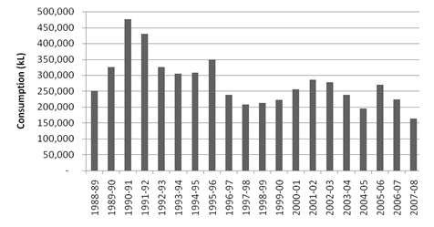
  - Figure 42 shows a breakdown of water use during 2007-08. “Other building water” includes the cold water used in bathrooms, kitchens and the swimming pool. The “flushometer” consumption is the water used for flushing toilets and urinals.
Figure 42—Breakdown of water use during 2007–08
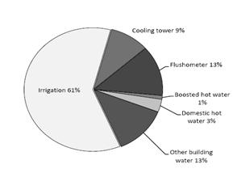
Water restrictions
  - ACT stage 3 water restrictions were in place for the full year and required a reduction in water use of 35% over the equivalent season in 2005–06. For DPS, this meant a target of 186,650 kL per annum. Figure 43 shows progress in meeting this target since the introduction of restrictions on 16 December 2006. A burst water pipe contributed to increased consumption in May 2008.
Figure 43—Actual water use compared to Stage 3 restrictions target
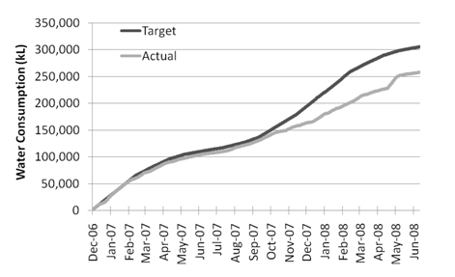
Water saving initiatives
Raising the cooling set point
  - The airconditioning system is a large consumer of water because of the evaporative cooling function of the cooling tower.
  - In May 2007 DPS raised the cooling set point from 22 to 24 degrees Celsius (°C) in many areas of the building. This measure contributed to water savings, notwithstanding that weather and occupancy can also have a significant effect. The higher cooling set point results in less waste heat needing to be removed by the cooling tower.
  - In summer 2007-08, which recorded 27% less water consumption than summer 2006-07, the cooling tower used an average of 74 kL per day. It did not exceed 200 kL on any occasion compared to nine occasions during the previous summer.
Savings in the landscape
  - The most significant water savings have been made in the Parliament House landscape. For the second year, annual flower displays were not planted, and watering was restricted in the grounds beyond Parliament Drive.
  - Late in 2007, DPS commissioned a review of the Parliament House landscape. The primary objective of the review was to reduce irrigation requirements, particularly in grassed areas.
  - DPS received the report of the Parliament House Landscape Review in June 2008, and DPS is currently considering implementation options.
Water features and the forecourt pond
  - The 20 external water features in and around Parliament House remained turned off and empty during 2007-08, except for the forecourt pond.
  - In May 2008,—for the 20th anniversary of Parliament House, the forecourt pond was filled with recycled water trucked in from the Lower Molonglo Water Quality Control Centre. Using recycled water ensured that DPS did not contravene ACT stage 3 water restrictions.
  - DPS has an agreement with ActewAGL to use the recycled water free of charge, provided we commit to use it in a safe way, such as putting up the “Not safe for drinking” signs. DPS pays for the transport costs.
Energy
  - Parliament House is a major energy consumer. The DPS Energy Strategic Plan 2007-2010 commits us to achieving a 10% reduction in usage over the life of the plan.
  - There are many priorities for energy improvements. During a parliamentary sitting day, electricity consumption peaks at about 6 megawatts—compared with a 5 megawatt peak on a non-sitting day—and is consistently above 4 megawatts. However, during late evening and early morning, when the building is largely unoccupied, consumption is still around 2 megawatts.
  - The challenge for DPS is to find ways to reduce that base load, as well as the peaks. An energy audit was commissioned in May 2008 and will make recommendations in this area.
Energy consumption
  - DPS’s energy profile consists of energy consumed at Parliament House and transport energy, including both passenger vehicles and maintenance vehicles (“other transport”). Figure 44 summarises energy use by these components in 2007–08.
Figure 44—Energy consumed at Parliament House and by transport
Category | Energy Consumption
Category | 2006-07 (GJ) | 2007-08 (GJ)
Parliament House building:
Electricity: non-renewable source | 70,488 | 66,482
Electricity: renewable source | 23,496 | 22,160
Natural gas | 45,382 | 41,015
Diesel | 480 | 393
Total | 139,846 | 130,050
West Block tenancy:
Electricity: non-renewable source | 903 | -
Electricity: renewable source | 79 | -
Total | 982 | not applicable
Passenger vehicles:
Automotive diesel | - | 41
Automotive gasoline (petrol) | 2,007 | 1,556
E-10 (biofuel) | 202 | 513
LPG | 125 | 111
Total | 2,334 | 2,221
Other transport:
Automotive diesel | 319 | 282
Automotive gasoline (petrol) | 112 | 124
LPG | 41 | 41
Total | 472 | 447
Total energy consumption | 143,634 | 132,718
  - Energy consumption in Parliament House in 2007-08 was the lowest recorded since the building opened in 1988.
  - Energy consumed in 2007-08 was 132,718 GJ, a decrease of 8% on the 143,636 GJ consumed the previous year. Passenger and other transport energy uses decreased by 5% from 2,336 GJ and 472 GJ respectively in 2006-07 to 2,221 GJ and 447 GJ in 2007-08.
  - Electricity and natural gas consumption at Parliament House comprised 98%—129,657 GJ—of total energy use. Gas is used for heating, domestic hot water and in kitchens. Electricity powers a variety of services including office lighting, mechanical services, lifts, chillers, computer equipment, central waste plant and boosted hot water heating. Figure 45 shows the downward trend in electricity and gas consumption since the building opened.
  - The federal election in November 2007 meant fewer sitting days in 2007-08, resulting in reduced energy consumption compared to the previous year.
Figure 45—Annual electricity and gas consumption (in 000’s of Gj)
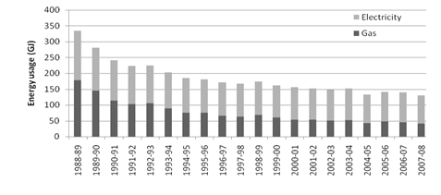
Vehicles
  - Parliament House’s passenger vehicle fleet consisted of 39 leased vehicles in 2007-08, including 31 SES vehicles. Six vehicles (five SES) scored higher than 10 in the Green Vehicle Guide.
Energy saving initiatives
  - Initiatives to conserve electricity included the continual monitoring and adjustment of the electrical load plant, implementing more energy-efficient lighting schemes, and reduced airconditioning during summer.
Chilling and boiling water
  - During 2007-08, a review of drinking water supply identified several locations where kettles could provide boiling water more efficiently than instant boiling water units and where water chillers were unwarranted. Changes will be made in the 2008-09 year.
Improved information on electricity usage
  - Energy use data is essential for identifying improvement initiatives. A metering project in September 2007 has helped us to understand that lighting represents the biggest proportion of usage in office areas, and standby power for office and kitchen equipment is also significant. An example of the metering results for a typical suite is shown in Figure 46.
Figure 46—Electricity consumption for a suite on different day types
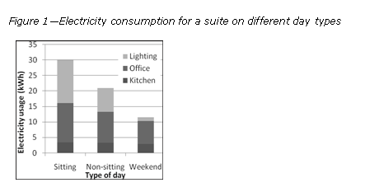
  - Energy use data is now informing decisions on refurbishment projects and replacement of office equipment and appliances.
Lighting
  - The phasing out of incandescent lamps is an ongoing initiative to save energy. This year compact fluorescent lights were installed in general circulation corridors and in the ground floor and first floor areas surrounding the reflection pool. Trials continued to identify alternatives to replace other incandescent lamps, including those in offices and the Parliamentary Library.
  - A project has begun to replace street and road lighting. The revised lighting scheme and lamp types will use 40% less energy than the existing scheme.
  - During 2007-08, occupancy sensors were incorporated into locations where we believed lights were being left on unnecessarily, such as public and internal general circulation toilets.
Earth Hour
  - Parliament House participated in Earth Hour on 29 March 2008.
  - During Earth Hour, there was an approximate saving of 50kWh, which was a 3% reduction compared to the same hour on the previous weekend. Savings were not high because most equipment and appliances would normally be in standby mode, with energy consumption already minimised.
  - All external lights were switched off except for those lights required for safety and security purposes—for example, lights on the flagpole.
Recycling and waste management
Waste generation and recycling
  - The amount of general waste (excluding construction waste) sent to landfill in 2007-08 was 471 tonnes, which is 10% more than the 428 tonnes sent the previous year. The quantity of recycled paper waste increased by 40%, from 260 tonnes in 2006-07 to 363 tonnes in 2007-08. Both the increased waste to landfill and increased waste paper to recycling statistics are attributable to the change of government in November 2007. Figure 47 shows trends since 1998.
Figure 47—Annual waste disposed to landfill and recycled
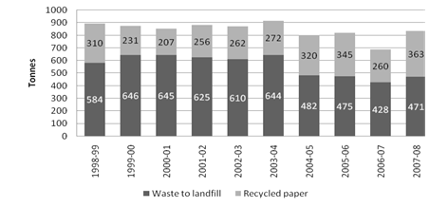
Landscape waste
  - The preferred method for disposing of green waste at Parliament House is to chip the material on-site and re-use it in the landscape. The amount of chipped material is not recorded. When waste generated in the landscape cannot be chipped on-site—due to volume, composition or resources—then the material is taken off-site to be recycled or disposed to landfill.
  - During 2007–08, 187 tonnes of landscape waste was generated from the Parliament House landscape. 94 tonnes was used for clean fill, 93 tonnes were composted, and no landscape waste was sent to landfill during the year.
  - Figure 48 shows annual trends in landscape waste and recycling rates. The peak in landscape waste during 2005-06 was because of a turf replacement project on the roof slopes. In 2005-06 775 tonnes of landscape waste was recycled.
Figure 48—Annual quantity of landscape waste
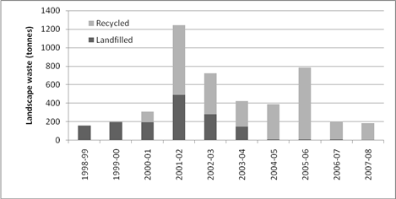
Waste management initiatives
Recycling facilities and introduction of co-mingled recycling
  - DPS provides facilities to recycle paper, cardboard, printer cartridges, lamps, used oil, grease, batteries, landscape and metal waste. From 4 February 2008, DPS expanded these facilities to provide building occupants the option of recycling co-mingled wastes. Co-mingling bins were also put in communal kitchens, lunch rooms and meeting rooms.
  - At 30 June 2008, 56 tonnes of co-mingled waste had been collected and recycled.
2008 waste audit
  - A waste audit was undertaken in May 2008 to help develop objectives in the DPS Waste Strategic Plan. All the rubbish generated in Parliament House kitchens, offices, dining rooms, public areas and courtyards on one parliamentary sitting day and one non-sitting day was weighed. Samples were then taken for closer analysis.
  - The total waste generated on the sitting day was three times the amount generated on the non-sitting day—3.6 tonnes compared to 1.2 tonnes. A positive finding was that there is negligible contamination in the paper recycling stream and little in the co-mingled streams—less than 3% by weight.
  - However, more than half the material in the general waste stream is recyclable, and incorrectly going to landfill. Compared to the 2005 waste audit, the contamination in the office waste stream on a non-sitting day has decreased from 69% to 57%.
  - DPS believes that the recycling rates can be improved with a strategy to increase awareness of waste management practices and a review of the bin type, placement and labelling.
Other waste initiatives
  - Putrescible waste—vegetable, fruit, meat, other food scraps and handtowel—from Parliament House currently goes to landfill. DPS is considering options for recovering and recycling putrescible waste in consultation with the waste contractor.
  - DPS is now procuring 100% recycled content copy paper, at a cost increase of approximately 27%. We aim to further reduce paper use to offset the additional cost.

Co-mingling in the House  Recognising and responding to the growing importance of environmental issues, DPS introduced a voluntary program to increase the level of waste recycling in Parliament House.  “Our co-mingling initiative took almost a year of planning before we started in early 2008” says Clare, an enthusiastic supporter of the idea. “The aim is to increase recycling. We started recycling paper ages ago. Now our plastics, glass and cartons are recycled and don’t go straight to landfill, as they did before”.    Clare explains that this has proven immensely popular, with staff from all parliamentary departments, contractors and licensees participating and, in many cases, wanting to do more. “I’ve seen lots of feedback from staff wanting more, such as bigger bins and more signage” Clare says. “They are seeking ways to have their recycling at work operate the same way as their recycling at home, and I think that’s great”. | Adopting similar arrangements is part of a growing trend among large workplaces. A meeting with staff from the ACT Government “No-Waste” initiative confirmed that DPS is doing well, with many of the recommended strategies (including ways to recycle batteries and toner cartridges, as well as standardised labelling practices for bins) already in place.  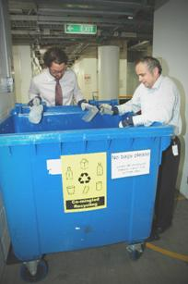  Clare is optimistic about the future of recycling in Parliament House. A recent co-mingling display at the entrance to the staff dining room also raised awareness and support for environmental initiatives. “A lot of people stopped to ask questions. People were amazed that their small actions at work could make such a huge difference”.

  - Strategies for DPS to reduce its paper consumption include ensuring personal computers default to double-sided printing, only printing emails when required for a file or when otherwise necessary, printing two pages onto a page and minimising printing of multiple copies of a document where possible—for example, sharing a single copy amongst team members.
  - Paper reduction targets for each DPS branch have been set and success against the targets is reviewed quarterly.
  - Since December 2007, catering contractors provide take-away cardboard cups which can be recycled. Staff may also provide their own cup.
Emissions and effluents
Greenhouse gas emissions
  - During 2007–08, 22,754 tonnes of carbon dioxide equivalent (CO₂e) were generated from energy consumption at Parliament House. Greenhouse emissions are described in Figure 49.
Figure 49—Parliament House emissions (direct and indirect, including SES and operational vehicle fleets)
Emission category | Comment | 2006-07  (tonnes CO₂e) | 2007-08  (tonnes CO₂e)
Scope 1 | Emissions at the source of the activity (eg emitted from gas and fuels used at Parliament House and by vehicles) | 2,587 | 2,318
Scope 2 | Emissions generated elsewhere (eg by the power plants that produce the electricity used at Parliament House) | 17,129 | 16,520
Scope 3 | Indirect emissions, meaning emissions generated during the delivery of electricity, gas and fuel to Parliament House, which DPS has little control over. | 4,307 | 3,916
Scopes 1 & 2 | DPS has direct responsibility for these emissions. | 19,716 | 18,838
Scopes 1,2 & 3 | Direct and indirect emissions. | 24,023 | 22,754

  - Figure 50 shows annual greenhouse gas emissions since Parliament House opened in 1988. Purchasing 25% of our electricity from renewable sources has helped to achieve record low emissions.
Figure 50—Annual greenhouse gas emissions from electricity and gas
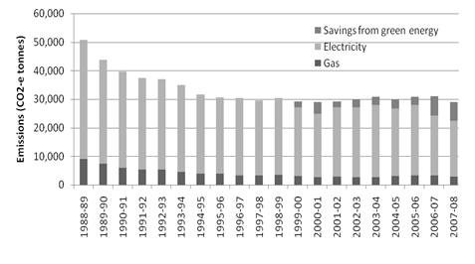
  - DPS is a member of the Greenhouse Challenge Plus program and has reported on greenhouse gas emissions since 1997 (see www.greenhouse.gov.au/challenge).
Ozone depleting substances
  - Parliament House uses refrigerants that contain ozone depleting substances. These are used for:
chillers, which provide cooling for the building’s airconditioning;
coolrooms;
freezers; and
refrigerators.
  - Figure 51 shows the type and “ozone depletion potential” of refrigerants purchased in 2007–08. This year, DPS did not maintain records of the quantity of refrigerants consumed. Use will be reported on for the 2008-09 financial year, with performance compared to consumption in 2006-07.
  - Refrigerants use increased in 2007-08 due to significant maintenance work on one of the five chillers providing the majority of airconditioning to Parliament House.
Figure 51—Type of refrigerant use
Refrigerant | Ozone Depletion Factor | Global Warming Potential  Factor
R404A | 0 | 3,260
R409A | 0.048 | 1,560
SPE34E | 0 | 1,280
R134A | 0 | 1,300
R410A | 0 | 2,000
R22 | 0.034 | 1,780

Air pollutants – NOx, SOx and particulates
  - The combustion of natural gas for heating, hot water and cooking purposes generated oxides of nitrogen (NOx), oxides of sulfur (SOx) and other air pollutants. Each year, DPS reports on these emissions to the National Pollution Inventory (www.npi.gov.au). Figure 52—Emissions of air pollutants from natural gas consumption lists these emissions for 2007-08. Because the amount of gas combusted was less than in 2006-07, emissions of air pollutants were also less.
Figure 52—Emissions of air pollutants from natural gas consumption
Air pollutants | 2006-07  (kg) | 2007-08  (kg)
Carbon monoxide | 1,800 | 1,680
Oxides of nitrogen | 2,100 | 1,993
Particulate matter (PM10) | 160 | 148
Particulate matter (PM2.5) | (not measured) | 148
Total Volatile organic compounds | 110 | 110
Sulfur dioxide | 11 | 32
Polycyclic aromatic hydrocarbons | <1 (0.014) | <1 (0.013)
Discharges to water
  - DPS does not monitor discharges into the sewage system. However, we estimate that 65 ML was discharged into the sewage system in 2007-08—assuming most non-irrigation water is discharged into the sewage system. This is a decrease of 15 ML compared to the 2006-07 figure of 80 ML. Estimates are based on water consumed for non-irrigation purposes.
  - Sewage from Parliament House is required under a trade waste agreement to be equivalent to domestic strength. To ensure these requirements are met, there is a:
    - grease trap on each kitchen drain;
    - coalescing plate filter on the vehicle washdown bay (to prevent oil from entering the sewer); and
    - system to remove paint solids from paint brush washing facilities before they enter the sewer.
Significant spills of chemicals, oils, and fuels
  - In 2007–08 there were no significant spills of chemicals, oils or fuels from Parliament House.

Part 6—Management and accountability

Part 6—Management and accountability
  - This Part provides information on the Department of Parliamentary Services (DPS) management and corporate governance practices, and how we meet our accountability obligations. It includes several specific reports required under Commonwealth legislation.

Corporate governance

Introduction
  - The President of the Senate and the Speaker of the House of Representatives (The Presiding Officers) have joint powers in relation to DPS similar, but not identical, to those of a Minister administering a Department of State (parliamentary departments are distinct from government departments, in that they serve the Parliament, not the government, and operate under the Parliamentary Service Act 1999, not the Public Service Act 1999).
  - The Presiding Officers are assisted by the Joint House Committee, the Joint Standing Committee on the Parliamentary Library, the Security Management Board, the Presiding Officers’ Information Technology Advisory Group and the Art Advisory Committee. The role of each of these committees is outlined below.
Committees advising the Presiding Officers
Joint House Committee
  - The Joint House Committee consists of the members of the House Committees of the Senate and the House of Representatives. Members of those committees are appointed under Senate Standing Order 21 and House of Representatives Standing Order 327 respectively. The two committees meet together as the Joint House Committee.
  - The Committee advises the Presiding Officers on the provision of services and amenities to Senators, Members and staff located in Parliament House.
Security Management Board
  - The Security Management Board (SMB) is established pursuant to section 65A of the Parliamentary Service Amendment Act 2005. The function of the SMB is to provide advice to the Presiding Officers on security policy and the management of security measures for Parliament House.
  - Membership of the SMB is as follows:
the Secretary of DPS;
the Usher of the Black Rod; and
the Serjeant-at-Arms.
  - In addition, the SMB may invite representatives of organisations involved in the development of security policy and provision of security services to Parliament House to attend meetings. Representatives include officials from the Australian Federal Police, the Attorney-General’s Department, the Department of Finance and Deregulation as well as DPS.
Joint Standing Committee on the Parliamentary Library
  - The Joint Standing Committee on the Parliamentary Library was re-established for the 42nd Parliament by motions of the Senate and the House of Representatives on 12 February 2008.
  - At the commencement of each Parliament, six Senators and seven Members of the House of Representatives are appointed to the committee.
  - Information about the role and functions of the Joint Standing Committee on the Parliamentary Library, including its Terms of Reference, can be found in Part 3 of this report.
Presiding Officers’ Information Technology Advisory Group
  - The Presiding Officers’ Information Technology Advisory Group (POITAG) comprises seven Senators and eight Members of the House of Representatives, appointed at the commencement of each Parliament.
  - POITAG’s terms of reference are to:
identify and advise the Presiding Officers on the information and communication technology (ICT) requirements of Senators and Members;
monitor and assess the performance of those areas of the parliamentary administration providing ICT-related services; and
advise and assist the Presiding Officers on issues relating to the efficient and cost-effective use of ICT in the Parliament.
Art Advisory Committee
  - As a result of the Churcher review—see paragraph 343 in Part 4—the Art Advisory Committee (AAC) was re-established in 2007.
  - The purpose of the AAC is to assist the Presiding Officers in determining the suitability of art works for addition to the Rotational Collection within the PHAC.
  - Membership of the AAC includes:
the Presiding Officers;
the Deputy President;
the Deputy Speaker; and
the Secretary of DPS.
  - AAC meetings are attended by an independent Art Adviser from the staff of the National Gallery of Australia.
  - The AAC’s terms of reference are to:
provide guidance on the Rotational Collection Acquisition Policy, and set short-term priorities for acquisitions;
assess acquisition proposals in accordance with the Acquisition Policy and priorities; and
provide advice on other matters relating to the display and management of artworks in the Parliament House Art Collection as considered necessary by the Presiding Officers.
DPS committees

Strategy and Finance Committee
  - The Strategy and Finance Committee (SFC)—changed from the Finance Committee during 2007-08—is an essential part of DPS’s corporate governance arrangements, and consists of the Secretary, the Deputy Secretary, the Parliamentary Librarian and the Chief Finance Officer.
  - The role of the SFC is to:
decide on DPS’s strategies and strategic policies;
approve DPS’s strategic plans;
promote and monitor continuous improvements in DPS;
approve business plans prepared by the Parliamentary Library and other branches;
formulate DPS policy on all financial matters;
allocate annual budgets, and reallocate funding during the year as required; and
monitor financial performance, including consideration of monthly reports.
Executive Committee
  - The Secretary is assisted in the management of the Department by the Executive Committee, which includes all DPS SES officers. The Executive Committee advises the Secretary and the Parliamentary Librarian on policy and operational matters affecting DPS as a whole or affecting significant parts of DPS.
  - This committee considers the development and implementation of the DPS governance framework and associated processes, including risk management and business planning. The committee also deals with a range of policy matters in areas such as OHS, environmental issues, and departmental organisation.
  - Discussion at the Executive Committee informs decisions of the Strategy and Finance Committee.
  - The Committee also acts as a communication tool and venue for discussing major departmental events.

Audit Committee
  - One of our primary mechanisms for testing departmental frameworks and controls is through the internal audit program, overseen by the DPS Audit Committee.
  - The Audit Committee comprises an independent chair, Mr Will Laurie, and between three and five DPS Senior Executive Service (SES) officers appointed for two-year terms.
  - During 2007-08, five DPS members served on the committee —the Deputy Secretary, the Parliamentary Librarian, and Assistant Secretaries from the Research Branch (Dr Jane Romeyn resigned from the committee on 29 February 2008), the Product and Service Development Branch and the Strategy and Business Services Branch (Mr Terry Crane being appointed to the committee on 1 March 2008).
  - The DPS Chief Finance Officer, and representatives of the Australian National Audit Office and our internal auditors, also attend Audit Committee meetings.
  - The functions of the Committee are to:
approve DPS’s annual or strategic audit plans, and request the preparation of any such audit plan as the Committee considers necessary;
ensure flexibility in such audit plans as to accommodate additional audits that the Secretary or the Executive Committee may commission from time to time;
review any audit report that involves any matter of concern to the Secretary or other senior management in DPS, and identify and disseminate good practices;
advise the Secretary on action to be taken on matters of concern raised in any report of an internal auditor or in a report about DPS by the ANAO;
coordinate, as far as practicable, internal audit programs and the DPS audit programs conducted by the ANAO; and
advise the Secretary on the preparation and review of DPS’s financial statements.

  - In 2007–08, the Audit Committee continued its reviews of financial and personnel processes for DPS. In addition, the Committee reviewed a range of matters relating to Parliamentary Security Services, looked at Environmental Governance and continued reviewing aspects of contract management and risk management.
  - The Audit Committee also used internal audit resources to provide advice to the Secretary on signing the Certificate of Compliance.
  - The Audit Committee met five times during 2007–08. Members’ attendance at the meetings is set out in the table below. Note that the Deputy Secretary absented himself from the meeting of 12 March 2008, whilst he was acting Secretary.
Figure 53—Audit Committee attendance

Member | Position | Meeting attendance
Member | Position | attended | out of
Mr Will Laurie | Independent Chair | 5 | 5
Mr David Kenny | Deputy Secretary | 4 | 4
Ms Roxanne Missingham | Parliamentary Librarian | 3 | 5
Ms Freda Hanley | Assistant Secretary, Product and Service Development Branch | 4 | 5
Dr Jane Romeyn | Assistant Secretary, Research Branch | 2 | 3
Mr Terry Crane | Assistant Secretary, Strategy and Business Services Branch | 2 | 2
Other governance matters
Risk management
  - During 2007-08 the Risk Management Policy and Framework was extensively revised. The revisions included a new risk matrix with revised “likelihood” and “consequence” descriptors. The Risk Management Policy and Framework also provides greater clarity regarding responsibilities for managing risk. Work will continue in 2008-09 to implement the revised policy and framework, including the development of new risk assessment templates and guides.
  - DPS participated in Comcover’s 2007-08 Risk Management Benchmarking Survey. DPS improved its score from 4.4 in 2006-07 to 5.3 in 2007-08, reflecting progress in DPS’s business continuity planning.
  - The DPS Risk Register portal continued to be maintained in 2007-08 and is updated as revised risk assessments are finalised.
  - DPS staff participated in training provided by Comcover on various aspects of risk management in 2007-08. Recent courses included risk management fundamentals and business continuity.
  - Progress in the development of a DPS-wide business continuity plan was slower than expected. However, in consultation with principal stakeholders DPS has identified its business-critical services and has prioritised preparation of business continuity plans for these services.
  - Work also continued on developing a Parliament-wide business continuity plan. An action plan was developed by DPS and has been considered by the Security Management Board. The plan is expected to be finalised in 2008-09.

Fraud control
  - The Fraud Control Policy and Framework was revised in 2007-08 to include all statutory reporting requirements. Work also commenced to update the DPS Fraud Control Plan. It is expected that a new Fraud Control Plan will be in place by 31 December 2008.
  - A number of fraud related articles were published in the DPS Dispatch newsletter to maintain fraud awareness amongst staff. The articles covered the definition of fraud and the responsibilities of staff for reporting fraud.
  - As required by Section 2.2 of the FMA Orders, DPS submitted a report on fraud control activities to the Presiding Officers.
  - DPS also submitted a response to the 2007-08 Commonwealth Fraud Control Guidelines Annual Reporting Questionnaire in accordance with the Guidelines.

Strategic plan
  - The DPS Corporate Plan 2004-07 was superseded by the DPS Strategic Plan 2007-2010 in November 2007. The plan provides high-level direction to guide branch business planning and priorities, and is intended to ensure that all DPS staff recognise, and share, a set of common goals for the future of the department.

Business planning
  - The DPS Business Planning Policy and Framework provides for the Executive Committee to decide strategic business directions and priorities each year. Each branch then develops an annual business plan that includes initiatives designed to implement strategic directions, as well as deliver ongoing services and facilities. The framework was reviewed during 2007-08 and a number of improvements were made to reporting processes to increase efficiency, reliability and usefulness of the reports.
  - Existing performance indicators were reviewed during 2007-08, and some changes were made to performance indicators used in the DPS Portfolio Budget Statement 2008-09.

DPS services catalogue
  - March 2008 saw the release of the DPS Services Catalogue for the 42nd Parliament.
  - The Services Catalogue provides a comprehensive overview of all services available to DPS customers and includes guidance on how to access the services and associated service level expectations.
  - The production of the services catalogue is a significant development in our continuing commitments to improved customer service delivery and improved departmental operations. It has already become a significant tool used by DPS managers.
  - Advantages of the catalogue include:
customers and stakeholders have a much clearer understanding of their rights and DPS obligations;
DPS has the basis for discussions with the chamber departments—and other clients such as DoFD—about changes to services and service levels; and
DPS staff have a clear understanding of what we do.
  - The catalogue is available to all building occupants in hardcopy, or electronically on DPS’s intranet and internet sites.

Appropriate ethical standards
  - The standards embraced in DPS reflect the Parliamentary Service Values and Code of Conduct contained in the Parliamentary Service Act 1999. These are promoted in DPS corporate documents including the DPS Strategic Plan 2007-2010, DPS Fraud Control Policy and Framework, guidelines on the acceptance of gifts and benefits, procurement procedures, and other financial and human resource documents. Among other things, these documents outline the standards that are expected of employees in their day-to-day work and interactions with third parties, including tenderers and contractors.

People management and strategy

Staffing, salary and classification structures
Remuneration for Senior Executive Service (SES) employees
  - The remuneration for all SES employees is prescribed in Australian Workplace Agreements (AWAs), and takes account of each employee’s responsibilities within the department as well as SES pay levels elsewhere in the public sector.
  - The level of remuneration, and in some cases the conditions attaching to remuneration, vary from employee to employee, but in general terms all salary increases provided to SES employees depend upon a rating of “fully effective” or higher through the performance management arrangements. Salaries for SES positions range from $128,166 to $205,000.
Performance-based pay arrangements for non-SES staff
  - For non-SES staff, salary advancement is based on performance assessment of individuals as required by the certified agreements and performance management arrangements.
  - The certified agreements for DPS staff —the Department of Parliamentary Services Certified Agreement 2005-2008, certified in August 2005, and the Department of Parliamentary Services (Parliamentary Security Service) Certified Agreement 2006-2008, certified in February 2006—provide for salary advancement within a salary range subject to the achievement of an overall rating of “effective” or higher through the performance management arrangements.
  - Increases in salary and allowances were paid under the certified agreements in July 2007. Both agreements provided for an increase of around 5%, comprising:
an at-risk component of up to 3.5% of the salary pool, (the component was subject to continuous improvement reviews identifying sufficient savings, which was achieved); and
a 1.5% increase in pay, paid as a flat dollar amount to all participants.
Overview of classification structures
  - Figure 54 sets out the non-SES classifications and salary ranges for DPS staff as at 30 June 2008.
Figure 54—Classification and salary ranges as at 30 June 2008
Classification | Salary range
Parliamentary Service Level 1 | $37,967 - $44,219
Parliamentary Service Level 2 | $44,320 - $48,421
Parliamentary Service Level 3 | $49,498 - $51,725
Parliamentary Service Level 4 | $52,365 - $57,329
Parliamentary Service Level 5 | $58,304 - $62,734
Parliamentary Service Level 6 | $63,148 - $71,918
Parliamentary Executive Level 1 | $77,869 - $88,907
Parliamentary Executive Level 2 | $89,591 - $105,420
  - Staff progress through the salary range in 3.5% increments, based on performance.
  - Figure 55 sets out actual staff (a headcount), by classification (including the broad-banded and apprenticeship levels separately), as at 30 June 2008.

DPS Annual Report 2007-08
Part 6—Management and accountability
Figure 55—Staff numbers as at 30 June 2008
146
Management of human resources

Introduction
  - In the reporting year the People Management and Strategy Section (PMAS) commenced implementation of the DPS People Strategy 2007-2010. The strategy aims to build and improve DPS’s organisational capability through integrated people management practices. Initial priorities were the establishment of a learning and development framework, employee induction, probation and staff selection.
  - PMAS continued to work on developing a range of policies and guidelines on personnel and workplace relations issues. The other substantial activities undertaken by the section were:
the development of a Union Collective Agreement to replace the current two certified agreements; and
a review of the DPS Studies Assistance policy.
Workforce planning, staff retention and turnover
  - Figure 56 provides information on staff retention and turnover for DPS during 2007-08 compared to the previous year.
Figure 56—Staff retention and turnover statistics
Staff retention and turnover statistics | 2006-07 | 2007-08 | Change
Staff Number | 862 | 929 | 67
Staff Separations (total) | 166 | 141 | -25
Turnover | 19.3% | 15.2% | -4.1%
Separations by type
transfers/promotions | 43 | 24 | -19
resignations | 49 | 42 | -7
age retirements | 4 | 10 | 6
invalidity retirements | 1 | 1 | 0
voluntary retirements | 49 | 30 | -19
terminations | 1 | 2 | 1
death | 0 | 1 | 1
end of temporary contract | 19 | 31 | 12
Exit Interviews
Interviews held | 63 | 41 | -34.9%
Participation rate | 38% | 29% | -9.0%
  - During the year, staff turnover fell by 4.1% from 19.3% in 2006-07 to 15.2% in 2007-08.
  - The increase in age retirements from four to ten staff reflects the increasing age of the workforce. It is anticipated that this trend will continue to increase in line with the ageing population.
  - The increase in end of temporary contracts from 19 to 31 reflects an increased use of non-ongoing employee and contractor arrangements to manage short-term increases in workloads and project activity.
Staff development and training
  - DPS provides a range of development opportunities to staff. Following the endorsement of the DPS People Strategy 2007-2010, a corporate learning and development framework was scoped in readiness for implementation in 2008-09.
  - DPS conducted a tender process to select a panel of training service providers to deliver training support services. The tender attracted 45 applicants, with 13 engaged under a standing offer arrangement for a three-year period.
  - Individual development plans (IDPs) completed as part of the performance management scheme, are a key avenue for identifying development needs. In May 2008, IDPs were the source of a corporate skills development needs analysis. The results have been used to develop a training calendar that addresses high demand training needs for 2008-09.
  - In 2007-08, DPS continued to provide training for employees in writing skills, project management and occupational health and safety responsibilities.
  - DPS provided support for external study to 42 staff members. Support included a combination of time to attend study activities and financial assistance towards compulsory costs. New studies assistance guidelines were endorsed for implementation in 2008-09.
Workplace relations
  - The focus of activity in the latter half of this year was the negotiation of a Union Collective Agreement to replace the two existing certified agreements. Both certified agreements had a nominal expiry date of 30 June 2008.
  - Other activity included the continuing administration of the two current agreements. This was done through:
the provision of secretariat support to the DPS Consultative Forum;
membership on the Workplace Consultative Committee convened by Building Services Branch for the Parliamentary Security Service;
the review and development of supporting policy documents; and
the provision of advice to management and employees.
Workplace diversity
  - The workplace diversity program 2006-2008 continued to focus on embedding DPS diversity principles into existing activities which support workplace diversity in DPS.
  - Supported by an annual diversity action plan some of these activities included:
maintenance of a harassment contact officer network;
promotion of events and activities that support diversity awareness—for example NAIDOC; International Day of People with a Disability and National Families Week—through DPS communication sources;
encouraging staff participation and feedback in activities such as National Families Week; and
the development of the recently revised workplace diversity program 2008-2011.
  - The parliamentary departments are also in the process of attaining breastfeeding friendly workplace accreditation. While this process takes place, staff of all parliamentary departments have been made aware of two rooms within Parliament House that are available for use by breastfeeding mothers.

In Safe Hands  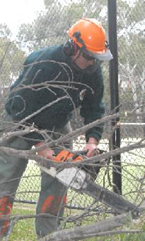  Part of the DPS Mission is to care for Parliament House and its surrounding gardens.  Our Landscape Services team are on the frontline in maintaining these standards, but their achievements in setting the Occupational Health and Safety (OHS) standard in DPS have also been acclaimed.  Jeff is one of the Health and Safety Representatives who volunteered for the role of improving the health and safety of his colleagues. “Gardening and landscaping work requires us to use potentially hazardous equipment including chainsaws, elevated work platforms, and a small fleet of garden vehicles including ride-on mowers and | tractors. All our operators receive regular training in the safe use of our equipment”.  Training is provided to cover other scenarios Landscape Services staff could face. Jeff adds “We’ve got ways to safely handle basic bushfire fighting, storm damage and lightning strikes and fallen trees. Add ultraviolet (UV) awareness and protection for outdoor work, training in occupational first aid (including defibrillator use) and chemical safety and we have a whole range of skills— many of which we are glad we haven’t had to use!”  Landscape Services have sought to make their working environment as safe as possible. Christine, another of the Landscape Services team, has researched the risks associated with hazardous gardening chemicals and substituting them with safer substances. “We’ve investigated and purchased equipment which reduces the amount of manual handling we need to do, and have sourced high-visibility UV-resistant ventilated clothing for outdoor use during summer months”.  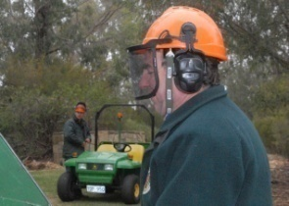  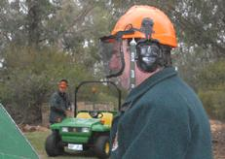
There have been improvements in OHS for staff working inside the building too. For example DPS Support Services has contributed to basement safety by providing regular forklift safety awareness, back-care training, and ensuring corridors are kept as clear as possible; and Hansard, where a major OHS review was undertaken in 2007 and the recommendations of which are currently being implemented.  Lee, a team member in the loading dock, has also noticed the changes. “With the basement a shared pedestrian and vehicle zone, lifts were recently upgraded to improve safety. A voice warning now alerts lift occupants that motorised traffic operates in the basement, while flashing lights warn drivers that the lift doors are about to open”.  Lee says this is “a huge improvement” in terms of reducing the potential for collisions with |  | 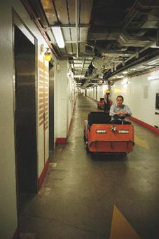  pedestrians, while Peter adds that “clearing the basement has removed hazards and minimised the risk of collision with items that were previously stored there”.
Occupational health and safety (OHS)
  - The DPS Occupational Health and Safety Committee met four times during the year. The work of the committee has primarily been directed at reviewing OHS policies and procedures. The DPS Contractors’ OHS Sub-committee also met four times. This forum provides a valuable mechanism to address OHS issues involving the work performed by the large number of contractors at Parliament House.
  - As a result of revised Health and Safety Management arrangements within DPS, branches are now holding branch OHS Committee meetings to address, as far as possible, OHS issues at the local level.
  - A range of OHS-related training was provided to staff throughout the year, including generic induction and OHS awareness sessions and occupation-specific training including first aid, working in confined spaces, manual handling and back care, basic bushfire fighting, chemical safety and ultraviolet awareness.
  - During the 2007-08 year, five incidents were notified to Comcare in accordance with section 68 of the Occupational Health and Safety (Commonwealth Employment) Act 1991 (the OHS Act). Each incident was also examined by DPS.
  - Comcare did not undertake any formal investigations in relation to any of the reported incidents.
  - There were no Provisional Improvement Notices issued under section 29 of the OHS Act and no directions or notices given under section 45, 46 or 47 of the OHS Act.
Commonwealth Disability Strategy
  - DPS has three roles under the Commonwealth Disability Strategy (CDS)—provider, employer and purchaser.
Provider role
  - DPS is the principal support agency for the operations of Parliament. In providing services to the occupants of and visitors to Parliament House, DPS maintained its compliance with the CDS.
  - In relation to physical changes in the building, the Building and Security Projects Section ensures that all projects are carried out in accordance with the Building Code of Australia (BCA). The BCA requires that Australian Standard 1428 (disabled access requirements) is met in any significant new works.
  - During 2007-08 the following projects and operational policy developments specifically relating to disabled access were undertaken:
additional signage was installed in the Senate and House of Representatives committee rooms and Parliament House theatre to comply with requirements to advise of a ‘T’ switch for hearing aids;
review and update of the building emergency procedures to include provisions for people with a disability;
review and update of security screening procedures to include provision for disabled access to Parliament House;
lowering of the public telephone located at the entrance of Checkpoint One to enable wheelchair access;
modifications to the doorways in the Senate car park to allow disabled access (project approved).
Employer role
  - As required under section 18 of the Parliamentary Service Act 1999, DPS has a workplace diversity program. The existing plan expired in June 2008. Following consultation with DPS staff, the DPS Workplace Diversity Program 2006-2008 was revised and another three year program developed for implementation during 2008-2011. The program is supported by an annual action plan. Both the program and the action plan include provisions to ensure that the department’s employment policies and procedures support equitable working conditions for employees, including those with disabilities.
  - All press and gazette advertising includes a reference to a TTY (Telephone Typewriter) number for potential applicants with hearing or speech disabilities.
  - The ‘reasonable adjustments’ principles are followed in the recruitment and management of staff.
Purchaser role
  - The department’s tender documentation includes a provision that contractors are compliant with their legislative obligations regarding the Disability Discrimination Act 1992.
Purchasing

Overview
  - The purchasing of property and services by DPS during 2007-08 was conducted with the aim of realising core business objectives, while achieving operational effectiveness and value-for-money outcomes. Purchasing was managed in accordance with the Commonwealth Procurement Guidelines (CPGs), and DPS Chief Executive’s Instructions and supporting procedures.
  - DPS’s primary purchasing objectives were:
to ensure the principle of value for money was consistently observed through:
encouraging competition;
promoting efficiency, effectiveness and ethical use of resources; and
conducting our business in an environment of accountability and transparency;
to support the business requirements of each branch within the department through a focus on better-practice procurement; and
to involve small to medium enterprises wherever practicable.
  - DPS has a specialist procurement unit to facilitate and monitor contracting and tendering activity across the department. The procurement unit ensures that established guidelines and procedures are observed and statutory reporting responsibilities are met.
Consultants
  - During 2007-08, 12 new consultancies were entered into involving total actual expenditure of $227,665 (GST inclusive). In addition, 25 ongoing consultancy arrangements were in place from previous years, involving total actual expenditure of $407,861 (GST inclusive) during the reporting year.
  - DPS used a combination of in-house resources and external consultants to deliver services according to the nature of each requirement. Private sector specialists were engaged under panel or discrete contract arrangements to provide the skills and expertise necessary to assist with the achievement of DPS objectives.
  - It is the policy of DPS to engage external consultants where they will add genuine value to the operational effectiveness of the department. Each proposal to engage a consultant is carefully scrutinised and considered on its individual merits, and justifying reasons include:
need for independent research or assessment;
a need for specialised or professional skills; and
skills currently unavailable within the agency.
  - The method of procurement for consultants is determined by the complexity, nature and value of each specific requirement. The methods used include open tendering, select tendering, or a direct sourcing arrangement. The method chosen is that which will achieve the best value-for-money outcome in each circumstance, and the Mandatory Procurement Procedures within the CPGs are applied where appropriate.
  - DPS currently has in place standing offer panel arrangements for the following consultancy services:
legal;
architectural;
engineering;
information technology;
audit; and
building management.
  - Particulars of consultancy contracts awarded to the value of $10,000 or more during 2007-08 are shown Appendix A (see page 221).
  - Information about expenditure on contracts and consultancies is also available on the AusTender website (http://www.tenders.gov.au).
Competitive tendering and contracting
  - During 2007-08, DPS did not allow any provisions in contracts prohibiting the Auditor-General’s access. DPS did not conduct any competitive tendering and contracting processes that involved contracting out the delivery of government activities, previously performed by this agency, to another organisation.

Exempt contracts
  - During 2007-08, no DPS contracts or standing offers were exempted by the Chief Executive from being published via AusTender on the basis that they would disclose exempt matters under the Freedom of Information Act 1982.

Asset management
  - The Parliament House building has a current replacement cost of $1.85 billion and an expected remaining life of some 186 years. The building represents a public investment, is a national and international tourist attraction and is an eminent work of architecture. The building is expected to accommodate growth and to adapt to the changing functional requirements of parliament.
  - DPS provides asset management services to Parliament House. We have implemented sophisticated asset management systems to ensure that the building fulfils its role as a functional parliamentary building, an office for the executive government and a publicly accessible place of significant community interest.
  - Asset management approaches used by DPS include building management and maintenance management systems, condition monitoring, asset management plans for five, 20 and 100 years, performance standards and benchmarking. Supported by planners and trade staff, these complementary management tools combine to ensure appropriate levels of condition and serviceability are maintained in a cost-effective manner.
  - We use a series of performance indices to measure asset management performance, including:
the Building Condition Index (BCI), which measures the current condition of the building fabric of Parliament House. A discussion on BCI performance and outcomes can be found in Part 4 of this report—see paragraphs and 263 to 264;
the Engineering Systems Condition Index (ESCI), which measures the current operation and condition of the engineering systems in Parliament House. A discussion on ESCI performance and outcomes can be found in Part 4 of this report—see paragraphs 267 to 268; and
the Landscape Condition Index (LCI), which measures the current condition of the landscape surrounding Parliament House. A discussion on LCI performance and outcomes can be found in Part 4 of this report—see paragraphs 265 to 266.
  - Other major assets of DPS comprise information technology, telecommunications, broadcasting and security infrastructure, equipment and systems, and the Parliament House Art Collection. A plant and equipment stocktake is conducted annually, including for information technology and office equipment, and the details recorded in the DPS asset register are confirmed or amended.

Accountability

External scrutiny

ANAO audits
  - During 2007–08, DPS was the subject of external performance and compliance audits by the ANAO in relation to its financial statements for the period ending 30 June 2007. These audits were unqualified.
  - The ANAO audits the compliance of agencies with the Senate Order for Departmental and Agency Contracts (the Senate Order) that requires the listing of contract details on the internet. As a parliamentary department, DPS is not required to comply with the Senate Order, but has chosen to do so. DPS was not selected for review during the 2007 calendar year.
  - Apart from ANAO Report No. 18 of 2007–08, which looked at the Audits of the Financial Statements of Australian Government Entities for the Period Ended 30 June 2007, there were no ANAO reports during 2007-08 that directly involved DPS.
Senate committees
  - DPS appeared before the Senate Finance and Public Administration Committee considering the department’s estimates on two occasions during 2007-08—18 February 2008 (Additional Estimates hearings) and 26 May 2008 (Budget Estimates hearings). Supplementary Budget Estimates hearings, scheduled for 12 November 2007, were not held due to the federal election.

Other scrutiny
  - DPS was not subject to any significant judicial decisions or decisions of administrative tribunals, nor did the Ombudsman report on the activities of DPS in 2007-08.

Freedom of information
  - While DPS is not subject to the provisions of the Freedom of Information Act 1982 (the FOI Act), DPS generally tries to respond to requests for information in accordance with the spirit of that Act.
  - DPS maintains documentation on its daily operations, the Parliamentary Library catalogue, the Hansard record, a large number of systems manuals, the ‘as-constructed’ drawings of Parliament House, and the Central Reference Document (a document that describes the principles underpinning the design of Parliament House).
  - When inquiries for information under the FOI Act are made, such requests are referred to the Director, Governance and Business Management.
  - In 2007–08, one request for information was received.

Discretionary grants
  - DPS does not administer any discretionary grant programs.

Advertising costs
  - All Commonwealth departments and agencies are required, under section 311A of the Commonwealth Electoral Act 1918, to provide a statement setting out particulars of amounts paid to:
advertising agencies;
market research organisations;
polling organisations;
direct mail organisations; and
media advertising organisations.

  - Figure 57—Advertising costs sets out amounts over $10,000 paid by DPS during the reporting year. No money was paid to any organisation covered in paragraph (b), (c) or (d).
Figure 57—Advertising costs
Supplier | Item | Amount  (GST inclusive)
Zoo Communications Pty Ltd | Parliament House promotional materials | $59,451
The Watermark Press | Parliament House book | $25,480
HMA Blaze | Tender advertisements | $8,995
HMA Blaze | Recruitment advertisements | $172,709
Total |  | $266,635
Legal services expenditure
  - The Legal Services Directions 2005 (paragraph 11.1(ba)) require FMA Act agencies to make publicly available their expenditure on legal services. During 2007–08, DPS spent the following amounts on legal services.
Figure 58—Legal services expenditure
Services | Amount  (GST exclusive)
External expenditure on solicitors | $192,638
Administrative disbursements on external legal services | $337
Total (legal services expenditure—all external) | $192,975

Financial Statements

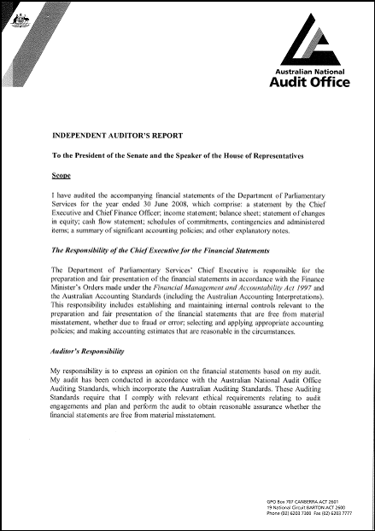
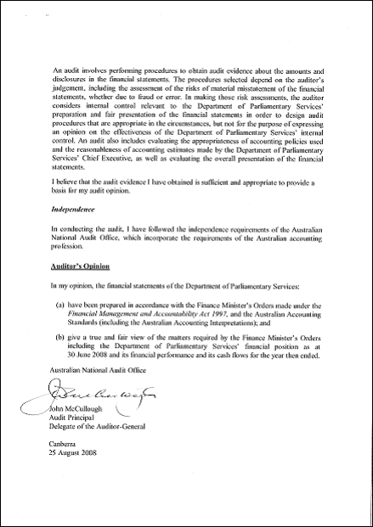

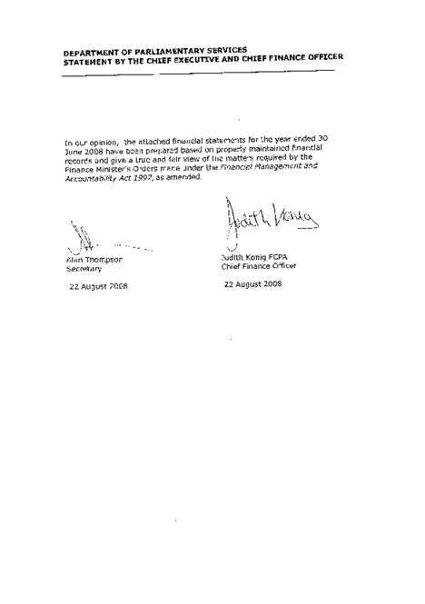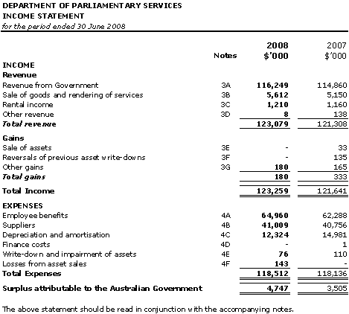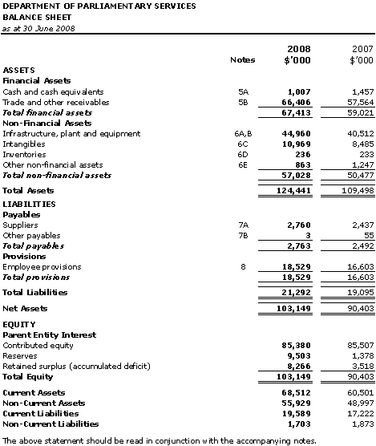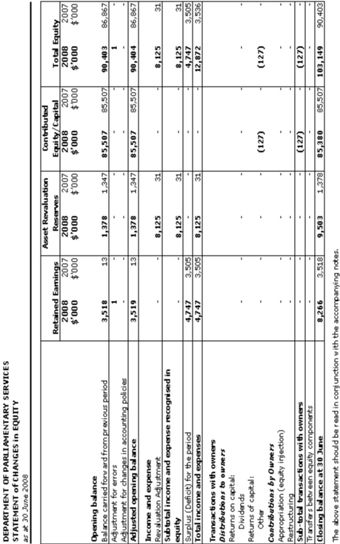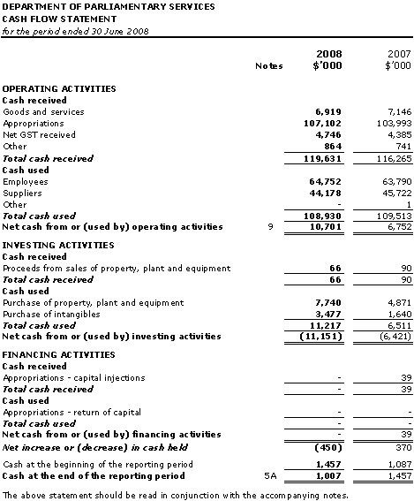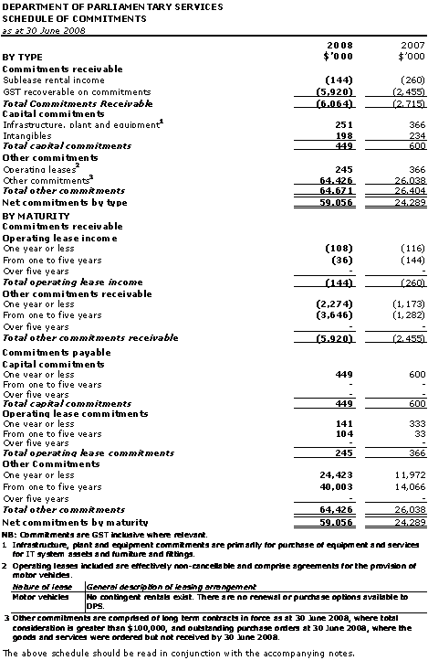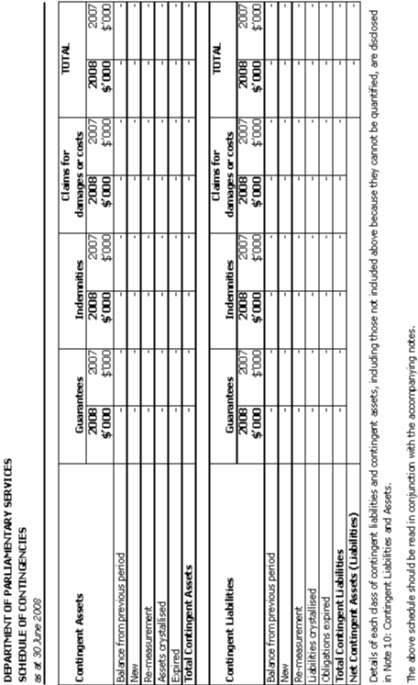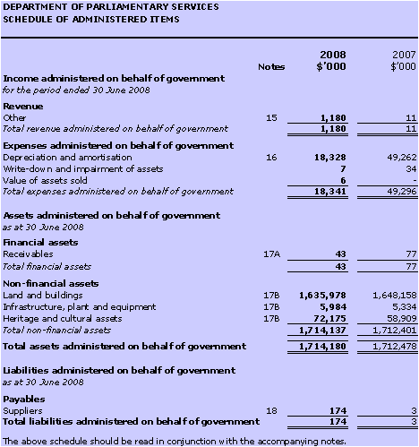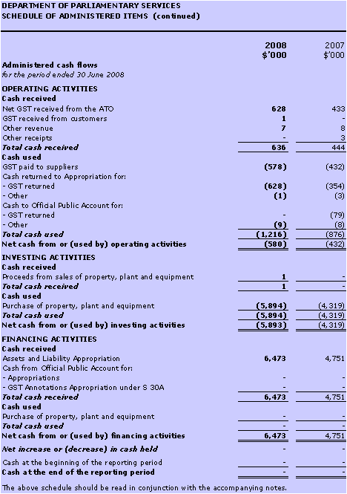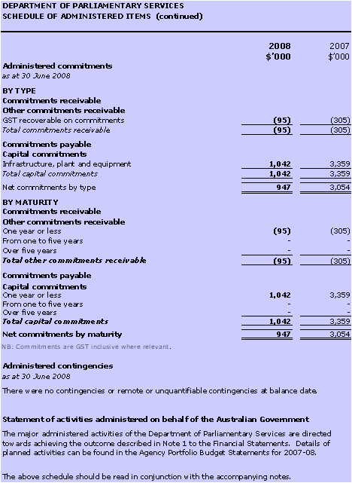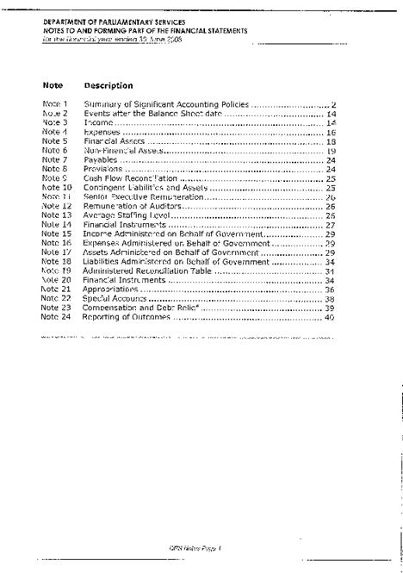

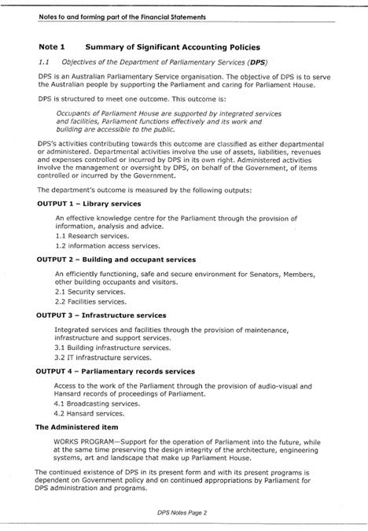

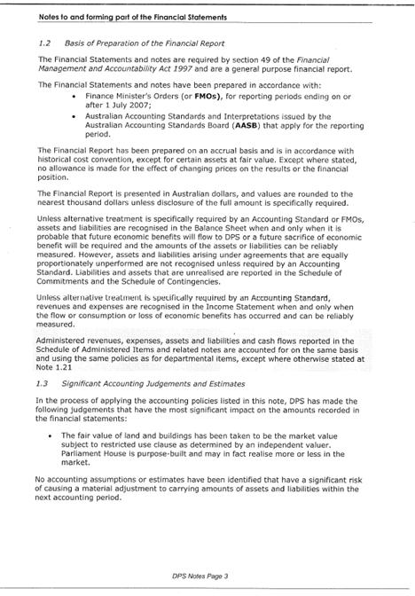

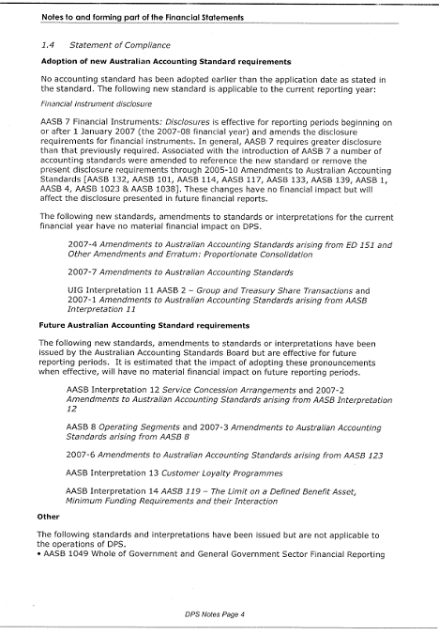

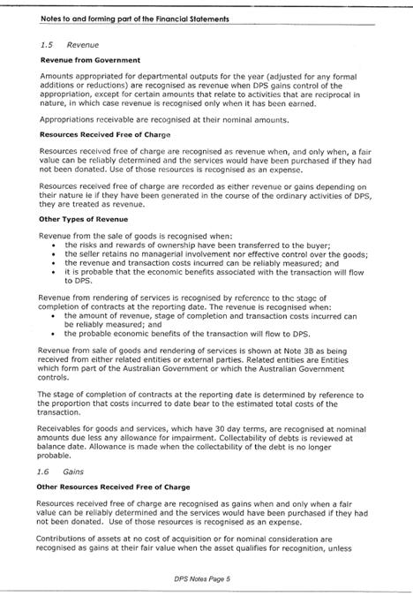
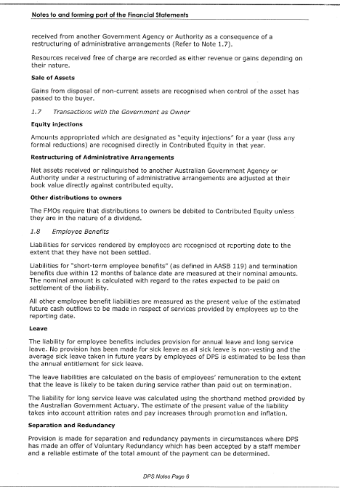
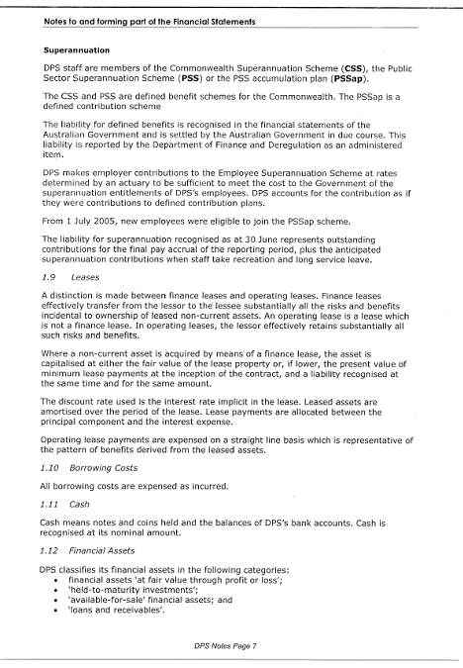
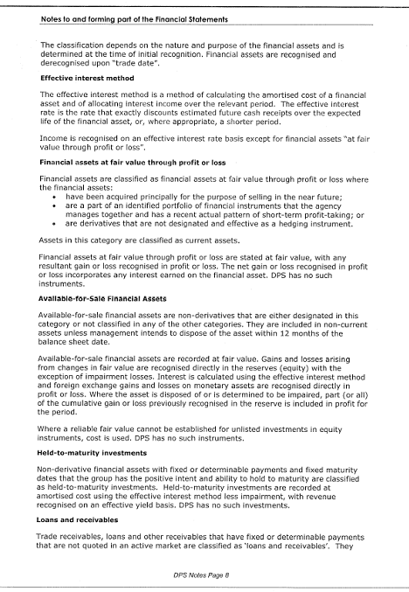
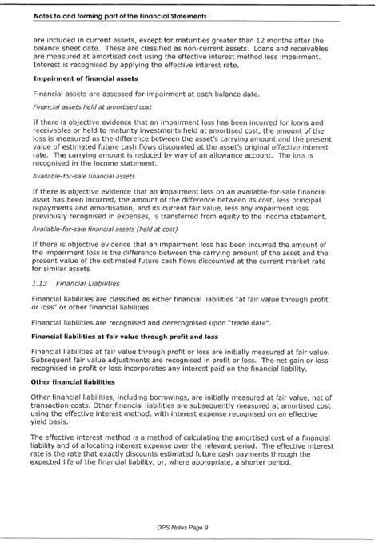
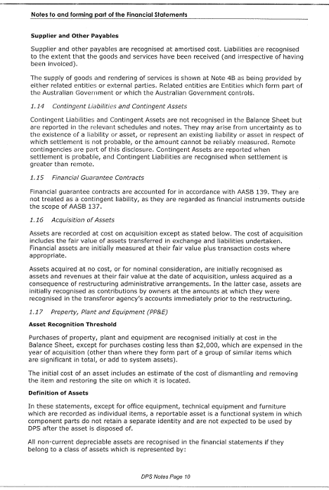
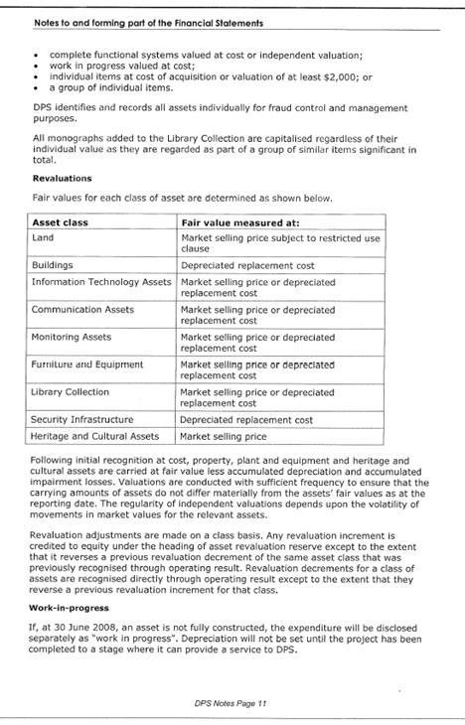
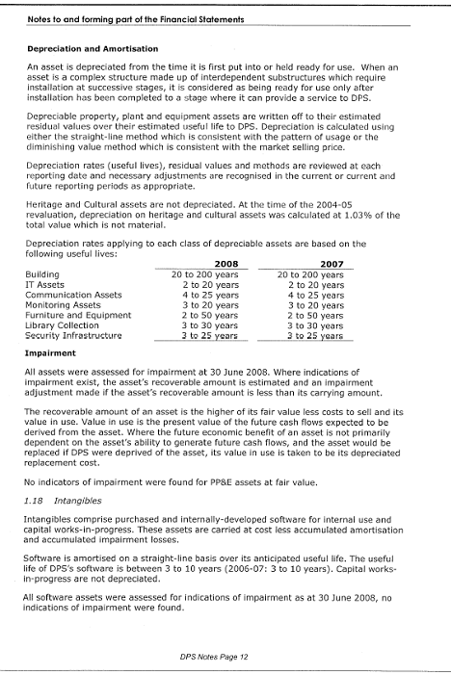
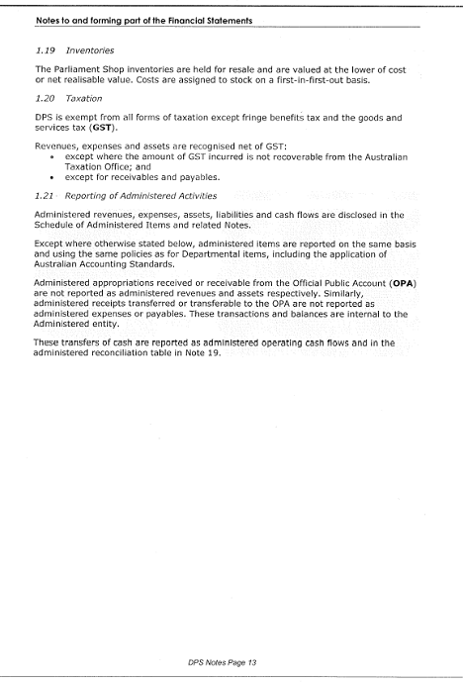
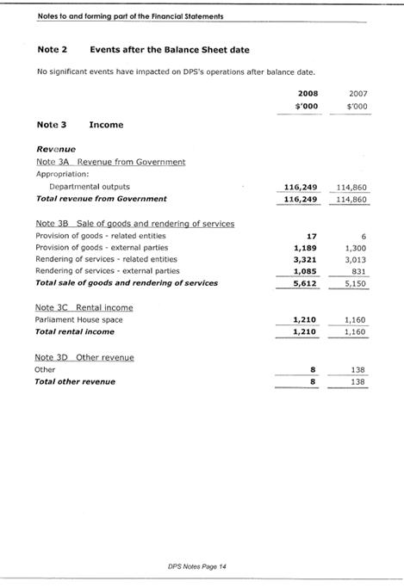
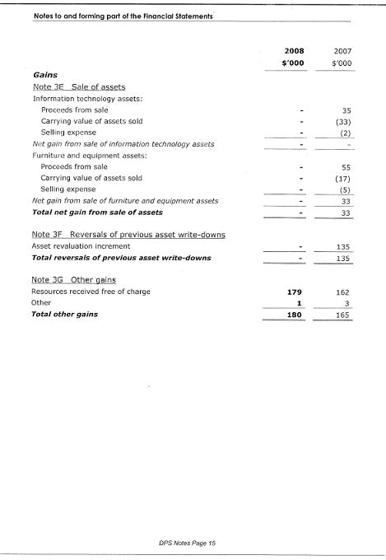
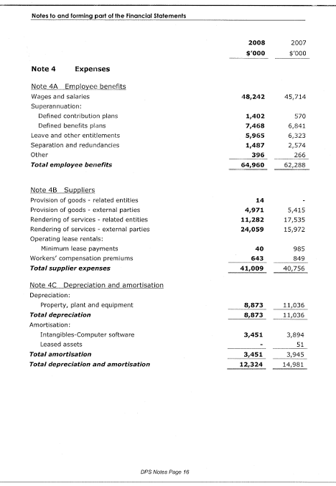
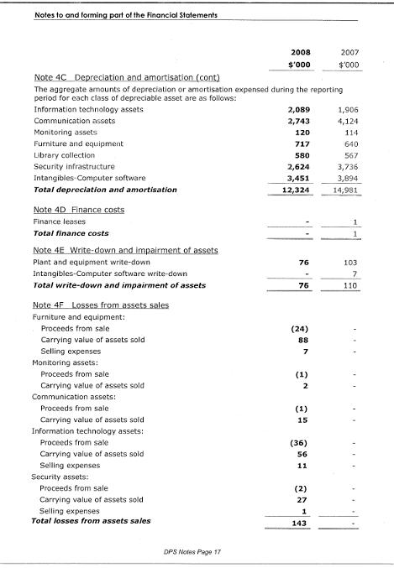
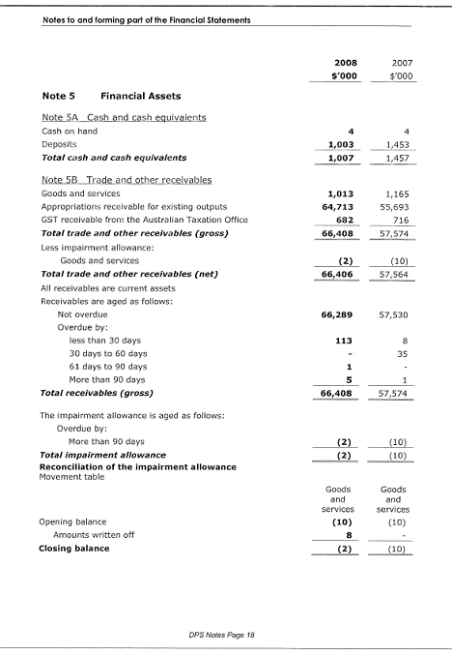
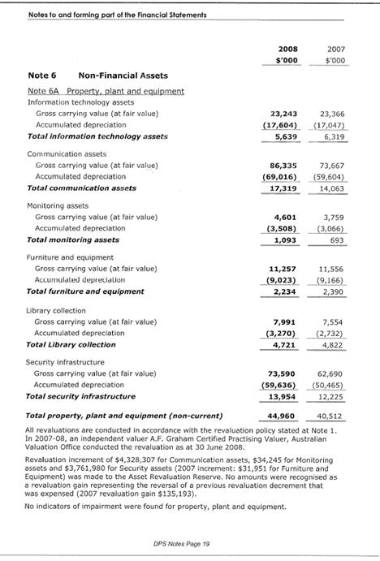
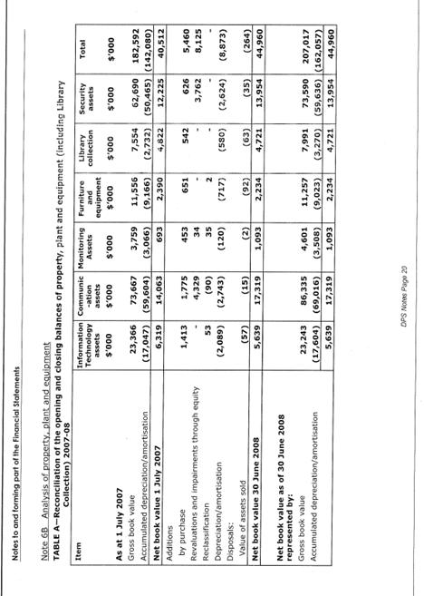
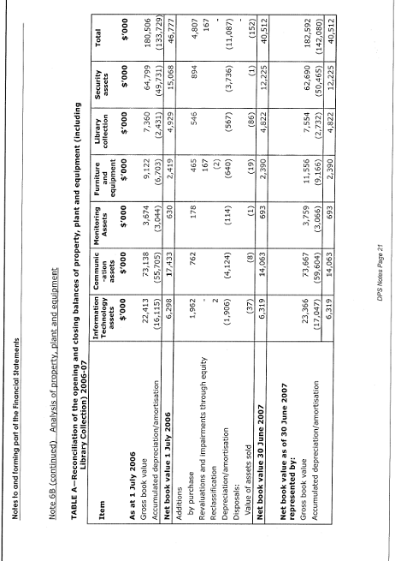
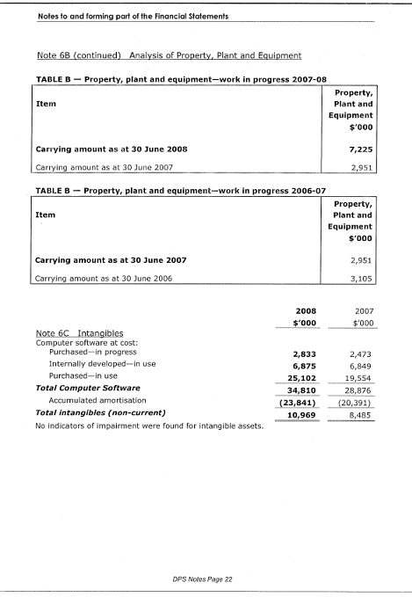
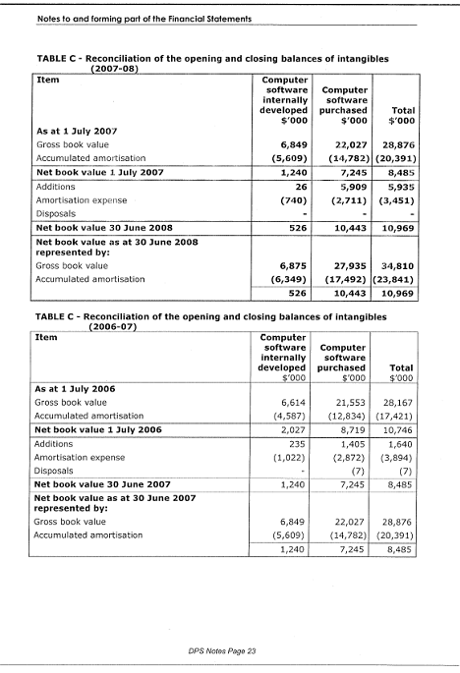
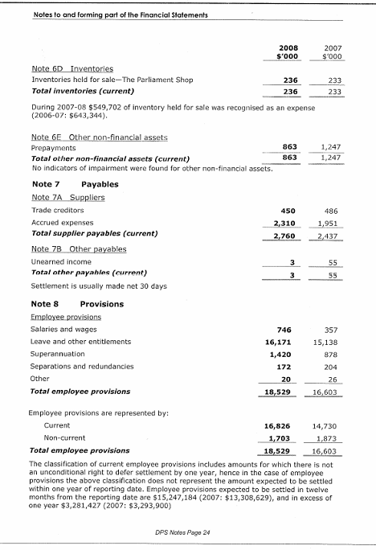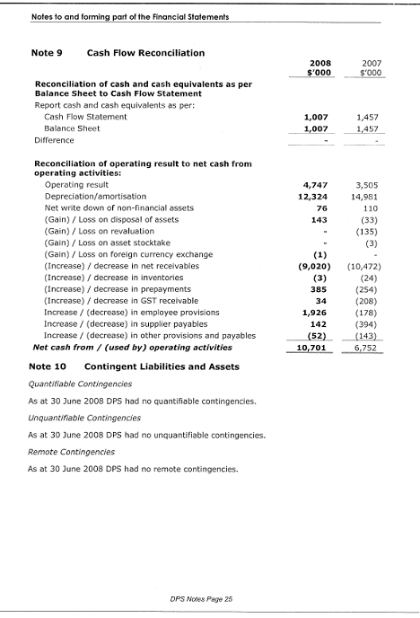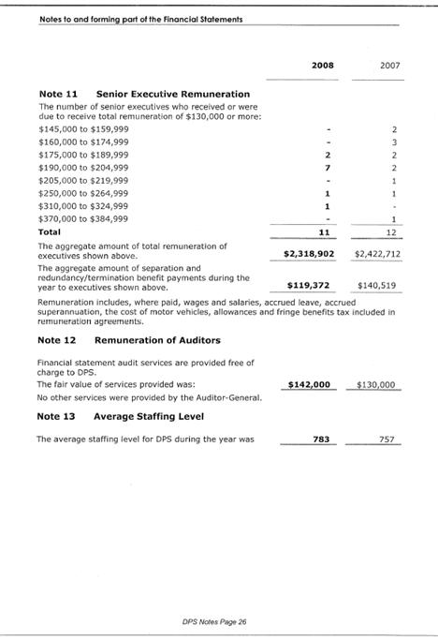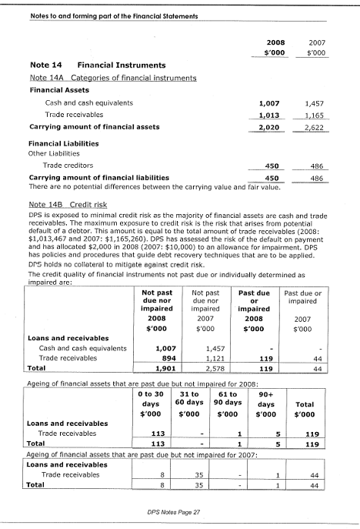
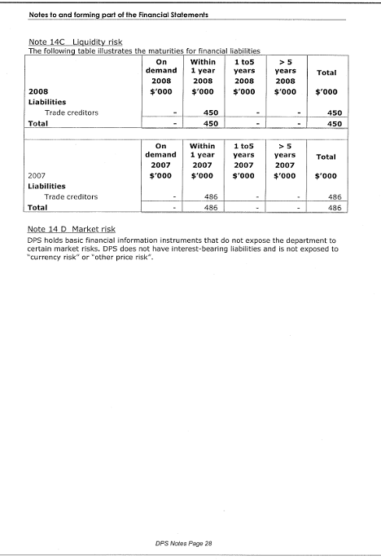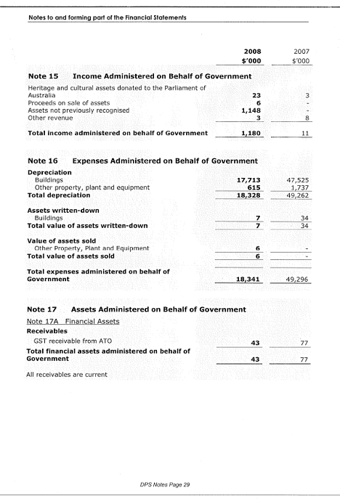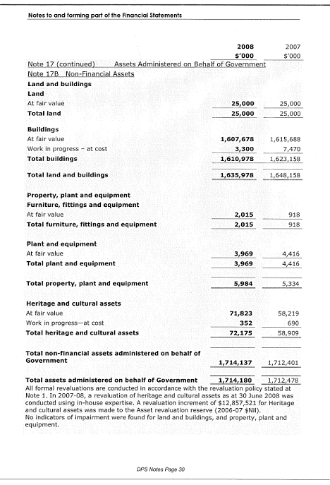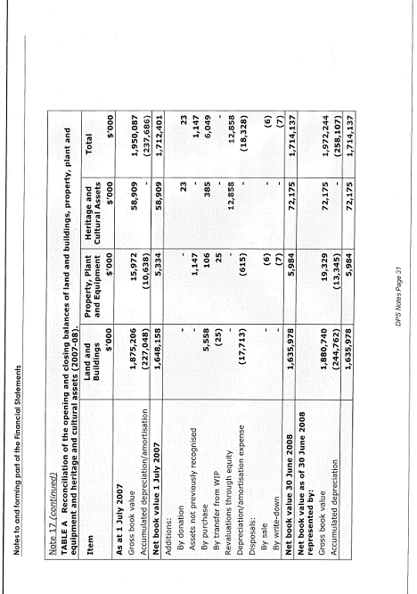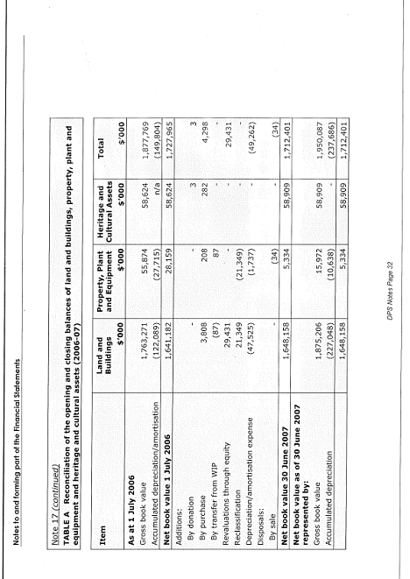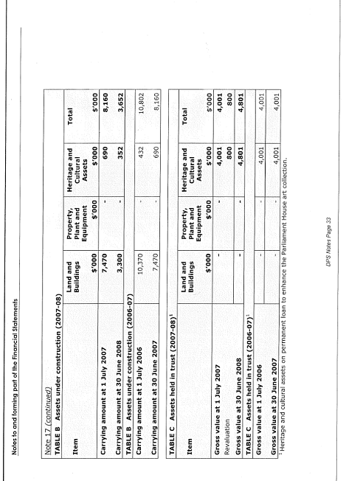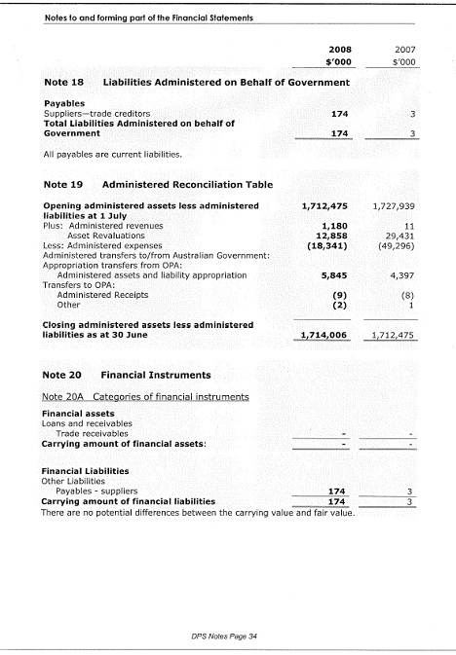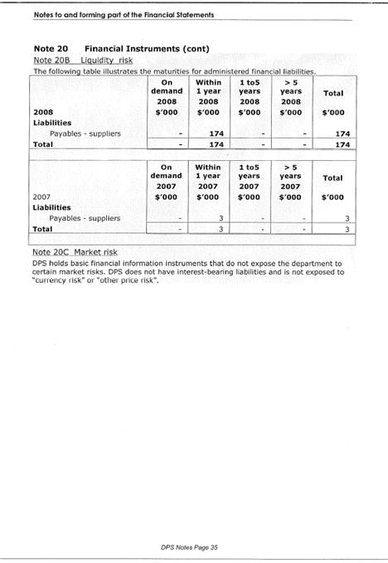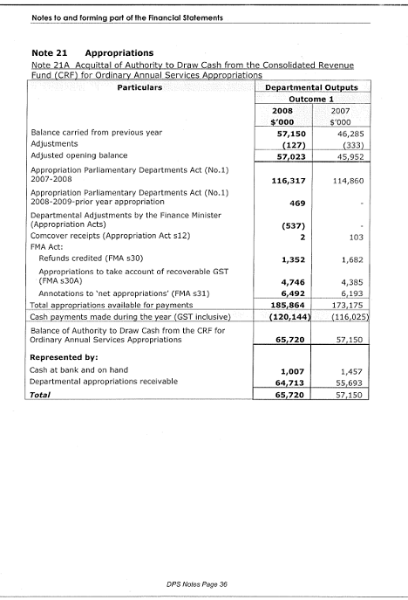
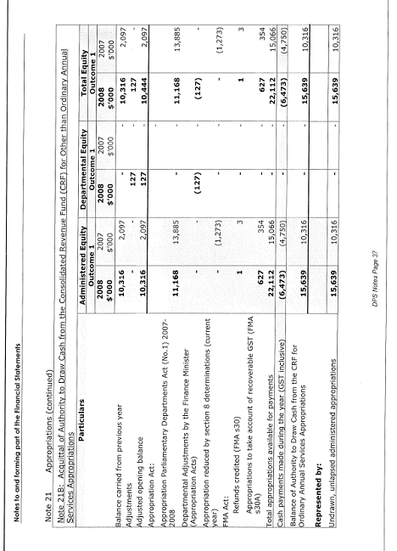

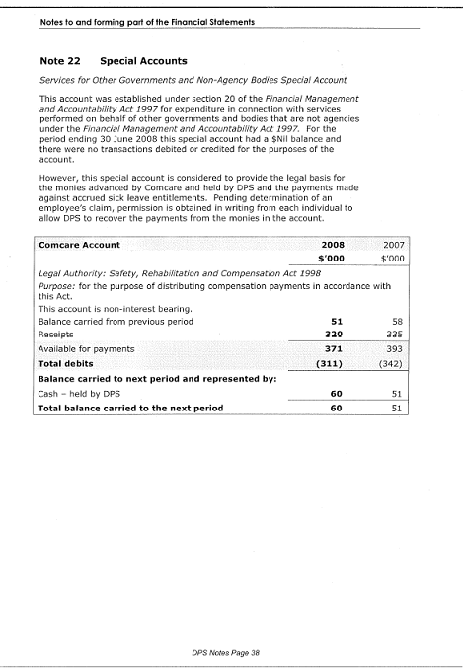
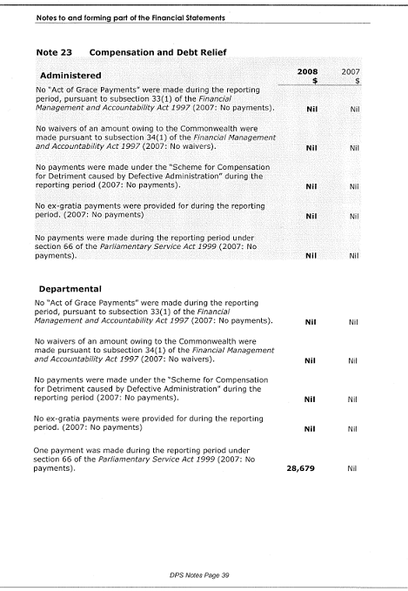
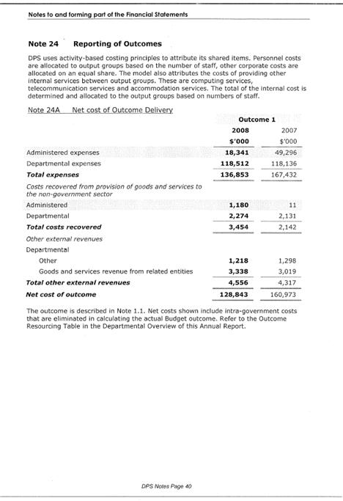
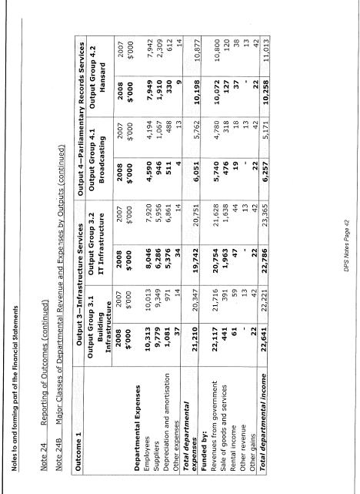
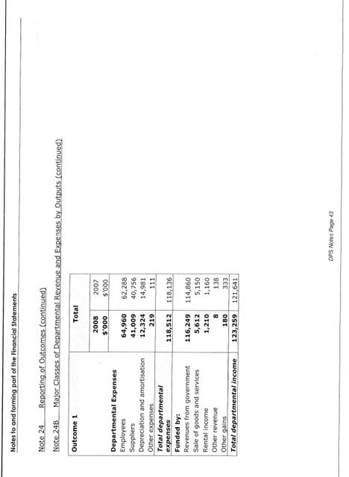
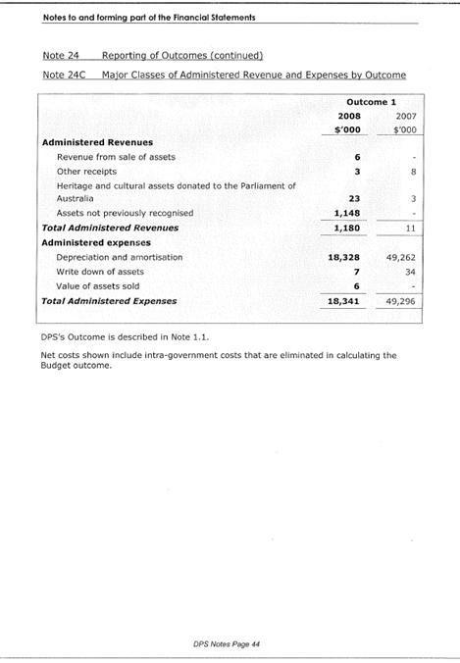

Appendices

Appendix A—Consultancy services 2007-08
Table 1: Consultancy expenditure for 2007-08 for $10,000 or more
Consultant | Description | Contract Price | Selection process⁽¹⁾ | Justification⁽²⁾
Walter Turnbull  (Internal audits) | IT Governance | $13,740 | Panel | C
Walter Turnbull  (Internal audits) | Financial processing Phase one | $13,196 | Panel | C
Walter Turnbull  (Internal audits) | Recruitment Processes | $20,398 | Panel | C
Walter Turnbull  (Internal audits) | Security roster system | $10,766 | Panel | C
Walter Turnbull  (Internal audits) | Contract management | $18,843 | Panel | C
Walter Turnbull  (Internal audits) | Taxation compliance | $15,881 | Panel | C
Walter Turnbull  (Internal audits) | Environmental governance | $12,375 | Panel | C
Walter Turnbull  (Internal audits) | PSS Leave Purchasing | $16,043 | Panel | C
Walter Turnbull  (Internal audits) | PSS night shift premium | $10,560 | Panel | C
Services for Art | Provision of art consultancy services | $65,526 | Open source | B
R D Gossip Pty Ltd | Post operational review - one way road project | $10,228 | Direct source | B
Northrop Consulting Engineers Pty Ltd | Lighting improvements for pedestrians at Parliament House | $68,805 | Open source | B
CRS Australia | Hansard OHS Audit | $14,575 | Restricted source | C
Foodservice Consultants Australia Pty Ltd | catering equipment assessment and replacement strategy | $40,662 | Direct source | B
Access UTS Pty Ltd | Advice on pest control service requirements at Parliament House | $15,477 | Direct source | B
Yarrimbah Consulting Pty Ltd | S33 Review of actions re performance management assessment ratings | $19,800 | Restricted source | A
Australian Government Solicitor | ADJR act advice | $21,371 | Panel | B
Grey Advantage Consulting Pty Ltd | Financial viability of the catering contracts | $19,820 | Direct source | C
Consultant | Description | Contract Price | Selection process⁽¹⁾ | Justification⁽²⁾
EMC Professional Services | Design solution for electoral office | $32,000 | Direct source | C
TOTAL |  | $440,065
(1) Explanation of selection process terms:
Direct sourcing: A single potential supplier is invited to bid because of their unique expertise and their special ability to supply the services sought.
Restricted sourcing: A number of potential suppliers are invited to bid because of their unique expertise and their special ability to supply the services sought.
Open sourcing: An opportunity for any potential supplier to bid to supply the services sought.
Panel: An arrangement under which a number of suppliers, usually selected through a single procurement process, may each supply services to the Department as specified in the panel arrangements. This category includes standing offers and supplier panels where the consultant offers to supply services for a pre-determined length of time, usually at a pre-arranged price.
(2) Justification for decision to use consultancy:
A Need for independent research or assessment
B Need for specialised or professional skills
C Skills currently unavailable within agency

Appendix B—Material errors in 2006-07 annual report
Value of the building
  - In the DPS Annual Report 2006-07 the replacement cost of Parliament House was stated as $1.62 billion. This amount was the Net Book Value. The replacement cost—at that time—was $1.84 billion.
Parliamentary Library staffing numbers
  - A mathematical error resulted in the total number of Parliamentary Library staff being reported as 132.64 in the DPS Annual Report 2006-07. The correct total for the 2006-07 year is 135.64.

Glossary
Set out below is a glossary of technical terms, or ordinary words used technically, and a list of acronyms and abbreviations used in this document.
Accrual accounting—The system of accounting where items are brought to account as they are earned or incurred (and not as cash received or paid) and included in the financial statements for the periods to which they relate.
Administered items—Expenses, revenues, assets or liabilities managed by agencies on behalf of the Commonwealth. Agencies do not control administered items. Administered expenses include grants, subsidies and benefits. In many cases, administered expenses fund the delivery of third party outputs.
AFP-Uniformed Protection—A part of the AFP’s Protection portfolio, AFP-Uniformed Protection (AFP-UP) ensures that individuals and interests identified to be at risk by the Commonwealth are kept safe and have their dignity preserved. AFP-UP provides protective security for Commonwealth Government facilities (including Parliament House) and personnel in a variety of locations throughout Australia and overseas.
Agencies—The basic unit of organisation covered by the budget, and focus for assessing management performance and implementing government policy. Agencies are Departments of State (eg the Department of Finance and Administration), parliamentary departments (eg DPS) and other agencies prescribed under the Financial Management and Accountability Act 1997 (eg the Australian Taxation Office). Authorities are bodies corporate (eg the Australian Broadcasting Corporation) which are, for legal purposes, entities in their own right in that they are separate from the Commonwealth Government and are governed by the Commonwealth Authorities and Companies Act 1997.
Appropriation—An authorisation by Parliament to spend monies from the Consolidated Revenue Fund.
Assets—Future economic benefits controlled by an entity as a result of past transactions or future events.
Authorities—see Agencies.
Building Condition Index—A measurement of the current condition of the maintenance of the building, expressed as a percentage of the original condition.
Building fabric—The basic elements making up a building; the carcass without finishings or decoration.
Business model—A business model describes a broad range of informal and formal models that are used to represent various aspects of business, such as operational processes, organisational structures and financial forecasts.
Capital expenditure—Expenditure by an agency on capital projects, for example purchasing a building.
Cash accounting—The system of accounting that records cash receipts, payments and balances and provides reports that show the sources of cash and how cash was used.
Chamber departments—The Department of the Senate and the Department of the House of Representatives, so called because each supports a “chamber” of the Commonwealth Parliament.
Chief Executive—The ultimate level of individual responsibility within an agency. In the case of DPS, synonymous with “Secretary”.
Chief Executive’s Instructions—Procedural instructions given by a Chief Executive to manage the affairs of the department in a way that promotes the efficient, effective and ethical use of Commonwealth resources.
Closed circuit television—Known as CCTV, the expression refers to the use of television cameras for surveillance purposes. Unlike broadcast television, all devices are linked directly, usually by cables. CCTV pictures are viewed and/or recorded, but are not broadcast.
Comcare—Comcare is the workers’ compensation insurer for the Commonwealth Government, providing safety, rehabilitation and compensation services to Commonwealth employees (and employees of the ACT Government) under the auspices of the Safety, Rehabilitation and Compensation Commission.
Competitive tendering and contracting—Represents the process of contracting out the delivery of government activities that were previously performed by a Commonwealth agency, to another organisation following a competitive tendering process.
Comcover—Comcover is the Commonwealth’s self-managed fund for insurable risk.
Consolidated Revenue Fund—Section 81 of the Constitution stipulates that all revenue raised or money received by the Commonwealth forms the one consolidated revenue fund (CRF). The CRF is not a bank account. The Official Public Account reflects most of the operations of the CRF.
Continuous improvement review (CIR)—Both DPS Certified Agreements set out that all parts of DPS will be reviewed over the life of the agreements. A key objective of the CIRs is to find more cost-effective and efficient means of delivering services.
Corporate governance—The structures and processes employed by an organisation to facilitate accountability to stakeholders, as well as successful performance. It is generally understood to encompass authority, accountability, stewardship, leadership, direction and control.
Departmental items—Assets, liabilities, revenues and expenses which are controlled by the agency in providing its outputs. Departmental items would generally include computers, plant and equipment assets used by agencies in providing goods and services and most employee expenses, supplier costs and other administrative expenses incurred.
Design Integrity Index—A measurement of the current condition of the building, assessed against the Design Integrity Indicators and expressed as a percentage of the original condition.
DPS Services Catalogue—A catalogue providing information about the services available from the Department of Parliamentary Services
Emergency Control Committee—An inter-departmental committee to coordinate fire and emergency arrangements, procedures and policy among Parliament House building occupants.
Engineering Systems Condition Index—A measurement of the current operation and condition of the engineering systems in Parliament House against the expected decline of those systems through their life cycles.
Equity—The residual interest in the assets of a reporting entity after deduction of its liabilities.
Expenses—Consumption or losses of future economic benefits in the form of reductions in assets or increases in liabilities of the entity.
Fabric—see Building fabric
Financial Management and Accountability Act 1997 (FMA Act)—The principal legislation governing the proper use and management of public property and other Commonwealth resources by Commonwealth agencies. FMA Regulations and FMA Orders are made pursuant to the FMA Act.
Financial results—The results shown in the financial statements of an entity.
Gift Collection—See Parliament House Art Collection
Hansard—Hard copy and electronic reports of proceedings in the Senate, the House of Representatives and the Main Committee of the House of Representatives and transcripts of parliamentary committees and some ministerial or parliament-related conferences. (from the CSBH portal).
Historic Memorials Collection—See Parliament House Art Collection
The Landscape Condition Index—A measurement of the current condition of the landscape surrounding Parliament House, expressed as a percentage of the total possible condition.
Liabilities—Future sacrifices of economic benefits that the entity is presently obliged to make to other entities as a result of past transactions or other past events.
Materiality—This concept is assessed taking into account the planned outcome and the relative significance of the resources consumed in contributing to the achievement of that outcome.
Operating result—The difference between revenues and expenses; either a surplus or a deficit.
Outcomes—Results, impacts or consequences of actions by the Commonwealth on the Australian community. Outcomes are the results or impacts that the government wishes to achieve. Actual outcomes are the results or impacts actually achieved.
Output groups—The aggregation of outputs, based on a consistent type of product or beneficiary target group. Aggregation may also be needed for the provision of adequate information for performance monitoring, or based on a materiality test.
Outputs—The goods and services produced by agencies on behalf of government for external organisations or individuals. Outputs include goods and services produced for other areas of government external to the agency.
Parliament House Art Collection—Comprises a number of stand-alone collections (the Rotational Collection, the Architectural Commissions, the Historic Memorials Collection, the Gift Collection, the Constitutional Documents and the Archive).
Parliamentary precincts—The parliamentary precincts are defined in the Parliamentary Precincts Act 1988; in general terms they consist of the area within the inner kerb of Capital Circle, and all buildings, structures and works, and parts of buildings, structures and works, on, above or under that land.
Performance information—Provides evidence about performance that is collected and used systematically, and that may relate to appropriateness, effectiveness and efficiency and the extent to which an outcome can be attributed to an intervention. Performance information may be quantitative (numerical) or qualitative (descriptive); however, it should be verifiable. Performance measures are more precise than indicators, and are used when there is a causal link between an intervention and a measurable change in performance.
Portfolio Budget Statements—Statements prepared by agencies to explain the Budget appropriations in terms of outcomes and outputs.
Purchaser/provider arrangements—Includes arrangements under which the outputs of one agency are purchased by another agency to contribute to the other agency’s outcomes.
Presiding Officers—Two members of parliament elected to preside over, or be in charge of, the business, proceedings and administration of a house of parliament. In the Senate the presiding officer is called the President, and in the House of Representatives, the Speaker.
Price—The amount the government or the community pays for the delivery of agreed outputs.
Quality—Relates to the characteristics by which customers or stakeholders judge an organisation, product or service. Assessment of quality involves use of information gathered from interested parties to identify differences between users’ expectations and experiences.
Quantity—The size of an output.
Receipts—The total or gross amount received by the Commonwealth. Each receipt item is either revenue, an offset within outlays, or financing transactions. Receipts include taxes, interest, charges for goods and services, borrowings and government business enterprise dividends received.
Security Management Board—This body is established by the Parliamentary Service Act 1999, and provides advice as required to the Presiding Officers on security policy, and the management of security measures, for Parliament House. The Board has three members, who may, with the Presiding Officers’ permission, invite others to attend their meetings.
Service charter—A public statement about the service that a department will provide and what clients can expect from the department. It is government policy that departments that provide services direct to the public have service charters in place.
Staff dinning room—The staff dinning room is also referred to as the Staff Cafeteria or the Staff Café.

Table Office—The office within the Department of the Senate or the Department of the House of Representatives which provides documentary and advisory support to facilitate the effective operation of the parliamentary chambers.
Third party outputs—Goods or services delivered to the community by entities outside the Commonwealth general government sector. They are outputs wholly or partly funded by administered items and are directed to achieving planned outcomes.

Acronyms and abbreviations

AFP | Australian Federal Police
AFP-UP | Australian Federal Police – Uniform Protection
ANAO | Australian National Audit Office
AWA | Australian Workplace Agreement
BCA | Building Code of Australia
BCI | Building Condition Index
BDMP | Broadcast and Digital Media Projects
BFG | Broadcast Facsimile Gateway
BSB | Building Services Branch
CA | Certified Agreement
CCTV | Closed Circuit Television
CDS | Commonwealth Disability Strategy
CEI | Chief Executive’s Instruction
CEO | Chief Executive Officer
CEP | Central Enquiry Point (Library)
CEP | Chief Executive Procedure
CFO | Chief Finance Officer
CIR | Continuous improvement review
CMB | Content Management Branch
CPG | Commonwealth Procurement Guidelines
DI | Design integrity
DII | Design Integrity Index
DPS | Department of Parliamentary Services
EAP | Employee assistance provider
EMMS | Electronic Media Monitoring Service
EMS | Environmental management system
ESCI | Engineering Systems Condition Index
ESD | Ecologically sustainable development
Finance | Department of Finance and Administration
FOI | Freedom of Information
GJ | Gigajoule (a joule is a measure of energy; giga is 10⁹)
HCO | Harassment Contact Officer
IAB | Information Access Branch
ICT | Information and communications technology
IDP | Individual development plan
ISB | Infrastructure Services Branch
ITSA | Information Technology Security Adviser
JHC | Joint House Committee
kL | Kilolitre (1,000 litres)
LCI | Landscape Condition Index
OHS | Occupational health and safety
OneOffice | Parliamentary computing platform
ParlInfo | Parliamentary information system
PBS | Portfolio Budget Statement
PCN | Parliamentary Computing Network
PHAC | Parliament House Art Collection
PMAS | People Management and Strategy Section
POITAG | Presiding Officers’ Information Technology Advisory Group
PSDB | Product and Service Development Branch
PSLO | Parliamentary Service Liaison Officer
PSS | Parliamentary Security Service
RAP | Request approval process
RB | Research Branch
SBSB | Strategy and Business Services Branch
SES | Senior Executive Service
TIPS | Threat Image Protection System
VBIEDs | Vehicle-borne improvised explosive devices

Compliance index
The Department of Parliamentary Services is required to present its annual report to each House of the Parliament under paragraph 65(1)(c) of the Parliamentary Service Act 1999.
Under subsection 65(2) of the Parliamentary Service Act 1999, the department’s annual report must be prepared in accordance with guidelines approved on behalf of the Parliament by the Joint Committee of Public Accounts and Audit (JCPAA). The Requirements for annual reports for departments, executive agencies and FMA Act bodies (the Requirements) were revised and reissued in June 2008.
The Requirements stipulate a core set of mandatory information which must be included in annual reports to ensure that accountability requirements are met and to provide consistency for readers. There are other items which are suggested for inclusion on the basis of making the annual report as informative as possible.
The following table shows where the mandatory information specified by the Requirements may be found in this report.

Part of report | Requirement item | Location
 | Letters of transmittal | Pages iii and v
Aids to access | Table of contents | Page vii
 | Index | Page 243
 | Glossary | Page 225
 | Abbreviations and acronyms | Page 231
 | Contact officer | Page ii
 | Internet address | Page ii
Part 1—Secretary’s review | Review by departmental Secretary | Pages 3 to 7
 | Summary of significant issues and developments | Pages 3 to 7
 | Overview of department’s performance and financial results | Pages 3 to 7
 | Outlook for 2008-09 | Pages 3 to 7
Part 2—Departmental overview | Description of department | Paragraphs 1 and 2
 | Role and functions | Paragraph 3
 | Organisational structure | Paragraphs 4 to 12
 | Outcome and output structure | Figure 11
 | Where outcome and outputs structures differ from PBS format, details of variation and reasons for change | Not applicable
Part 4—Report on performance | Review of performance in relation to outputs and contribution to outcome | Paragraphs 210to 217  Paragraphs 162 to 203 (Parliamentary Library)
 | Actual results against performance targets set out in PBS | Paragraphs 218 to 363  Paragraphs 162 to 203 (Parliamentary Library)
 | Performance of purchaser / provider arrangements | Paragraphs 353 to 361
 | Where performance targets differ from the PBS, details of both former and new targets, and reasons for the change | Not applicable
 | Narrative discussion and analysis of performance | Paragraphs 218 to 363  Paragraphs 162 to 203 (Parliamentary Library)
 | Performance against service charter customer service standards, complaints data, and the department’s response to complaints
 | Discussion and analysis of financial performance | Financial statements, pages 163 to 218
 | Summary resource tables by outputs | Note 24 to financial statements
 | Developments since the end of the financial year that have affected or may significantly affect the department’s operations or financial results in future | Not applicable
Part 6—Management and accountability |  | Paragraphs 463 to 581
Corporate governance | Statement of the main corporate governance practices in place | Paragraphs 463 to 581
 | Senior management committees and their roles | Paragraphs 463 to 513
 | Corporate and operational planning and associated performance reporting and review | Paragraphs 505 to 507
 | Identification of areas of significant financial or operational risk and arrangements in place to manage risks | Paragraphs 493 to 494
 | Certification of department’s compliance with the Commonwealth Fraud Control Guidelines | Page 146
 | Maintenance of appropriate ethical standards | Paragraph 513
External scrutiny | Significant developments in external scrutiny | Paragraphs 569 to 573
 | Judicial decisions and decisions of administrative tribunals | Paragraph 573
 | Reports by the Auditor-General, a Parliamentary Committee or the Commonwealth Ombudsman | Paragraphs 569 to 571
Management of human resources | Assessment of effectiveness in managing and developing human resources | Paragraphs 522 to 551
 | Workforce planning, staff turnover and retention | Paragraphs 524 to 527
 | Impact and features of certified agreements and AWAs | Paragraphs 514 to 521
 | Training and development undertaken and its impact | Paragraphs 528 to 532
 | Occupational health and safety performance | Paragraphs 538 to 543
 | Statistics on staffing | Paragraphs 519 to 521
 | Certified agreements and Australian Workplace Agreements | Paragraphs 514 to 521
 | Performance pay | Paragraphs 516 to 521
Asset management | Effectiveness of asset management | Paragraphs 564 to 568
Purchasing | Assessment of purchasing against core policies and principles | Paragraphs 552 to 563
Consultants | Summary statement detailing consultancy services contracts | Paragraphs 555 to 563 and Appendix A, page 221
Competitive tendering and contracting | CTC contracts let and outcomes | Paragraph 562
Australian National Audit Office Access Clauses | Absence of provisions in contracts allowing access by the Auditor-General | Paragraph 562
Exempt contracts | Contracts exempt from AusTender | Paragraph 563
Commonwealth Disability Strategy | Report on performance in implementing the CDS | Paragraphs 544 to 551
Financial statements |  | Pages 165 to 224
Other information required by legislation | Occupational health and safety | Paragraphs 538 to 543
 | Freedom of information | Paragraphs 574 to 577
 | Advertising and market research | Paragraphs 579 to 580
 | Ecologically sustainable development and environmental performance | Paragraphs 388 to 390
Other mandatory information | Discretionary grants | Paragraph 578
 | Correction of material errors in previous annual report | Paragraph 582 and 583

Global Reporting Initiative index

Environmental information contained in Part 5 of the DPS Annual Report is structured using the core Global Reporting Initiative (GRI) environment performance indicators as a framework—see www.globalreporting.org for more information. The GRI is an independent institution that provides a reporting framework allowing suitable benchmarking currently used by several Commonwealth agencies—including the Department of the Environment, Water, Heritage and the Arts (DEWHA).

DPS has reported against GRI indicators relating to its specific functions since 2003-04, in separate stand-alone environmental performance reports. Previous reports are available on the DPS website at the following address: http://www.aph.gov.au/dps/building/EMS/EM_Perfomance.htm.
GRI environmental indicators | Location
Material indicators
EN 1 Total materials use other than water, by type | Paragraphs 378, 427 and 442 indicate some purchased materials with environmental impacts. Data not available on total use.
EN 2 Percentage of materials used that are wastes (processed or unprocessed) from sources external to the reporting organisation. | See paragraphs 449 and 452.
Energy indicators
EN 3 Direct energy use segmented by primary source | See Figure 44.
EN 4 Indirect energy use | Indirect energy not measured. Greenhouse gas emissions from indirect energy use are shown in Figure 49.
Water indicator
EN 5 Total water use | See paragraph 407
Biodiversity indicators
EN 6 Location and size of land owned, leased, or managed in biodiversity-rich habitats | Not applicable in 2007-08
EN 7 Description of the major impacts on biodiversity associated with activities and/or products and services in terrestrial, freshwater, and marine environments | Not applicable in 2007-08.
Emissions, effluents and wastes indicators
EN 8 Greenhouse gas emissions | See Figure 49.
EN 9 Use and emissions of ozone depleting substances | See paragraph 456 and Figure 51.
EN 10 NOx, SOx, and other significant air emissions by type | See Figure 52.
EN 11 Total amount of waste by type and destination | See paragraphs 438 to 441.
EN 12 Significant discharges to water by type | See paragraphs 460 to 461.
EN 13 Significant spills of chemicals, oils, and fuels in terms of total number and total volume | See paragraph 462.
Products and services indicators
EN 14 Significant environmental impacts of principal products and services | Not applicable in 2007-08.
EN 15 Percentage of the weight of products sold that is reclaimable at the end of the products’ useful life and percentage that is actually reclaimed | Not applicable in 2007-08.
Compliance indicator
EN 16 Incidents of and fines for non-compliance with all applicable international declarations/conventions/treaties, and national, sub-national, regional, and local regulations associated with environmental issues. | See paragraph 462

List of figures

Figure 1—DPS Departmental Structure at 30 June 2008 13
Figure 2—Australian Parliamentary Fellows Dr Joel Bateman (2008) and Dr Tim Kendall (2007) 41
Figure 3—Sub-output 1.1—Research services—quality indicator 49
Figure 4—Sub-output 1.1—Research services—quantity indicators 50
Figure 5—Distribution of client service hours by service type 54
Figure 6—Sub-output 1.1—Research services—price indicator 55
Figure 7—Sub-output 1.2—Information access services—quality indicator 56
Figure 8—Sub-output 1.2—Information access services—quantity indicator 58
Figure 9—Sub-output 1.2—Information access services—quantity indicators 60
Figure 10—Parliamentary Library Organisation Chart 62
Figure 11—Relationship between Outcome and Outputs 66
Figure 12—Sub-output 2.1—quality indicator 69
Figure 13—Sub-output 2.1—quantity indicators 70
Figure 14—Number of parliamentary and non-parliamentary functions requiring additional security resources 71
Figure 15—Sub-output 2.1—price indicator 72
Figure 16—Sub-output 2.2—quality indicators 74
Figure 17—Sub-output 2.2—quantity indicators 75
Figure 18—Parliament House Visitors 1988-2008 77
Figure 19—Number of Open Day Visitors 2001 to 2008 78
Figure 20—Sub-output 2.2—price indicator 78
Figure 21—Sub-output 3.1—quality indicators 81
Figure 22—Building Condition Index score by zone 82
Figure 23—Sub-output 3.1—quantity indicators 84
Figure 24—Sub-output 3.1—price indicators 85
Figure 25—Sub-output 3.2—quality indicators 86
Figure 26—Sub-output 3.2—quantity indicator 90
Figure 27—Registered PCN users 91
Figure 28—Sub-output 3.2—price indicators 92
Figure 29—Sub-output 4.1—quality indicator 93
Figure 30—Sub-output 4.1—quantity indicator 94
Figure 31—Broadcasting and Hansard—Chamber Hours 1993-94 to 2007-08 Sub-outputs 4.1 and 4.2 95
Figure 32—Broadcasting and Hansard—Committee Hours 1993-94 to 2007-08, Sub-outputs 4.1 and 4.2 96
Figure 33—Sub-output 4.1—price indicators 97
Figure 34—Sub-output 4.2—quality indicators 98
Figure 35—Sub-output 4.2—quantity indicators 101
Figure 36—Sub-output 4.2—price indicators 102
Figure 37—Administered items—quality indicators 103
Figure 38—Administered items—quantity indicator 105
Figure 39—Administered items—price indicators 105
Figure 40—Design Integrity Index score by area 117
Figure 41—Annual water consumption 119
Figure 42—Breakdown of water use during 2007–08 119
Figure 43—Actual water use compared to Stage 3 restrictions target 120
Figure 44—Energy consumed at Parliament House and by transport 122
Figure 45—Annual electricity and gas consumption (in 000’s of Gj) 123
Figure 47—Annual waste disposed to landfill and recycled 125
Figure 48—Annual quantity of landscape waste 126
Figure 49—Parliament House emissions (direct and indirect, including SES and operational vehicle fleets) 129
Figure 50—Annual greenhouse gas emissions from electricity and gas 130
Figure 51—Type of refrigerant use 131
Figure 52—Emissions of air pollutants from natural gas consumption 132
Figure 53—Audit Committee attendance 140
Figure 54—Classification and salary ranges as at 30 June 2008 145
Figure 55—Staff numbers as at 30 June 2008 146
Figure 56—Staff retention and turnover statistics 147
Figure 57—Advertising costs 159
Figure 58—Legal services expenditure 159

Index

Accountability 159
Acronyms and abbreviations 233
Administered items 103
Advertising costs 160
AFP-Uniform Protection 15, 70
Air pollutants See Environment
Apology to Australia’s Indigenous Peoples 16, 22, 93
Art Advisory Committee 139
Art Collection 103
Art Services
Overview 23
Performance 103
Asset management 158
Audio-visual services 96
Audit Committee 140
Australia 2020 Summit 4, 16, 22, 80, 93
Australian National Audit Office 42, 141, 159, 233
Australian Parliamentary Fellowship 41
Bills Digests 52
Briefing book 53
Broadcasting Content
Overview 21
Performance 93
Broadcasting Infrastructure Support
Costs 92
Overview 19
Performance 86
Budget Review 2008–09 53
Building Condition Index 81, 82
Building Services Branch
Highlights and achievements 16
Overview 14
Performance 69
Business planning 145
Catering See Facilities
Certified Agreement 26, 36, 146, 233
Chambers 94, 98
Chief Finance Officer Branch
Highlights and achievements 27
Overview 26
Childcare Centre 5, 6, 118
Cleaning See Facilities
Client-specific services (broadcasting) 96
Committees 94, 98, 139
Commonwealth Disability Strategy 154
Competitive tendering and contracting 157
Compliance index 237
Computing Services
Overview 18
Performance 86
Consultants 156
Content Management Branch
Highlights and achievements 22
Overview 20
Performance 93
Continuous Improvement Review 40
Corporate governance 137
Cost recovery arrangements 108
Critical systems 87
Customer satisfaction 49, 74, 86, 87, 93, 98
Customer Services and Communication Section 25
Department
Overview 11
Performnce 65
Structure 11
Departmental services 14
Design Integrity Index 103, 117
Discretionary grants 160
DPS services catalogue 145
Electorate office support 107
Electricity costs 85
Energy
Costs 85
Performance 121
Engineering Systems Condition Index 81, 83
Environment
Air pollutants 132
Communication and promotion 114
Considerations 113
Contributions of outcomes 116
Ecologically sustainable development 115
Emissions and effluents 130
Greenhouse gas emissions 130
Identification, management and monitoring of impacts 116
Legal Requirements 115
Overview 111
Recycling and waste management 125
Strategic plan 112
Sustainable Purchasing practices 112
Environmental Performance 118
Ethical standards 146
Executive Committee 140
Facilities
Catering 80
Cleaning 79
Costs 78
Customer satisfaction 74
Health and Recreation Centre 77, 80
Nurses Centre 76
Overview 16
Parliament Shop 78, 80
Performance 74
Visitors 75
Finance Section 27
Financial statements 163
Fraud control 143
Freedom of information 160
Gas costs 85
Global Reporting Indicators index 241
Glossary 227
Governance and Business Management Section 25
Hansard
Overview 21
Performance 98
Health and Recreation Centre See Facilities
Heritage
Communication and promotion 113
Considerations 113
Legal Requirements 114
Performance 117
Information Access Branch
Overview 46
Performance 55
Infrastructure Services Branch
Highlights and achievements 19
Overview 17
Performance 80, 86
IT Operations
Overview 17
Performance 86
IT Problem resolution 89
IT Services 92
IT Support 89, 90
IT Systems availability 87
Joint House Committee 137
Joint Standing Committee on the Parliamentary Library 35, 138
Knowledge Management Section 21
Landscape 126
Landscape Condition Index 81, 82
Legal services expenditure 161
Maintenance Services
Overview 17
Performance 80
Management and accountability 137
Management of human resources 149
Master control services 97
National Apology to the Stolen Generation 3
Nurses Centre See Facilities
Occupational health and safety 153
Other reporting requirements 106
Outcome and Outputs
Administered items 103
Departmental outcome statement 11
Outcome
Effectiveness in achieving 67
Structure 66
Output 1—Library Services
Sub-output 1.1—Research services 48
Performance Indicators
Price 55
Quality 49
Quantity 50
Sub-output 1.2—Information access services 55
Performance Indicators
Price 60
Quality 56
Quantity 58
Output 2— Building and Occupant Services
Sub-output 2.1—Security services 69
Performance Indicators
Price 71
Quality 69
Quantity 70
Sub-output 2.2—Facilities services 74
Performance Indicators
Price 78
Quality 74
Quantity 75
Output 3—Infrastructure Services
Sub-output 3.1—Building infrastructure services 80
Performance Indicators
Price 85
Quality 80
Quantity 84
Sub-output 3.2—IT infrastructure services 86
Performance Indicators
Price 92
Quality 86
Quantity 90
Output 4—Parliamentary Records Services
Sub-output 4.1— Broadcasting services
Performance Indicators
Price 97
Quality 93
Quantity 94
Sub-output 4.1—Broadcasting services 93
Sub-output 4.2—Hansard services 98
Performance Indicators
Price 102
Quality 98
Quantity 101
Output cost attribution 65
Parliament Shop See Facilities
Parliamentary Computing Network 90, 91, 92
Parliamentary Librarian
Office of the 45
Review 33
Parliamentary Library
Assistance to parliamentary libraries in the region 43
Australian Parliamentary Fellowship 41
Bills Digests 52
Briefing book 53
Budget Review 2008–09 53
Client requests 49, 51, 54
Client's 37
Collection 59
Databases 58, 59
Electronic Media Monitoring Service 60
Feedback 42
Financial Report 61
Improvements 43
Information Access Branch See Information Access Branch
Introduction 33
Organisation Chart 62
Overview 14, 45
Performance 37
Publications 34, 52, 54, 56
Resource Agreement 36
Seminars 54
Strategic and Workforce Planning 44
ParlInfo 5, 24, 29, 34, 43, 52, 59, 60
People management and strategy
Classifications 146
Overview 25
Performance-based pay 146
Performance Indicators See Outcome and Outputs
Performance information and reporting model 65
Procurement 27, 155
Product and Service Development Branch
Highlights and achievements 23
Overview 22
Performance 103
Projects
Building and Security Projects 23
Performance 103, 105
Project Management Office 23
Technology Projects 23
Purchaser-provider arrangements 106
Research Branch
Overview 45
Performance 48
Risk management 142
Security
Additonal security for non-parliamentary functions 71
Costs 71
Incidents 70
Overview 14
Performance 69, 70, 71
Services 71
Systems Performance 83
Security Management Board 137
Senate committees 159
Sercurity
Costs 72
Staff development and training 150
Strategic plan 145
Strategic Planning and Policy Overview 24
Strategy and Business Services Branch
Highlights and achievements 26
Overview 24
Strategy and Finance Committee 139
Support Services 27
Telecommunications
Overview 18
Performance 86
Transcription 99, 101
Vehicles 123
Visitors 75, 77, 78
Water 118
Water and sewerage 85, 133
Web Content Section 22
Workforce planning 149
Workplace diversity 151
Workplace relations 150

Parliamentary adjournment periods occur when Parliament is not sitting for a period of more than two weeks.
In addition, temporary hearing-impaired facilities may be set up in other Parliament House locations by special arrangement.
Records authorities (RAs) are legal instruments issued by the National Archives of Australia that provide authorisation for the destruction of Commonwealth records. RAs also identify records that must be retained as national archives.
Parliamentary Service Act 1999 section 38B (1).
The Parliamentary Library’s expenditure for information resources in 2007-08 was approximately $2m while the Australian National University’s 2005-06 expenditure was $7.3m, the University of Melbourne’s $12.6m and the University of New South Wales’ $12m.
An assessment is undertaken once each Parliament. This figure is from the 2007 assessment.
Assessment is undertaken once each Parliament. This figure is from the 2007 assessment.
‘Monographs’ are non-journal publications complete in one volume or a finite number of volumes.
Not included in the operational budget, represents funding from depreciation of the collection.
During 2006–07 a number of positions in the Research Branch were held vacant following the draft report of the Continuous Improvement Review of the Branch structure, pending finalisation of the report and implementation plan.
Analysis of the results of the DPS Customer Survey 2007 can be found in Part 1 of Department of Parliamentary Services Annual Report and Financial Statements 2006-07.
This is a summarised figure of information reported in Figure 16, page 89, of the Department of Parliamentary Services Annual Report and Financial Statements 2006-07.
DPS conducts a customer satisfaction survey once for each Parliament. The last survey was conducted for the 41st Parliament in 2006-07.
As at 30 June 2008.
No Open Day was held in 2006-07.
The target is a minimum 12% of revenue.
For this measure greenhouse gas emissions include emissions generated from electricity and gas consumption only.
This is a summarised figure of information reported in Figure 25, page 103, of the Department of Parliamentary Services Annual Report and Financial Statements 2006-07.
DPS conducts a customer satisfaction survey once for each Parliament. The last survey was conducted for the 41st Parliament in 2006-07.
In 2006-07 a 96 minute outage affected several critical systems simultaneously. This was reported as a single interruption. The calculation of this indicator has been changed in 2007-08 to total each simultaneous interruption so as to more accurately reflect the impact on clients.
Support Services measure d) was found to be a duplicate of the Volume of IT services required measure, and is therefore not required.
Only telephone calls that leave Parliament House.
A consultation is when Client Support attends a client’s office or undertakes a remote assistance activity in response to a client problem. It does not include a call to 2020 first level support.
DPS conducts a customer satisfaction survey once for each Parliament. The last survey was conducted for the 41st Parliament in 2006-07.
Indirect costs include infrastructure costs, utilities charges and the cost of corporate activity not directly related to broadcasting.
DPS conducts a customer satisfaction survey once for each Parliament. The last survey was conducted for the 41st Parliament in 2006-07.
Building and security projects only.
Art, building and security projects.
Also known as the DPS Sustainability Report. Previous reports are available at http://www.aph.gov.au/dps/building/EMS/EM_Perfomance.htm
http://www.aph.gov.au/dps/building/EMS/EM_Perfomance.htm
The National Strategy for Ecologically Sustainable Development (http://www.ea.gov.au/esd/national/nsesd/index.html), endorsed by all Australian jurisdictions in 1992
DPS’s tenancy at West Block ceased from 1 July 2007.
This includes vehicles across the three Parliamentary Departments.
Page 100 of the 2006-07 DPS annual report incorrectly stated that 3,000 tonnes of landscape waste was recycled during 2005-06.
The weight of co-mingled waste is based on a conversion factor of 250 kg per cubic metre collected. This factor is provided by DPS’s waste management contractor and based on weighing random bin samples.
Carbon dioxide equivalent, CO2e, is an internationally accepted measure that expresses the amount of global warming of greenhouse gases in terms of the amount of carbon dioxide (CO2) that would have the same global warming potential.
This emissions total is calculated according to DEWHA’s methodology for recording greenhouse data for Government programme reporting. The EEGO policy requires DPS to use this methodology. Emissions from electricity and gas comprise the majority of this total (22,286 tonnes CO2-e).
The emissions reported in 2006-07 were 24,290, not 24,023 tonnes CO₂e. The difference is due to a change in the emissions factor that calculates the CO₂e associated with fuel consumption.
The building is re-valued every three years, and was last re-valued in 2006.
Revaluations of the building assess how maintenance activities may prolong its useful life beyond the starting point of 200 years in 1988. DPS maintenance activities have currently prolonged the life by an additional 6 years.

